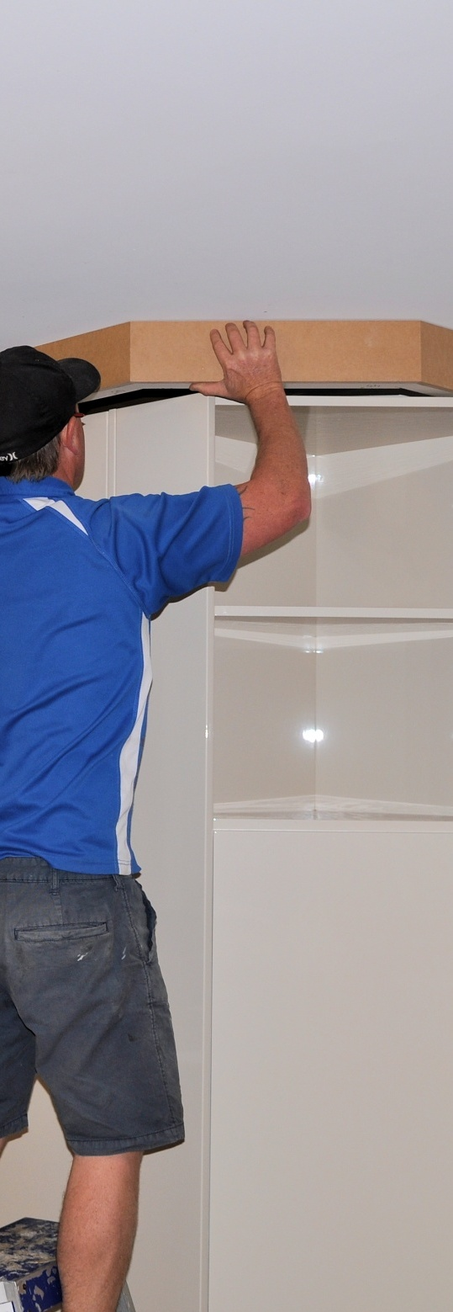

**Supporting:**

***LMFKB3006A   
Install fitted cabinets and components***

Installing cabinets on-site

**Learner guide**

**Developed in 2011-2012 for the WELL Program**

DRAFT VERSION

October 11

Installing cabinets   
on-site

Learner Guide

This unit is also available in an e-learning format, which contains additional photos, interactive exercises and a voice-over narration of the text. It can be viewed on CD-ROM, or live on the web at:

<http://www.kbcabinetmaking.com.au/>



Developed by Workspace Training for the 2011-2012

Workplace English Language and Literacy (WELL) Program

Kitchen and Bathroom Cabinetmaking resource development project



[www.workspacetraining.com.au](http://www.workspacetraining.com.au)

ISBN: 978-0-9873327-0-7

Funded under the Workplace English Language and Literacy Program by the Australian Government through the Department of Education, Employment and Workplace Relations.

COPYRIGHT

© Commonwealth of Australia. 2012



***CC BY-NC-SA***

This work is copyright. Except where otherwise indicated, and save for the Commonwealth Coat of Arms, the Department has applied the Creative Commons Attribution-Noncommercial-Share Alike 3.0 Australia Licence to this work.

The Department of Education, Employment and Workplace Relations must be attributed as the author of the Department’s copyright material.

As far as practicable, material for which the copyright is owned by a third party has been clearly labelled. The Department has made all reasonable efforts to ensure that this material has been reproduced in this print-based resource and the accompanying website with the full consent of the copyright owners.

Requests and enquiries concerning the Department’s copyright material should be addressed to:

The Copyright Officer

Department of Education, Employment and Workplace Relations

Location code C148CW2

GPO Box 9880 Canberra ACT 2601

Email: [copyright@deewr.gov.au](mailto:copyright@deewr.gov.au)

Questions about the design and content of the resource itself should be addressed to the project manager:

David McElvenny

Workspace Training

PO Box 1954 Strawberry Hills, NSW, 2012

Email: [david@workspacetraining.com.au](mailto:david@workspacetraining.com.au)

## About this resource

This learner guide is one of 11 learner guides developed for the *Kitchen and Bathroom Cabinetmaking* project, funded by the WELL Program in 2011-2012. The guides are aligned to the following core and elective competencies from the *Certificate III in Cabinetmaking (Kitchens and Bathrooms) LMF32109*:

*LMFKB2001A Prepare for cabinet installation*

*LMFKB3001A Identify processes in kitchen and bathroom*

*LMFKB3002A Determine requirements for installation*

*LMFKB3003A Check and measure fit of cabinets*

*LMFKB3004A Conduct on-site adjustments to cabinets*

*LMFKB3005A Fabricate cabinets for the built-in environment*

*LMFKB3006A Install fitted cabinets and components*

*LMFFM3006B Install furnishing products*

*MSAENV272B Participate in environmentally sustainable work practices*

*MSAPMOHS200A Work safely*

*MSAPMOPS101A Make measurements*

The purpose of the guides is to help apprentice cabinetmakers acquire the background knowledge needed to satisfy the theoretical components of these units. However, they are not designed to replace the practical training necessary to develop the hands-on skills required. Learners will still need to receive extensive on-the-job training and supervision before they will be ready to be formally assessed in these units.

### E-learning version

All of these units are also available in an e-learning format, which contains additional photos, interactive exercises and a voice-over narration of the text. The   
e-learning version can be viewed live on the web at:

<http://www.kbcabinetmaking.com.au/>

The web version can also be purchased on a CD at a cost-recovery price from the project developer:

David McElvenny (project manager)

Workspace Training

PO Box 1954 Strawberry Hills, NSW, 2012

Email: [david@workspacetraining.com.au](mailto:david@workspacetraining.com.au)

## Acknowledgements and disclaimer

### Project team

Project manager: David McElvenny

Instructional design: Kath Ware

Technical developer (website): Jim Vaughan

Assistant technical developer (and voice-over artist): Alex Vaughan

Quality assurance consultant: Giselle Mawer

Industry coordinator: Gary Dunshea (MSA Industry Skills Council)

Lead advisor: Rob Cole (Furnishing Industry Association of Australia)

### Technical Advisory Group

**New South Wales**

Brad Holmes – Hunter TAFE

Grant Cohen – Hunter TAFE

Dean Brakell – Furnishing Industry Association of Australia

Warren Peters – South West Sydney Institute of TAFE

Sean Greening – South West Sydney Institute of TAFE

**ACT**

Martin Jud – Canberra Institute of Technology

**Victoria**

Bryon Stanley – Furnishing Teacher's Advisory Group (VIC, SA, TAS)

Richard Brooks – Cabinet Makers Association

Simon Hampton – Wodonga TAFE

John Simpson – Holmesglen TAFE

**Tasmania**

Stephen Kirkman – Skills Institute Tasmania

**Queensland**

Rob McAdam – Skills TECH Australia

Brad Buhse – Skills TECH Australia

Roberto Viola – Gold Coast Institute of TAFE

**South Australia**

John Holst – Marleston TAFE

Dean Hart – Mt Gambier TAFE

Martin Videon – Furnishing Industry Association of Australia

**Northern Territory**

Hermann Oltrop – Charles Darwin University

**Western Australia**

Garry Michels – Polytechnic West

Keith Campbell – Polytechnic West

Adrian Boyling – Polytechnic West

David Boaden – Polytechnic West

Lorenzo Procopio – South West Institute of Technology

**National**

Laurie Kruize – Housing Industry Association

### Photographs and graphics

All photos were taken by David McElvenny. All graphics were drawn by Kath Ware. We would like to thank the following companies for allowing us to take photos of their installers and workshop employees and generously providing technical advice:

Canobolas Kitchen Designs Flair Kitchens

Danson’s Kitchens and Joinery Lamtex Innovative Furniture

Fewings Joinery Stateline Cabinets

B&B Joinery Ian McConnell Constructions

Krauss Kitchens

### Financial contributions

This resource was largely funded by the Workplace English Language and Literacy Program, through the Department of Education, Employment and Workplace Relations. However, due to the scale of the project and the provision of print-based and website resources, additional financial assistance was provided by the following organisations:

Manufacturing Skills Australia (Industry Skills Council)

Furnishing Industry Association of Australia

### Disclaimer

The content of this learner guide is provided for educational purposes only. No claim is made as to the accuracy or authenticity of the content. The views expressed in this publication do not necessarily represent the view of the Minister for Education or the Australian Government. The Australian Government does not give any warranty nor accept any liability in relation to the contents of this work.

**Table of contents**

[**Introduction 1**](#_Toc326166394)

[Section 1](#_Toc326166395) [Fasteners and sealants 3](#_Toc326166396)

[Overview 5](#_Toc326166397)

[Fasteners for masonry 6](#_Toc326166398)

[Fasteners for stud walls 9](#_Toc326166399)

[Durability of fasteners 11](#_Toc326166400)

[Sealants and fillers 13](#_Toc326166401)

[Assignment 1 15](#_Toc326166402)

[Section 2](#_Toc326166403) [Installing modular units 17](#_Toc326166404)

[Overview 19](#_Toc326166405)

[Installing the base 21](#_Toc326166406)

[Installing floor cabinets 23](#_Toc326166407)

[Installing wall cabinets 24](#_Toc326166408)

[Fitting doors and drawers 26](#_Toc326166409)

[Fitting bench tops 28](#_Toc326166410)

[Finishing to the wall 30](#_Toc326166411)

[Assignment 2 32](#_Toc326166412)

[Section 3](#_Toc326166413) [Installing appliances 33](#_Toc326166414)

[Overview 35](#_Toc326166415)

[Ovens and stoves 36](#_Toc326166416)

[Dishwashers and sinks 39](#_Toc326166417)

[Assignment 3 41](#_Toc326166418)

[Section 4](#_Toc326166419) [Final presentation 43](#_Toc326166420)

[Overview 45](#_Toc326166421)

[Finishing and handing over 46](#_Toc326166422)

[Assignment 4 49](#_Toc326166423)

[Practical demonstration 50](#_Toc326166424)

|  |
| --- |
| Introduction |

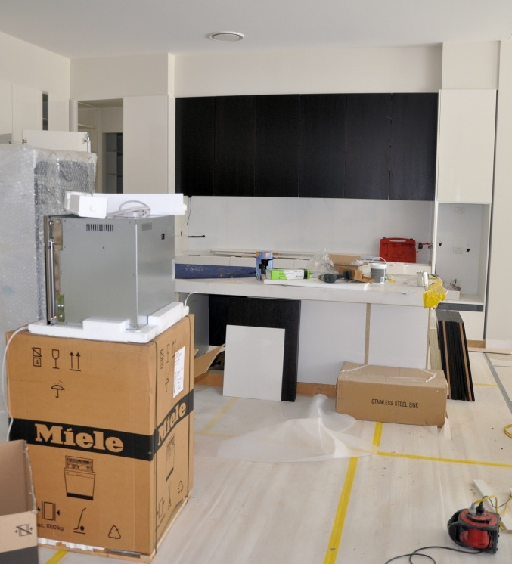Everything comes together when the actual installation begins. All the work that’s gone into designing the room, assessing conditions, measuring up, manufacturing cabinets, and organising the supporting tradespeople, is finally on full show as the room takes shape and the design becomes a reality.

In this unit we’ll cover the main methods used to install cabinets and components on-site. We’ll also look at some of the design considerations relating to the installation of appliances. And we’ll discuss the process of finishing off the job, carrying out a final inspection and handing it over to the client.

### Is this the right unit for you?

The content material in this unit is much the same as in the unit: *Installing furnishing products*. You should decide with your trainer which of these two units is most appropriate to your needs and then choose one or the other.

Your decision will be based on the requirements imposed by the Department of Fair Trading in your state or territory for the issue of a Contractor’s licence in kitchen and bathroom installations. Most jurisdictions have now recognised the new specialist competency*: LMFKB3006A Install fitted cabinets and components,* which is the basis for this on-line unit.

However, some jurisdictions have not yet incorporated the new competency into their pre-requisites for a licence, and still require the completion of *LMFFM3006B Install furnishing products* (which is supported by the Learner guide: *Installing furnishing products*).

At the time of publication, the NSW Department of Fair Trading was still listing the ‘furnishing’ competency as the appropriate accreditation for obtaining a licence.

### Working through the unit

There are four sections in this unit:

* Fasteners and sealants
* Installing modular units
* Installing appliances
* Final presentation.

Each section contains an *Overview*, an *Assignment*, and *Lessons* which cover the content material. Your trainer may ask you to submit the assignments as part of your assessment evidence for the unit. You will find hard-copy templates for these assignments in the separate Workbook.

Electronic ‘Word’ templates of the assignments are available on the website for this resource, at: <http://www.kbcabinetmaking.com.au/>

The electronic versions can be completed on-screen and sent to the trainer either as:

* a printed hard copy, mailed through the post
* an electronic file, emailed as an attachment.

### Practical demonstration

Your final assessment of competency in this unit will include various practical demonstrations. Their purpose is to assess your ability to physically carry out the process of installing cabinets and components on-site. To help you get ready for these hands-on assessment activities, there is a *Practical demonstration* checklist at the back of this Learner guide.

The checklist sets out the sorts of things your trainer will be looking for when you undertake the practical demonstrations. Make sure you talk to your trainer or supervisor about any of the details that you don’t understand, or aren’t ready to demonstrate, before the assessment event is organised. This will give you time to get the hang of the tasks you will need to perform, so that you’ll feel more confident when the time comes to be assessed.

# DSC_0171.JPGSection 1

# Fasteners and sealants

|  |
| --- |
| Overview |

**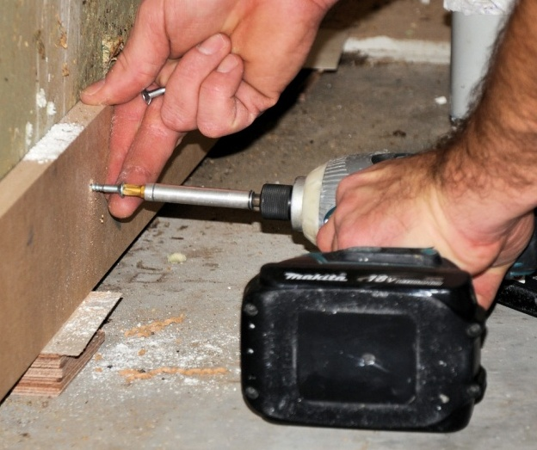Fasteners** are mechanical devices used to hold items together. In kitchen and bathroom installations, they are used to fix cabinets and components to each other and to walls, ceilings and floors.

Because the structural parts of the building are often made from different materials, there are also different types of fasteners available, each one designed for a specific purpose.

Some people like to make a distinction between ‘fasteners’, ‘fixings’ and ‘anchors’. However, most manufacturers and distributors use these terms interchangeably, so we won’t use separate definitions here. What they all have in common is some mechanical method for holding an item in place under pressure.

In this section, we’ll look at different types of fasteners and their main features. We’ll also cover the main types of sealants and gap fillers used in kitchen and bathroom work.

### thinking manCompleting this section

The assignment for this section is designed to test your knowledge of fasteners and sealants used in on-site installations. Have a look at the *Assignment* on page 15 to see what you’ll need to do to complete it.

There are four lessons for this section:

* *Fasteners for masonry*
* *Fasteners for stud walls*
* *Durability of fasteners*
* *Sealants and fillers.*

These lessons will provide you with background information relevant to the assignment.

|  |
| --- |
| Fasteners for masonry |

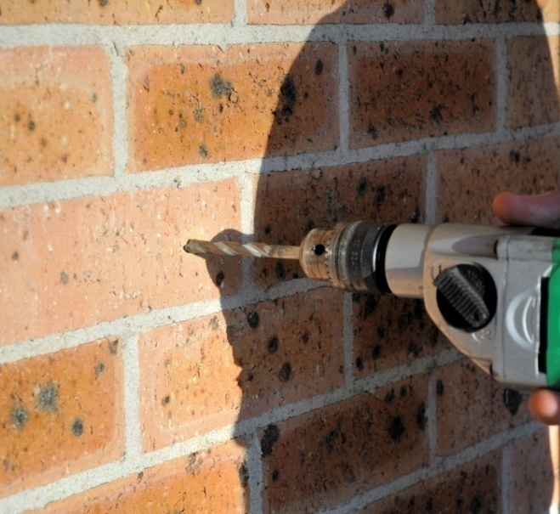Masonry fasteners are used to fix items to brickwork, stone, concrete, and similar materials. Most of them require a pre-drilled hole to allow the fastener to be pushed into position and then secured. An exception is hardened steel nails, which are fired into place using an explosive powered tool.

Where a pre-drilled hole is required, you need to use a **masonry drill bit**, which is similar to a standard ‘twist drill’ bit but with a tungsten carbine tipped point.

You should also use a drill that has a **hammer** or **percussion** setting, unless you’re drilling into soft material such as mortar joints between bricks.

Set out below are some common examples of masonry fasteners.

### Anchor bolts

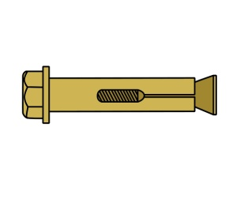These are sometimes called sleeve anchors, expansion anchors, or simply ‘dynabolts’, which is a particular brand name. They work by expanding the sides of the sleeve inside the hole as the bolt is tightened up.

### Self-tapping masonry screws

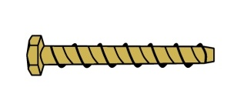Self tapping masonry screws cut their own thread into the concrete or brick as they are screwed in. They have less strength than a dynabolt, but are quick to install and useful for lighter loads.

### fasteners_4.jpgNylon screw plugs

There are various designs of nylon plugs for screws, but they all work on the same principle. As the screw is tightened up, the plug expands and holds fast inside the hole.

### Nylon anchors

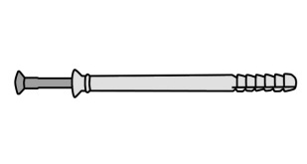Nylon anchors work in a similar way to nylon plugs. The difference is that they use a nail with a threaded shank to expand the sleeve, which means that they are hammered into place, rather than screwed.

### fasteners_6.jpgPlastic Plugs

Plastic plugs are designed for wood screws. They are a simpler version of the nylon screw plugs, and come in a range of colour-coded sizes.

### fasteners_7.jpgPower actuated fasteners

These fasteners are generally hardened nails, and are fired into place using an explosive charge. The gun is commonly called by its brand name, such as ‘Ramset gun’ or ‘Hilty   
gun’.

### Chemical anchors

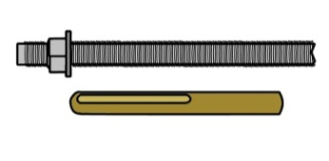Chemical masonry anchors use a heavy-duty adhesive to glue the bolt in place. Because the anchor does not require an expansion sleeve, it can be used close to an edge without the fear of the edge breaking out under pressure.

##### Learning activity

You’re probably familiar with at least some of these fasteners, and you may have used them many times in your work. However, there could be particular fasteners that you have never used or even seen before.

Patented designs are always known by their brand names, such as ‘Loxin’ (a type of expansion sleeve anchor bolt) and ‘Chemset anchor stud’ (a chemical anchor).

Choose a masonry anchor that you either currently use at work, or would like to know more about. If you’re not very familiar with the anchor, do some research on what its particular advantages are (that is, why it is used in certain situations) and how it is fitted. If possible, see if you can use it in a couple of jobs to find out for yourself how it works. When you’ve finished, write down the following details:

* Brand name of fastener
* General class of fastener (e.g. ‘expansion sleeve anchor’, ‘nylon anchor’ etc.)
* Advantages (including the applications for which it is most suitable)
* Disadvantages (including situations where you would not use it).

Share your findings with other learners in your group and your trainer. You may take digital photos of the anchor, both loose and in a completed job, to include with your answers.

|  |
| --- |
| Fasteners for stud walls |

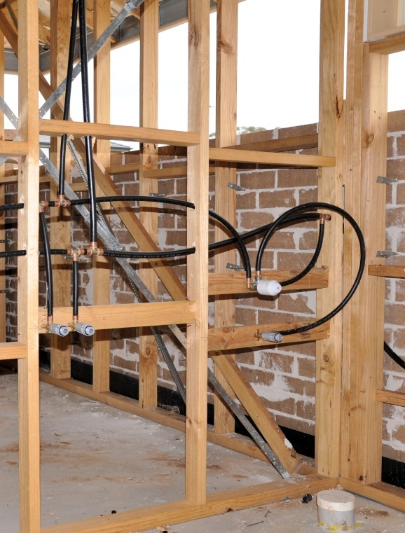Most new homes have a brick veneer wall structure, with an external skin of brickwork and an internal wall frame. The wall frames are often called **stud walls**, because the main structural members are the vertical studs. For more details on the structural aspects of these walls, see the unit: *Installation requirements.*

Stud walls are generally made of timber, although sometimes steel is used, particularly in localities that are known to have high termite activity. In the kitchen it is common to have plasterboard sheeting (such as ‘Gyprock’) fixed to the wall frame. In the bathroom, the sheeting is more often fibre cement (such as ‘Villaboard’), which is water resistant and easy to tile.

Most fixings for stud walls are designed to go into the studs themselves. However, for lighter loads, it is sometimes possible to use fasteners that fix to the internal wall lining in between the studs – that is, in the wall cavity.

Set out below are the main types of fasteners used for stud walls.

### fasteners_8.jpgNails

Nails are best for replacing skirtings and architraves. They’re also suitable for fixing timber blocks to a timber floor or the base of a wall. In general, you shouldn’t use nails for fixing cabinets or other units that need to be levelled and plumbed.

### Self-drilling timber screws

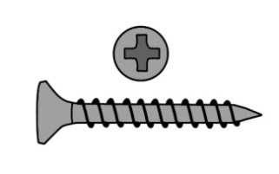The most common screws used by installers are ‘posi-drive’ or Phillips-head timber screws. These are self-drilling screws, driven with a Phillips bit on a variable-speed drill. One example is the ‘chipboard screw’, which is also used in assembling particleboard cabinets.

### fasteners_9.jpgSelf-drilling metal screws

In buildings that have steel wall frames, metal screws need to be used. Again, these self-drilling screws are generally driven by a variable speed drill. However, depending on the gauge of the screw, they may have a Phillips head or a hex head.

### fasteners_11.jpgToggle bolt

Toggle bolts are **cavity fasteners** – that is, they fix to the plasterboard or other internal wall lining material in the cavity between the studs. When the bolt is pushed through the hole, the toggle springs open and provides a restraint for the bolt as it is tightened. They are only suitable for light loads.

##### Learning activity

Like the masonry fasteners we discussed in the previous lesson, you have probably used some of these items on-site but not others. Again, there are various patented designs, such as ‘Interset’ cavity fasteners and ‘Rawlnut’ multi-purpose fasteners.

Choose a fastener that you either work with now or would like to know more about. Again, if you’re not very familiar with the fastener, try to use it in a couple of jobs to see how it works.

When you’ve finished your research, write down the following details:

* Brand name of fastener
* General description (i.e. cavity fastener, timber fastener, steel fastener)
* Advantages (including the applications for which it is most suitable)
* Disadvantages (including situations where you would not use it).

Share your findings with your trainer and other learners in your group. You may take digital photos of the fastener, both loose and in a completed job, to include with your answers.

|  |
| --- |
| Durability of fasteners |

**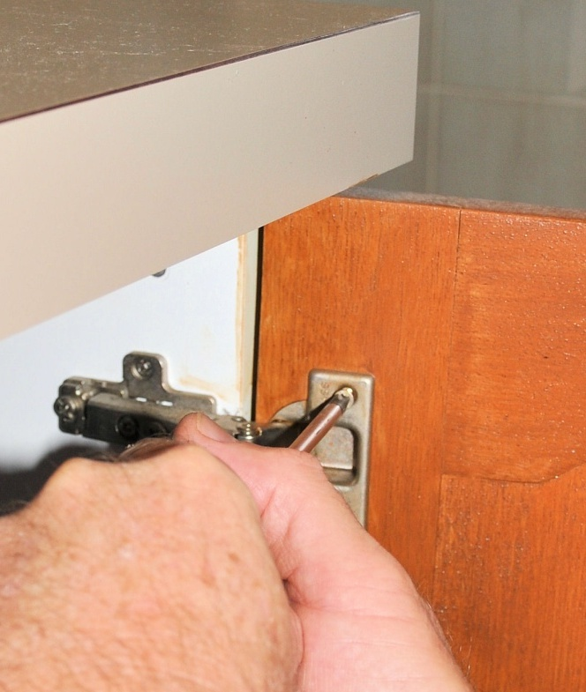Corrosion** is the process of a metal rusting away, or breaking down into the natural materials it is made from. There are many corrosive agents, including air, water, salt and acids. The higher the level of exposure to these agents, the faster the corrosion will be.

Although the fasteners used in kitchen and bathroom installations are generally shielded from the outside elements, there are still times when their location may put them into direct contact with water or a high humidity atmosphere. In these instances, you need to make sure that the fasteners will be durable enough to resist corrosion.

There’s a wide range of coatings available for fasteners, providing varying degrees of protection to rust. There are also particular metals, such as stainless steel, that are very durable in their own right. In the end, you need to strike a balance between the cost of the fastener and its ability to do the job expected of it over the lifetime of the installation. Below are the main finishes you’re likely to use.

### Hot dipped galvanising

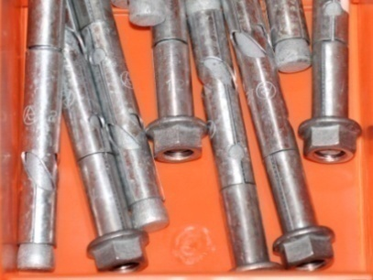Galvanising is the process of coating a steel fastener with zinc by passing it through a bath of molten zinc. The finished surface has a dull grey look with a ‘spangle’ pattern. Hot dipped gal fasteners are very durable, and are used in areas of high exposure to corrosive agents, or when long term reliability is critical.

### DSC_0029.jpgZinc plating

Zinc plating is a cheaper process than hot dipped   
galvanising, but the coating is much thinner. The steel   
is immersed in a zinc salt solution and an electrical   
current is applied through a process called ‘electrolysis’.   
Zinc plated fasteners are generally bright silver or gold  
 in colour, and are suitable for most internal applications.

### DSC_0032.jpgStainless steel

Stainless steel fasteners don’t require a coating at all, because the steel alloy is already extremely resistant to corrosion. They are also much more expensive than most other fasteners. Although they’re not normally needed for internal applications, they are used in high exposure conditions, such as around spas and saunas.

##### k&b_la_drawingLearning activity

Most of the bolts, screws and other fasteners you use at work are probably zinc plated. But there may be times when you need to use hot dipped gal or stainless steel fasteners. You may even use other types of plating from time to time, such as nickel, chrome or molybdenum.

List some examples of fasteners you use at work. Beside each one state the metal (or other material) it’s made from as well as its protective coating (if there is one). Try to choose fasteners that have a range of different materials and coatings. Share your answers with your trainer and other learners in your group.

|  |
| --- |
| Sealants and fillers |

**Sealants** are used to provide a waterproof seal around sinks, basins and other fitted items that may be splashed by water. **Fillers** are used to fill small gaps between the wall and cabinets, so that there is no visible gap remaining.

Some people refer to sealants and fillers as **caulks** or **caulking compounds**, and call the tool that holds the cartridge a **caulking gun**. The word ‘caulk’ dates back to the days when boat hulls were made of wooden planks and had to be sealed with fibre caulking to make them waterproof.

There are dozens of different products on the market, each of which has a particular formulation designed for specific uses. Some sealants and fillers have anti-mould additives, or chemicals that make them more flexible, or bonding agents that help them to stick better to certain materials.

They can be grouped into three main categories, as described below.

### Solvent-based silicone

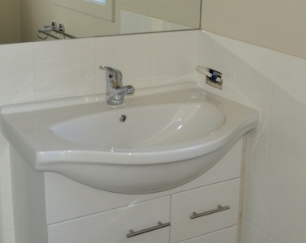Silicone is waterproof and flexible, and bonds well to glass, metal, ceramic tile, and porcelain. It’s typically used to seal bath tubs, shower screens, vanity basins and stainless steel sinks. Because it is highly weather resistant, it’s also used by other building trades to seal roof guttering, downpipes, flashing, vents and window glass.

One of its main disadvantages is that it doesn’t stick well to timber. It can also be difficult to work with, and requires solvents to clean up. Most silicone sealants can’t be painted over; however, they are available in a range of colours, including translucent.

### Water-based caulks

Water-based caulks are flexible and able to be painted over. They are also easier to apply than solvent-based silicone, because the excess can be wiped off with a damp cloth. Some water-based caulks contain silicon, such as Selleys ‘No more gaps’, which is used widely as a gap filler in bathrooms and kitchens.

However, unlike the solvent-based silicones, they are not fully waterproof and are not suitable for damp locations, such as shower recesses or other areas subjected to a lot of moisture.

### Polyurethane

Polyurethane bonds well to concrete, metal and timber. It can withstand harsh weather conditions, abrasion and joint movement. Polyurethane can also be painted over, particularly with acrylic paints. It is often used in high traffic areas, such as on floors and driveways.

On the downside, polyurethane is toxic and emits fumes while it is being applied. It also needs to be cleaned up with a special solvent.

##### k&b_la_drawingLearning activity

You’ve probably seen the huge range of sealants lined up along the wall at your local hardware store or building supplier. The particular brands that your company uses will have been chosen because they are the best suited for the types of jobs you do.

Choose one sealant brand and have a look at the information written on the side of the cartridge. Answer the following questions

What is the trade name of the sealant?

What are its features? (That is, what sorts of jobs does it do best?)

Does it clean up with water or a solvent?

Share your answers with your trainer and other learners in your group.

|  |
| --- |
| Assignment 1 |

### Question 1

Choose two types of fasteners used for fixing cabinets or components to masonry. Provide the following details for each one.

Trade name or brand name

Class of fastener (generic description)

Main uses (what you use it for in your own installations)

Finish (e.g. zinc plated, hot dipped gal, stainless steel etc.)

Tools required (for drilling the pilot hole, inserting the fastener and securing it)

Safety considerations (specific safety issues and PPE e.g. dust mask)

Cautions (typical things that might go wrong and how you guard against it).

### Question 2

Choose two types of fasteners used for fixing materials to stud walls (either into studs or cavities). Provide the following details for each one.

Name of fastener (including brand name if applicable)

Main uses (what you use it for in your own installations)

Tools required (for inserting and securing it)

Cautions (typical things that might go wrong and how you guard against it).

### Question 3

Choose two types of caulking compounds, preferably for two different purposes (e.g. one may be a gap filler and the other may be a sealant). Provide the following details for each one.

Brand name of product

Generic description (purpose and main chemical ingredients)

Main uses (what you use it for in your own installations)

Equipment required (for application)

Clean-up agent (water or solvent)

Safety considerations (specific safety issues and PPE e.g. gloves)

Cautions (typical things that might go wrong and how you guard against it).

# DSC_0171.JPGSection 2

# Installing modular units

|  |
| --- |
| Overview |

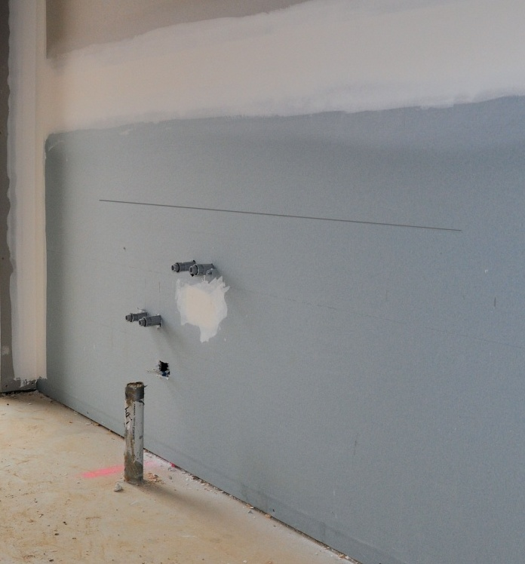In this section, we’ll pick up from the point where the setting out has been completed and the cabinets are ready to install. For more information on the types of adjustments that may need to be made before the cabinets can be put in place, see the unit: *Adjusting cabinets on-site*.

The first step in the installation process is to determine what the finishing height of the bench top will be. This may have been specified to match existing units, or to ensure that the bench top fits underneath a window sill or other feature.

Once the height has been established, you should subtract the thickness of the bench top and then draw a horizontal line around the room to mark where the tops of the cabinets will finish. This forms the ‘zero point’, or reference line for the installation. For more details on the process of checking floor levels and deciding on the height of this line, go back to the unit: *Checking fit of cabinets*.

### thinking manCompleting this section

The assignment for this section is designed to test your knowledge of the principles involved in installing cabinets on-site. Have a look at the *Assignment* on page 32 to see what you’ll need to do to complete it.

There are six lessons for this section:

* *Installing the base*
* *Installing floor cabinets*
* *Installing wall cabinets*
* *Fitting bench tops*
* *Fitting doors and drawers*
* *Finishing to the wall.*

These lessons will provide you with background information relevant to the assignment.

|  |
| --- |
| Installing the base |

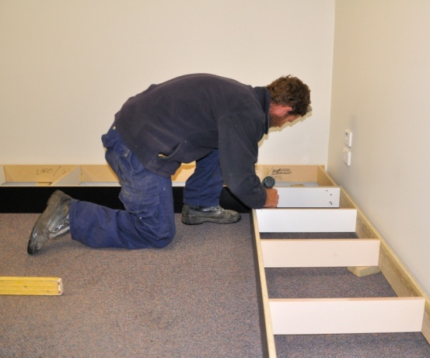Most modular floor cabinets are designed to sit on a separate base, called a **plinth**.

This may be prefabricated in the workshop, or built up piece by piece   
on-site.

Set out below is a common method of installing and levelling a plinth with a kickboard across the front.

1. Read off the locations and dimensions of the floor units from the plan, and mark them on the floor with a pencil.

Cut the plinth components to length and lay them in position.

1. 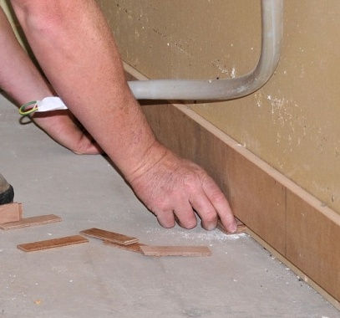Level the top edge of the plinth with a spirit level or laser level, and make adjustments as required. If only small adjustments are needed, you can use packing pieces, such as 4 mm plastic laminate.

For bigger gaps or variations in floor levels, you may need to scribe the kickboard to the contours or slope of the floor, and reshape the underside of the kickboard with a plane.

1. Seal the exposed edge of the kickboards that come into contact with the floor, and fix the rear of the plinth to the floor or base of the wall.

If the floor and walls are timber framed, you can use nails or screws. If the floor is concrete, use brackets screwed to the inside of the plinth and fastened to the floor with masonry anchors.

##### Learning activity

The method described above is just one way of constructing a plinth. There are also cabinet designs that have built-in bases, which means that a separate plinth isn’t needed at all.

What methods does your company use to carry out this part of the installation? How is the levelling done? What are the kickboards fixed to?

Write down your answers and share them with your trainer and other learners in your group. If possible, take digital photos to go with your descriptions.

|  |
| --- |
| Installing floor cabinets |

Below is a common approach to installing floor cabinets. This method is used when a separate plinth is installed first.

1. Finish off any adjustments that need to be made to the cabinets, such as cutting holes for plumbing, electrical or gas services. See the lesson: ‘Service outlets’ from the unit *Checking fit of cabinets* for more details on how to set out for these modifications.

Also remove the doors and label them so they can be matched up again later.

1. 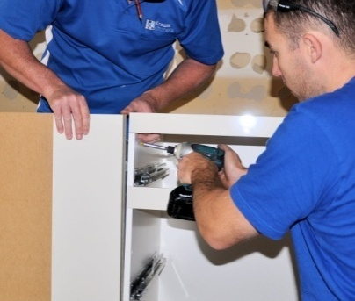Place the cabinets one by one onto the plinth. In most cases, you’ll find it easiest to begin with a corner unit and work progressively along the wall.

As each cabinet is put in position, fasten it to the previous cabinet or other panel, using the screws or bolts that have been specified for the job. Dress any visible screw or bolt heads with plastic trim caps.

1. 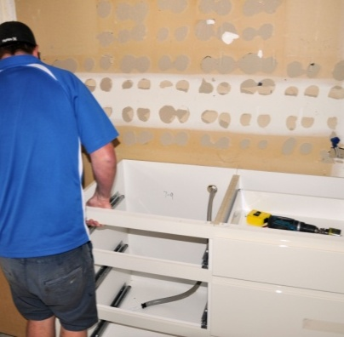Fasten the floor units to the wall, using the appropriate fasteners for the material you’re fixing to – which will most likely be timber studs, steel studs or masonry.

If there’s a gap between the wall and the back of the unit, insert a packing piece. Make sure the packing piece is exactly the right thickness to keep the cabinet plumb when you pull it up tight with the fastener.

##### Learning activity

You’ll use different fasteners for different purposes and materials when you fix the cabinets into position. Name the fasteners you’re likely to use when installing a set of floor cabinets in a timber framed kitchen. Include the fasteners used to fix the cabinets to each other as well as the fasteners that go down to the floor and through to the wall frame.

Share your answers with your trainer and other learners in your group.

|  |
| --- |
| Installing wall cabinets |

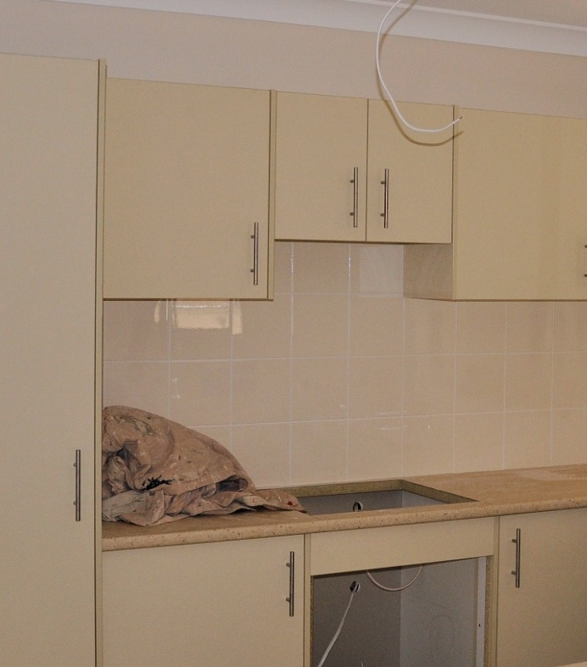The overhead cabinets are called **wall cabinets** because they’re fastened directly to the walls. Their heights will be specified in the plan. The Australian Standard for domestic kitchen installations (AS 4386) sets various minimum requirements for wall cabinet heights.

For example, the Standard states that the clearance between the top of the bench top and the underside of a wall cabinet must be at least 450 mm. In the case of a cooktop, the minimum clearance between the top of the highest burner and the underside of a range hood or exhaust fan is 600 mm.

Apart from these clearance requirements, the height of the wall cabinets will also be influenced by the design and materials chosen for the splashback. For example, if the splashback behind the stove is going to be 4 rows of 150 mm tiles (as shown in the photo above) and you want to avoid cutting the tiles, the height would need to be 600 plus a grout width of 2 mm on either side of each tile – making it a total of 610 mm.

The process for installing the wall cabinets is as follows.

1. 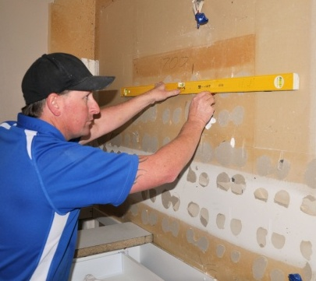Draw a horizontal line along the wall to mark where the underside of the cabinets will go. Note that the plan is likely to specify the height measured from the top of the bench top, so if it hasn’t been installed yet you will need to mark that finishing line first.

If the wall is timber or steel framed, mark the stud positions on the wall. This may simply involve extending the marks used for the floor cabinets.

1. 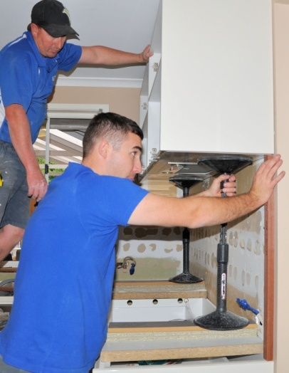Put adjustable cabinet supports, or some other form of support, in place to take the weight of the wall cabinets. Then lift the cabinets into position one by one.

This photo shows an installer using a cut-to-length stick to set the exact height of the wall cabinet above the carcase of the floor cabinet under it. Note that in this case the bench top has not yet been installed, so the length of the stick will be the height of the splashback plus the thickness of the bench top.

1. 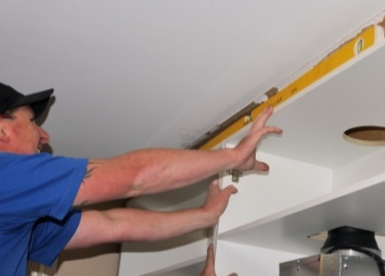Check the cabinet for level and plumb. If there is a gap to the wall, you’ll need to use packing pieces in the same way as for the floor units.

Fix the cabinet to the wall using appropriate fasteners, depending on whether you are fixing to studs or masonry.

##### Learning activity

You need to take just as much care making the wall cabinets level and plumb as for the floor cabinets. See if you can list some of the problems you might be faced with if the wall cabinets weren’t installed level and plumb. Be as specific as you can. Share your answers with your trainer and other members of your group.

|  |
| --- |
| Fitting doors and drawers |

The prefabricated cabinets will have had their doors and drawers fitted in the workshop. However, it’s common for at least some components to be removed when the cabinets are delivered to the site. At any rate, you may need to remove doors and drawers when you’re installing the carcases and fixing them in position.

### Doors

If the doors use two-piece concealed hinges, they can be re-attached by clipping the hinge arm onto the mounting block and securing it in position.

You’ll need to check the clearance gaps and alignment of the doors as you go. We covered this process in detail in the lesson: ‘Doors’ from the unit *Adjusting cabinets on-site*.

### Drawers – up to here

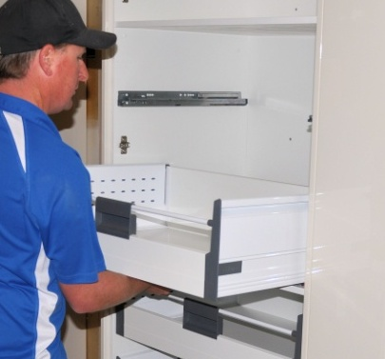When the drawers are replaced, it should be a simple matter of sliding them back onto their runners. However, it is possible that some re-adjustments will need to be made, particularly to the drawer fronts if they don’t line up or the gaps are uneven.

This process is covered in detail in the lesson: ‘Drawers’ from the unit *Adjusting cabinets on-site*.

### Handles

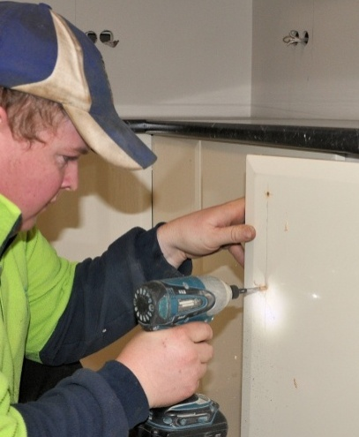If the doors and drawers have handles, you can fit them once the doors and drawer fronts have been properly aligned. On floor cabinets the handles should be positioned near the top of the doors, and on overhead cabinets they should go near the bottom. If the cabinet is at eye level, the handles can be closer to the centre.

Most door handles are set in between 25 mm to 50 mm from the side of the door, but the final decision will depend on the design of the handle and client’s preference.

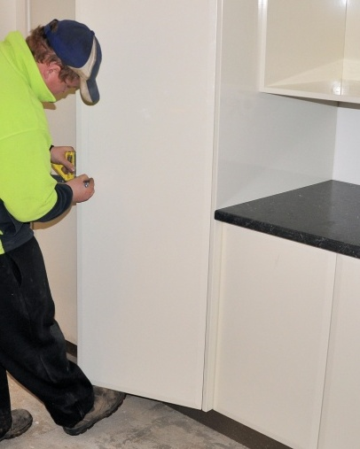Mark the centre points for the screw holes by measuring down from the top of the door (or up from the bottom) and then in from the side.

If you’re putting handles on a lot of doors, it’s best to make up a template or jig to transfer the measurements quickly. Some installers use the simple method of setting the blade on a combination square to the longest length required, and then taking off the other measurements from the markings on the rule.

##### Learning activity

Depending on the types of hinges and drawer slides you’re using, there may be other items of hardware that also need to be fitted. These could include door catches and soft close mechanisms.

What hardware items do your clients ask to be fitted to doors and drawers? Write down the names of the components and their manufacturers, and provide a brief description of what they do. Share your answers with your trainer and other learners in your group.

|  |
| --- |
| Fitting bench tops |

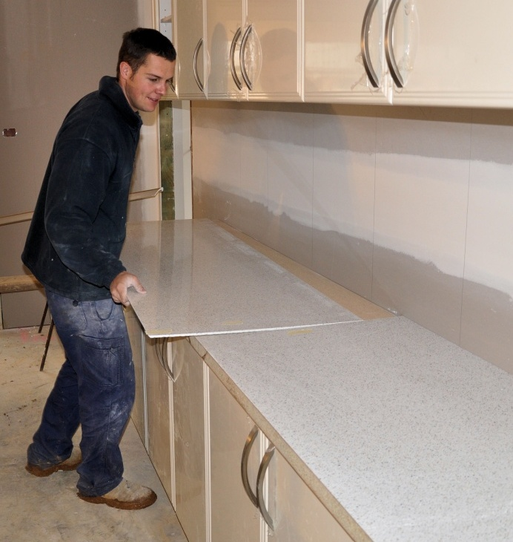Once the floor units have been fixed to the kickboard and wall, the bench top can be fitted. Bench tops are generally prefabricated in pieces as large as possible, while still being manageable for transporting and putting into position. This helps to create a smooth finish with the minimum number of joins.

There are many different types of materials used in bench tops. The most common tops are made from moisture resistant particleboard or MDF (medium density fibreboard) finished with laminated plastic or melamine.

More expensive tops use solid timber, stainless steel, stone such as granite or marble, ‘engineered’ stone such as CaesarStone, and synthetic products such as Corian.

If the top is laminated particleboard or MDF, it’s likely that your own company will have prefabricated it and you’ll install it. If it is a more specialised product, the manufacturer may send their own person out to do the on-site installation.

Set out below is a typical installation procedure for a laminated particleboard bench top.

1. 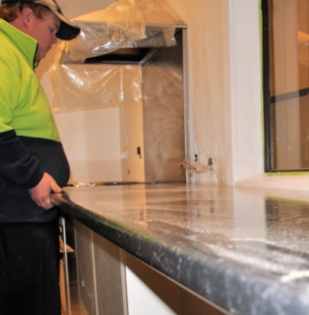Place the bench top in position on the floor cabinets. Set the overhangs to the specified measurements – often 35 mm to the front and sides. Make sure that the overhang is parallel right along the front.

If the top needs to be cut back or scribed to the wall, mark the top and re-cut or shape it using the appropriate tools. For more details on this process, see the lesson: ‘Panels and bench tops’ from the unit *Adjusting cabinets on-site*.

1. 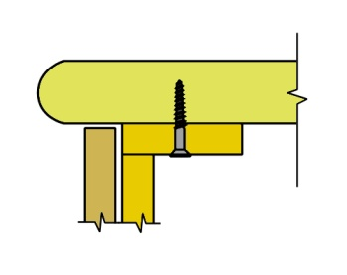Check that the finished bench top has a gap of no more than 2 mm at any point to the wall. Fix it to the cabinets with screws, working from the underside of the cabinets’ top rails. Be careful that the screws are long enough to provide a sound fixing into the bench top, but are short enough to avoid going right through.
2. 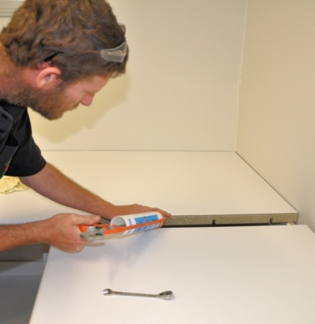If the wall is already finished or only needs to be painted, put a bead of silicone-based sealant along the joint. However, if you know that the wall is going to be tiled later or fitted with a splashback panel, you may be able to leave the gap as it is.

Where there are joins in the bench top itself, use a silicone-based adhesive to secure the joint and provide a water-tight seal. Then tighten up the screws or bolts used to draw to two pieces together.

Never use glue to fasten the bench top to the cabinets. Glue doesn’t allow for any movement that might occur due to variations in humidity or changes in temperature. The result is that the glue joint may fail over time, or alternatively the stresses may cause damage to the materials.

##### Learning activity

What types of bench tops do you (or your company) install as part of your on-site fit-outs? What other bench tops does your company offer clients that require installation from a specialist contractor?

For each bench top you list, write a brief description of its advantages and disadvantages. Share your answers with your trainer and other learners in your group. You might like to include digital photos of any bench tops you’re able to photograph, either in the workshop or installed in a client’s home.

|  |
| --- |
| Finishing to the wall |

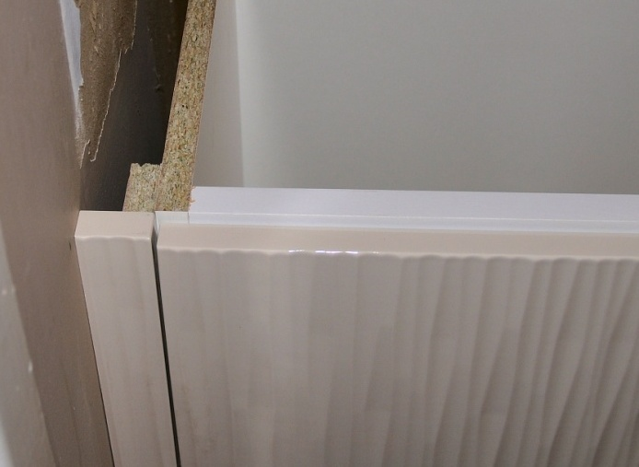It is common practice to use a filler piece between an end cabinet and the wall. This gives you a bit of leeway with the measurements while you're positioning and levelling the cabinet.

It also lets you scribe and re-cut the filler if it turns out that the wall isn’t plumb or there is a hollow or curve in the wall.

### Out-of-plumb walls

The process for scribing and recutting a filler piece to match the deviations in a wall is much the same as for scribing templates and larger panels. We’ve talked about this process in the lesson: ‘Templates’ from the unit *Checking fit of cabinets*. The process of recutting or shaping a piece is covered in the lesson: ‘Panels and bench tops’ from the unit *Adjusting cabinets on-site*.

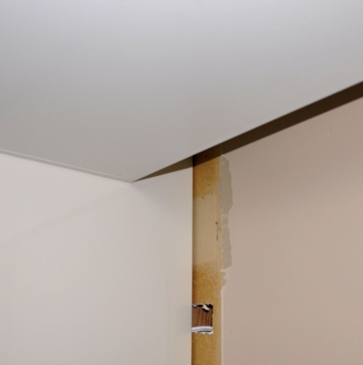If the out-of-plumb wall is behind the cabinet, you can use a scribed end panel to fit flush with the wall. Note that the cabinet itself will need to have a reduced depth so that the wall deviations don’t push the cabinet forward.

This photo shows a cabinet set in 200 mm from the wall, with a scribed end panel. Just remember that if you’re using this technique, you need to make allowance for the extra board thickness, generally 16 mm.

### cornice_fit.jpgCornices

If you’re installing wall cabinets that go right to the ceiling, you may find that you need to scribe around a cornice. In this instance, it’s often easiest to use a pair of dividers to draw the shape. The profile line can either be scribed onto a template or directly onto the panel itself. Make sure you keep the dividers horizontal so that the line stays exactly parallel at all times.

### service_pipes_1.jpgService pipes

There may be times when you need to work around existing service pipes, such as electrical conduits, air conditioning ducts and waste pipes. This particularly occurs in older buildings with masonry walls.

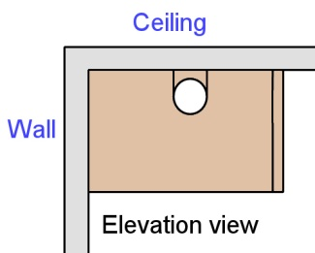If the pipes or obstacles are against the wall, you can install a cabinet with a reduced depth and cover the gap in the same way as for out-of-plumb walls.   
The drawing above shows a plan view of a cabinet   
with filler pieces finishing to the side and rear walls.

For service pipes near the ceiling, you can cut an end panel that goes around the pipe. This drawing shows an end panel with a hole cut for the pipe, and two vertical cuts that allow the bridging piece to be removed while the panel is fitted. The bridging piece is then replaced and fixed in position.

##### profile_gauge 2.jpgLearning activity

We’ve talked about using dividers to scribe the profile of a fancy cornice. But there are other tools available, such as a profile gauge, which can be used to transfer very detailed shapes across to a panel.

Have you ever seen or used a profile gauge? If not, ask your supervisor or work colleagues if they can show you one and demonstrate how it works.

|  |
| --- |
| Assignment 2 |

### Question 1

Describe two methods for putting a level base or support underneath a floor cabinet.

### Question 2

Let's say you need to install two floor cabinets in a kitchen. The cabinets will sit side by side on a single plinth with a kickboard across the front. All boards are 16 mm melamine particleboard. The floor is bare concrete. The stud walls are constructed from radiata pine with plasterboard linings.

List each of the different types of fasteners you would take on-site with you to carry out this installation. For each fastener, state where you will use it.

Note that you do not have to include fasteners for the bench top or any other components.

### Question 3

Why do cabinets need to be installed perfectly level and plumb, regardless of the state of the floor and walls? Name four problems you might have to deal with if the carcases were not level and plumb. Note that these problems may occur during the installation of the carcases, or later on when you come to install other components or items.

# DSC_0171.JPGSection 3

# Installing appliances

|  |
| --- |
| Overview |

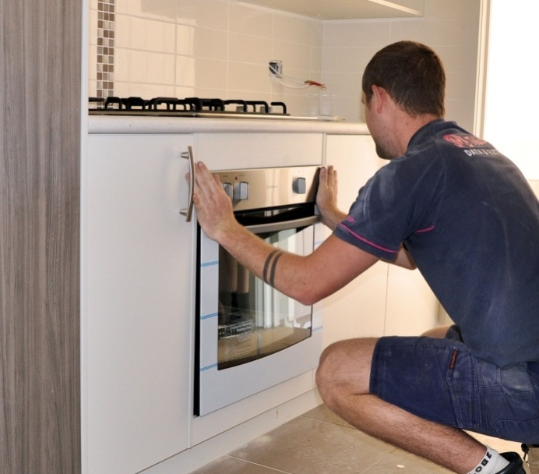Kitchen appliances are often built into the cabinetry, particularly if they’re wired directly into the electrical system or fitted to the gas service. Other appliances are more likely to be free standing, but still incorporated into the design of the kitchen.

In this section, we’ll look at the main design issues relating to built-in ovens, cooktops and rangehoods. We’ll also discuss techniques used to install dishwashers and sinks.

### Completing this section

The assignment for this section is designed to test your understanding of clearances and measurements for different appliances. Have a look at the *Assignment* on page 41 to see what you’ll need to do to complete it.

There are two lessons for this section:

* *Ovens and stoves*
* *Dishwashers and sinks.*

These lessons will provide you with background information relevant to the assignment.

|  |
| --- |
| Ovens and stoves |

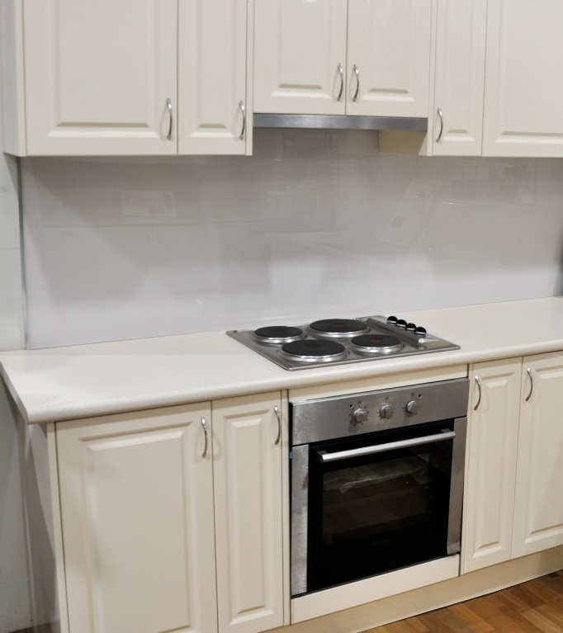The Australian Standard (*AS/NZS 4386.2: Domestic kitchen assemblies – installation*) sets out various specifications for oven and stove installations. These include minimum clearances between cooktop burners and ‘combustible surfaces’, and ventilation requirements for built-in ovens.

Some appliances may require greater clearances or ventilation spaces if they have an unusually high heat output or physical size. These will be specified in the manufacturer’s installation instructions.

In practice, you shouldn’t have to worry too much about the specifications when you’re carrying out the on-site installation, because they will have already been built into the design of the kitchen. So the dimensions of the prefabricated cabinets should take these clearances into account.

One requirement that applies to every built-in appliance is that the power connection must not be located directly behind it, and preferably should be in an adjacent cabinet. Most electric ovens and stoves are wired directly into the house mains power system, so the final connection will have to be done by a licensed electrician. If the appliance runs on gas, the connection must be done by a licensed gas fitter.

### Freestanding cookers

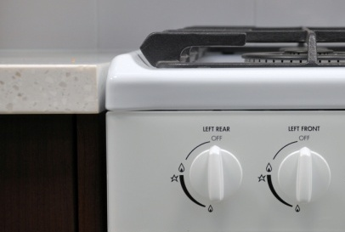Freestanding cookers typically have a stove on top and oven underneath. For gas burners, there is a requirement that if any burner is less than 200 mm from a combustible horizontal surface, such as a bench top, the cooktop hob must be at least 10 mm above that surface.

### Built-in ovens

Built-in ovens can be installed under a bench top or in a full height wall unit. The manufacturer’s instructions will specify the amount of ventilation required for each model, including minimum space allowances at the sides and rear of the unit. It may also include cut-outs in the base of the cabinet and venting space above.

### cooktop_1.jpgHobs

There are various design issues that need to be considered for cooktop hobs. Firstly, the minimum space allowed between the cooktop elements or gas burners and combustible materials directly overhead is 600 mm.

50

600

(Note that it’s normal practice to mount a rangehood above the cooktop, which will help to protect any wall cabinets above it.)

300

Secondly, there must be at least 50 mm clearance from the back edge of the cooktop to a non-combustible wall surface or splashback. Non-combustible surfaces include tiles, glass, stainless steel and stone.

Thirdly, there must be at least 300 mm horizontal clearance from the outside edge of an electric element or gas burner to a combustible surface on the side of a cooktop. Combustible surfaces are defined as any material that might catch fire and burn at a temperature exceeding 500C above the ambient temperature. These surfaces include adjoining cabinets faced with melamine or plastic laminate.

The cooktop hob is set into a hole cut into the bench top. If the bench top substrate is made of particleboard, MDF or timber, the exposed edge should be re-sealed to protect it from moisture. There’ll also be a rubber seal supplied with the cooktop that will provide a waterproof seal between the cooktop and bench top. Note that silicone should not be used, because you need to be able to remove the cooktop easily if it ever needs to be serviced.

### Rangehoods and extractors

Rangehoods are covers and extraction systems mounted over a cooktop. They’re designed to either recirculate air back into the room or provide an exhaust duct to the outside.

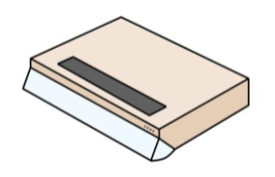Below are the main designs available.

**Slimline rangehoods** are fitted under the wall cabinet immediately above the cooktop. Some have a visor at the front to deflect the fumes back into the unit.

**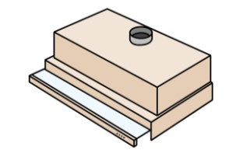**

**Slideout rangehoods** are built into the wall cabinet to enable the doors to close over the front. When the glass shelf is pulled out it automatically starts the extraction fans.

**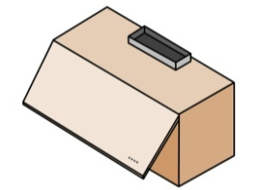**

**Swingout or ‘hide-a-hood’ rangehoods** also fit inside a cabinet. When the cabinet door is pulled up the rangehood starts to operate.

**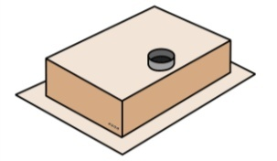**

**Undercupboard rangehoods** can be enclosed on all vertical sides and either mounted to the wall or suspended from the ceiling.

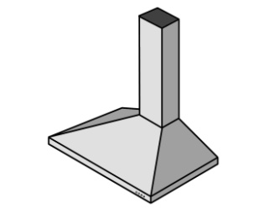

**Canopy rangehoods** are made of stainless steel and mounted to the wall. They must be ducted to the outside of the building.

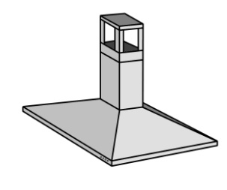

**Island rangehoods** are like canopy rangehoods but are suspended from the ceiling over the cooktop. They also need to be ducted to the outside.

##### k&b_la_drawingLearning activity

You’ll find more details on the installation requirements for ovens and stoves in AS/*NZS 4386.2: Domestic kitchen assemblies – Part 2: installation*. The Standard also contains other specifications and measurements for appliances and cabinets.

Ask your supervisor or trainer if you can borrow a copy of the Standard. Alternatively, you can download a PDF version for yourself by going to the Standards Australia International website at: <http://infostore.saiglobal.com/store/>. But note that you will have to purchase it, and Part 2 costs about $80.

|  |
| --- |
| Dishwashers and sinks |

### dishwasher_2.jpgDishwashers

Dishwashers are generally positioned under the bench top and close to the sink, so that they can share a common waste pipe.

The plumbing outlets and powerpoint are typically housed in the sink cabinet, because there is often very little space behind the dishwasher once it’s pushed into position.

The powerpoint needs to be freely accessible without having to remove   
the dishwasher. This means that you’ll need to cut access holes into the sink cabinet for the water hose, electrical lead and waste hose.

Normally one hole will go through the side of the sink cabinet into the plinth area and another hole through the floor of the cabinet. The holes can be cut with a hole saw.

The space you leave for the dishwasher should be tight enough to give it a built-in appearance, but with at least 5 mm on each side for clearance. Dishwasher heights are generally in the range of 820 to 870 mm, but remember that if a floor covering is going to be installed under the dishwasher, you’ll need to add the thickness of the flooring to get the effective height.

### Sinks

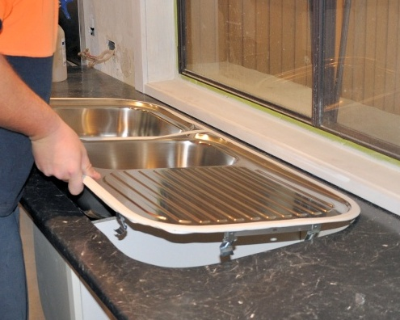Most sinks are ‘over-mount’, meaning that the outer flange sits on top of the bench top. The sink manufacturer may provide a template to mark the cut-out lines in the bench top.

Alternatively, you can turn the sink upside down, trace the outline, and then draw the cut-out line inside that mark, making sure you have the correct amount of overlap for the mounting clips to function properly.

Put a bead of mould-resistant waterproof sealant around the top edge of the cut-out and place the sink on top. Then tighten up the clips. Wipe off any excess sealant that has oozed out with a damp cloth.

##### Learning activity

Have a close look at the drawing on the previous page. You’ll see that the waste pipes from the two sinks go through a **P trap** before the pipe drops down through the floor.

All waste pipes go through an S trap or P trap. ‘S’ and ‘P’ refer to the shape the pipe forms in the U-bend. The purpose of a trap is to permanently hold water.

Why do you think it would be necessary to do that? Here’s a hint – all waste pipes that run into the sewerage system have an S trap or P trap.

Write down your answer and share it with your trainer and other learners in your group. If you’re sharing your answers via email or the web, you might also want to take a photo of the waste pipe under the sink or basin in the nearest kitchen or bathroom and include it as an attachment. Write down what type of trap it is (that is, either S or P).

|  |
| --- |
| Assignment 3 |

### dishwasher_1.jpgQuestion 1

You have been asked to build in a space for a dishwasher between the sink cabinet and the cutlery drawers. The dishwasher dimensions are:

Width: 590 mm

Height: 850 mm (minimum height, with adjustable legs screwed in)

1. You decide to allow a clearance of 5 mm on each side of the dishwasher.

What will the total width of the opening be for the dishwasher?

1. The floor is currently bare concrete, but the client has told you that it will be tiled later with tiles that are 12 mm thick. They will cover the entire kitchen floor area, including the space provided for the dishwasher. You will need to allow 12 mm for the tiles plus 3 mm for the glue thickness.

Your bench top height is 920 mm above the concrete floor and its thickness is 35 mm.

How much clearance will there be between the top of the dishwasher and the underside of the bench top after the tiles are laid?

### Question 2

You are about to install a cooktop. The splashback behind the cooktop is glass and the vertical panel to the right is particleboard with a timber veneer.

Once it’s installed, the clearances to the back and right hand side of the cooktop will be the minimum allowed under AS 4386. The space between the underside of the rangehood and the top of the cook

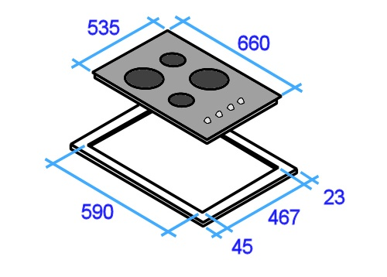

The diagram at left shows the cooktop dimensions and cut-out dimensions.

The white border around the cut-out represents the cooktop overlap where it sits on the bench top.

1. How far in from the splashback will you draw your rear cut-out line?
2. How far in from the right hand panel will you draw the right hand cut-out line?

### cooktop_4.jpg

# DSC_0171.JPGSection 4

# Final presentation

|  |
| --- |
| Overview |

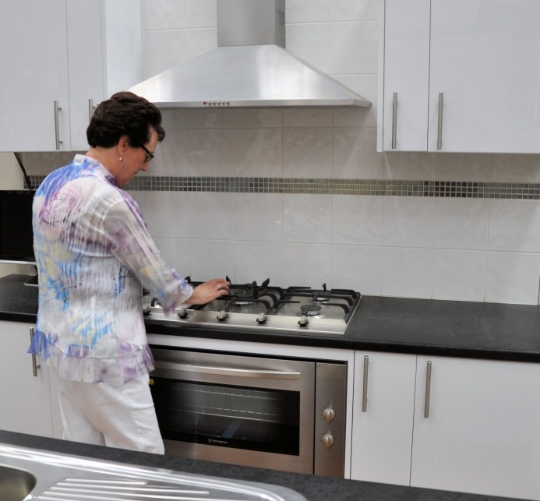When the client shows up to see their finished kitchen or bathroom, they’ll be full of expectations. That’s why it’s so important for the work you’ve done to look spick and span, and for everything to be operating properly.

There are three main elements to wrapping up a project. These are:

* site clean-up
* inspection, testing and fault finding
* hand-over.

In this section, we’ll discuss these three activities and the steps involved in carrying them out.

### Completing this section

The assignment for this section asks you to develop a final inspection checklist for a kitchen or bathroom installation. Have a look at the *Assignment* on page 49 to see what you’ll need to do to complete it.

There is one lesson for this section, which will provide you with background information relevant to the assignment:

* *Finishing and handing over.*

|  |
| --- |
| Finishing and handing over |

Below are the three main elements involved in finishing an on-site installation.

### Site Clean Up

During installation, kitchens and bathrooms are basically building zones. The various trades generate all sorts of dust and waste products while they’re working, which should be kept under control so that it doesn't to build up.

At the end of the job, you'll need to do a final meticulous clean-up to make the room presentable for the client.

Put hard waste, such as off-cuts and cardboard packaging, into a skip bin or other container that can easily be removed from the site. Sweep up the bulk of the dust and put it into the bin too. Then vacuum up any remaining dust with a vacuum cleaner.

Once all the rubbish and dust are removed, you can wipe over the finished surfaces with a damp cloth. For surfaces that require a cleaning agent, make sure you use the right product – don’t scratch or dull the gloss of finished surfaces with an abrasive cleaner.

### Inspection, testing and fault-finding

Check the following elements in the kitchen or bathroom:

**Moving parts** – check that all doors, drawers and other moving parts operate smoothly and silently, and do what they are supposed to do.

**Visual alignments** – stand back from the units and check that all gaps, handles and fillers form symmetrical lines, and that adjustable shelves are correctly placed.

**Cleanliness** – make sure that there are no manufacturing marks, glue, overspray or dust visible on any surfaces.

**Other trades** – check that all other work has been completed properly, including plumbing and electrical, and that fixtures are clean and functioning correctly.

### Hand over

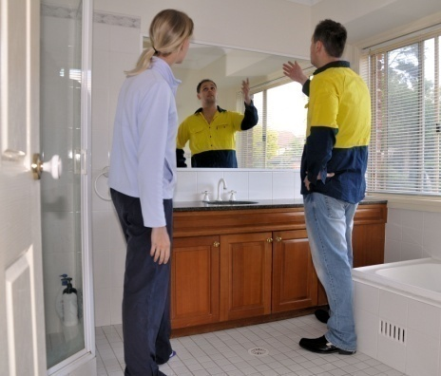Now comes the part that everyone’s been waiting for – the hand over. The client is the person who pays the bill, and they’re also your best form of advertising for future work, so it’s important that you present yourself and the finished installation as professionally as possible.

Take the time to show your client how the different features work, and how to make any adjustments that may be necessary.

Give them the manufacturers’ booklets and warranty details for the various appliances. Answer any questions they may have, make sure they’re happy to accept the project as ‘finished’ and ready for final payment.

If you’re not personally responsible for issuing the invoice, advise the appropriate person at your company that the job has been formally completed and is ready for invoicing.

Also provide feedback to the workshop supervisor about how the installation went, and whether there were any problems with the prefabricated units or other items supplied by the company.

Remember, feedback – both good and bad – is central to maintaining quality in any business. When the workers back at the workshop are doing a good job, they deserve to hear about it!

And when something has gone wrong or a quality problem is starting to creep into their work, they need to hear about that too. Feedback from the on-site installers keeps the company’s management and workshop staff informed on what they’re doing well and what they need to improve on.

##### k&b_la_drawingLearning activity

Below is a sample checklist for a final inspection on a kitchen project. Its purpose is to guide your inspection so you don’t overlook anything important.

Your company will have its own version of an inspection checklist. If you haven’t already got a copy, ask your supervisor if you can look at one. Compare your own company’s list of items with the items shown on this sample checklist. Are they much the same? Is there anything missing from this sample checklist that you think should be included?

Write down your answers and share them with your trainer and other learners in your group.

### Sample inspection checklist

|  |  |  |
| --- | --- | --- |
| **Item** | **Checked** | **Comments / Fixes** |
| Doors plumb and all gaps even |  |  |
| Drawers close smoothly and all gaps even |  |  |
| Buffer pads installed to doors and drawers |  |  |
| Handles fitted |  |  |
| Adjustable shelves fitted |  |  |
| Panels scribed and gaps filled |  |  |
| Screws capped in all carcases |  |  |
| Cut outs for services neat and in position |  |  |
| Kickboards fitted and exposed ends edged |  |  |
| Cutlery tray provide |  |  |
| Accessories fitted and running correctly |  |  |
| Capping mould fitted |  |  |
| Bench tops secured and cut outs sealed |  |  |
| Sink secured and sealed |  |  |
| Doors, drawer fronts, end panels cleaned |  |  |
| Interiors cleaned |  |  |
| All rubbish removed |  |  |

|  |
| --- |
| Assignment 4 |

In the last lesson we looked at a sample inspection checklist for use at the completion of an installation. For this assignment, your task is to write your own checklist, showing the things you would look for when carrying out a final inspection.

You should choose a particular design of kitchen or bathroom installation that you’re familiar with, so you can include the specific features that need to be checked. It may be a standard design your company has on display in its showroom, or it may be an on-site installation you are doing at the moment. Alternatively, it could be any other kitchen or bathroom project that has recently been installed.

Write up the inspection checklist showing all the details you believe are important. Then carry out the inspection, ticking off each item and making notes as required.

You may use the template layout provided in the Workbook or design you own layout. You may also use the design your company has developed for its final inspections.

# Practical demonstration

The checklist below sets out the sorts of things your trainer will be looking for when you undertake the practical demonstrations for this unit. Make sure you talk to your trainer or supervisor about any of the details that you don’t understand, or aren’t ready to demonstrate, before the assessment event is organised. This will give you time to get the hang of the tasks you will need to perform, so that you’ll feel more confident when the time comes to be assessed.

When you are able to tick all of the YES boxes below you will be ready to carry out the practical demonstration component of this unit.

### Practical demonstration checklist

You will be asked to carry out on-site installations of kitchen or bathroom cabinets. Your trainer will need to see you carry out these activities over a period of time, to make sure that you are satisfying these ‘demonstration criteria’ consistently under different conditions.

|  |  |
| --- | --- |
| Demonstration criteria | YES |
| 1. Follows all company safety policies and procedures while at work and any additional site-specific policies while at the jobsite. | ❑ |
| 1. Prepares the correct tools and equipment for the job to be undertaken, and checks that they are in good working order. | ❑ |
| 1. Reads plans and other documents correctly, and uses them to determine the exact positioning and fixing requirements of the cabinets. | ❑ |
| 1. Checks the cabinet measurements and makes adjustments to ensure they fit properly, including cutting access holes and scribing panels. | ❑ |
| 1. Installs cabinets, ensuring they are level, plumb and correctly fitted. | ❑ |
| 1. Fixes components correctly, such as legs, handles, latches, drawers. | ❑ |
| 1. Installs built-in appliances correctly, or makes provision for them according to the plans and specifications | ❑ |
| 1. Uses hand and power tools safely and efficiently. | ❑ |
| 1. Cleans up work area when finished and disposes of rubbish in an approved way. | ❑ |
| 1. Carries out a final inspection of the installation, checking alignments and tolerances to ensure that they meet the required standards | ❑ |
| 1. Completes documentation accurately according to company requirements | ❑ |