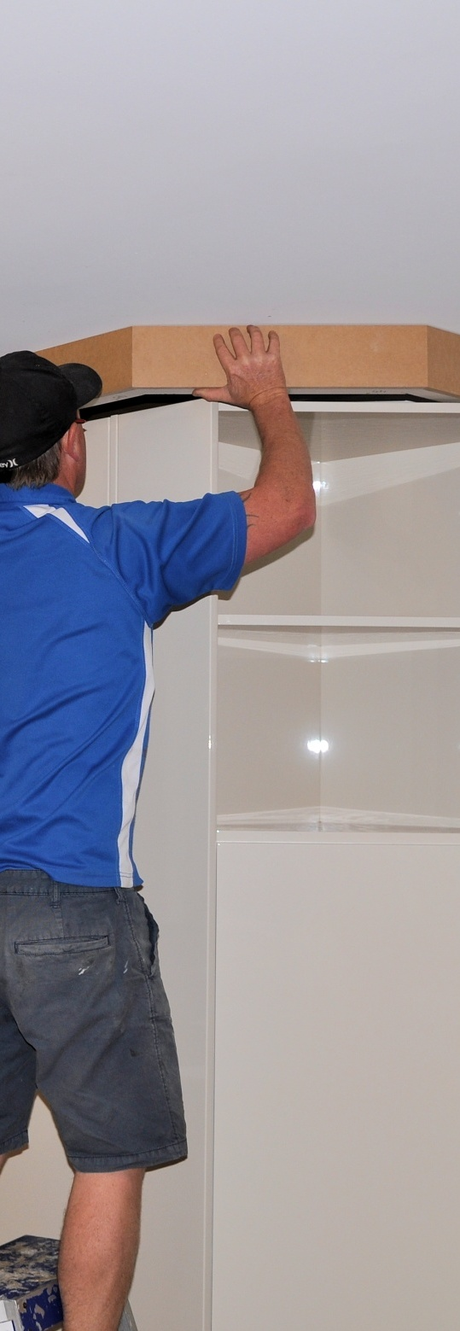

**Supporting:**

***LMFKB3006A  
Install fitted cabinets and components***

Installing cabinets on-site

**Work book**

**Developed in 2011-2012 for the WELL Program**

Installing

cabinets on-site

Workbook

Containing print-version written assignments supporting the unit of competency:

***LMFKB3006A Install fitted cabinets and components***

These assignments are also available in an electronic ‘Word’ version, downloadable from the Kitchen and Bathroom Cabinetmaking website at:

[www.kbcabinetmaking.com.au](http://www.kbcabinetmaking.com.au)



Developed by Workspace Training for the 2011-2012

Workplace English Language and Literacy (WELL) Program

Kitchen and Bathroom Cabinetmaking resource development project



[www.workspacetraining.com.au](http://www.workspacetraining.com.au)

ISBN: 978-0-9873327-0-7

Funded under the Workplace English Language and Literacy Program by the Australian Government through the Department of Education, Employment and Workplace Relations.

COPYRIGHT

© Commonwealth of Australia. 2012



CC BY-NC-SA

This work is copyright. Except where otherwise indicated, and save for the Commonwealth Coat of Arms, the Department has applied the Creative Commons Attribution-Noncommercial-Share Alike 3.0 Australia Licence to this work.

The Department of Education, Employment and Workplace Relations must be attributed as the author of the Department’s copyright material.

As far as practicable, material for which the copyright is owned by a third party has been clearly labelled. The Department has made all reasonable efforts to ensure that this material has been reproduced in this print-based resource and the accompanying website with the full consent of the copyright owners.

Requests and enquiries concerning the Department’s copyright material should be addressed to:

The Copyright Officer   
Department of Education, Employment and Workplace Relations   
Location code C148CW2   
GPO Box 9880 Canberra ACT 2601   
Email: [copyright@deewr.gov.au](mailto:copyright@deewr.gov.au)

Questions about the design and content of the resource itself should be addressed to the project manager:

David McElvenny  
Workspace Training  
PO Box 1954 Strawberry Hills, NSW, 2012   
Email: [david@workspacetraining.com.au](mailto:david@workspacetraining.com.au)

# Table of contents

[The assessment process 1](#_Toc326318339)

[Completing the assignments 3](#_Toc326318340)

[Assignment 1 4](#_Toc326318341)

[Assignment 2 8](#_Toc326318342)

[Assignment 3 11](#_Toc326318343)

[Assignment 4 13](#_Toc326318344)

# The assessment process

Kitchen and bathroom cabinetmaking is a practical trade that requires good hands-on skills and a sound knowledge of construction methods. Your assessor will use a range of methods to assess your ‘competence’ in the units that make up this qualification.

These may include:

* on-the-job discussions about how you go about particular workplace activities
* learning activities undertaken while you’re progressing through the unit
* practical demonstrations of your ability to use certain pieces of equipment competently and safely
* examples of products you have made and documents you have completed
* written assignments contained in the Workbooks.

The assignments contained in this Workbook are only a part of the overall assessment process for the unit. However, they are an essential part, because they allow you to demonstrate your understanding of the concepts and principles behind the skills involved.

Your assessor will talk to you about the other activities and practical demonstrations you’ll need to carry out and the timetable for completion.

### Literacy and numeracy skills

Literacy is the ability to read and write. To complete this trade qualification, you will need sufficient literacy skills to fill in forms and other types of workplace documents correctly. You will also need the skills to be able to read and understand workplace documents such as order sheets, project briefs and safe operating procedures.

Numeracy is the ability to work with numbers. Cabinetmakers need to do lots of calculations with measurements and quantities, so there will be many opportunities for you to learn and practice your numeracy skills.

When it comes to completing the written assignments for this qualification, a certain level of literacy ability is required to read the questions and write down your answers. Obviously, it’s important that you clearly understand what the assignment is asking you to do, and that your answers are a good reflection of what you really know. So if you’re having trouble reading the questions or writing down your answers, make sure you speak to your trainer before you hand the assignment in.

There are various ways your trainer can help you. For example, they may be able to ask the assignment questions verbally and help you to write down your answers. They may also be able to show you sample answers to similar questions, which will let you look at the way they’re written and give you hints on how to write your own. You may also be allowed to do the assignment with the assistance of another person.

### Applying for RPL

RPL stands for **Recognition of Prior Learning. It is a** form of assessment that acknowledges the skills and knowledge you have gained through:

* on-the-job experience
* formal training in other courses
* life experience, through your hobbies or other outside activities.

If you believe that you are already competent in some or all of the skills covered in this unit, ask your assessor about how to apply for RPL.

You’ll find an RPL checklist for this unit on the Kitchen and Bathroom Cabinetmaking website.

# Completing the assignments

There are four assignments for the unit *Installing cabinets on-site*.

These are shown on the following pages, in a layout suitable for hand-written answers. You should detach each assignment from the workbook when you have finished it and hand it to your trainer for marking.

Some of the assignments may be completed electronically on your computer. If you prefer to do this you should go to the website version of this unit and look for the *Assignment* link in each of the four sections. This will allow you to save your answers in an electronic file, which can either be printed out as a hard copy or emailed direct to your trainer as an attachment.

Before you begin each assignment, make sure you read the information in the Learner Guide or on the website for this unit. You’ll find a page relating to the assignment that summarises the questions and provides extra material and pointers to help you complete them.

|  |
| --- |
| Assignment 1 |

|  |  |  |  |
| --- | --- | --- | --- |
| Name |  | Date |  |

### Question 1

Choose two types of fasteners used for fixing cabinets or components to masonry. Provide the following details for each one.

* Trade name or brand name
* Class of fastener (generic description)
* Main uses (what you use it for in your own installations)
* Finish (e.g. zinc plated, hot dipped gal, stainless steel etc.)
* Tools required (for drilling the pilot hole, inserting the fastener and securing it)
* Safety considerations (specific safety issues and PPE e.g. dust mask)
* Cautions (typical things that might go wrong and how you guard against it).

**Example 1**

|  |  |
| --- | --- |
| Type of fastener |  |
| **Trade name** |  |
| **Class of fastener** |  |
| **Main uses** |  |
| **Finish** |  |
| **Tools required** |  |
| **Safety considerations** |  |
| **Cautions** |  |

**Example 2**

|  |  |
| --- | --- |
| Type of fastener |  |
| **Trade name** |  |
| **Class of fastener** |  |
| **Main uses** |  |
| **Finish** |  |
| **Tools required** |  |
| **Safety considerations** |  |
| **Cautions** |  |

### Question 2

Choose two types of fasteners used for fixing materials to stud walls (either into studs or cavities). Provide the following details for each one.

* Name of fastener (including brand name if applicable)
* Main uses (what you use it for in your own installations)
* Tools required (for inserting and securing it)
* Cautions (typical things that might go wrong and how you guard against it).

**Example 1**

|  |  |
| --- | --- |
| Type of fastener |  |
| **Main uses** |  |
| **Tools required** |  |
| **Cautions** |  |

**Example 2**

|  |  |
| --- | --- |
| Type of fastener |  |
| **Main uses** |  |
| **Tools required** |  |
| **Cautions** |  |

### Question 3

Choose two types of caulking compounds, preferably for two different purposes (e.g. one may be a gap filler and the other may be a sealant). Provide the following details for each one.

* Brand name of product
* Generic description (purpose and main chemical ingredients)
* Main uses (what you use it for in your own installations)
* Equipment required (for application)
* Clean-up agent (water or solvent)
* Safety considerations (specific safety issues and PPE e.g. gloves)
* Cautions (typical things that might go wrong and how you guard against it).

**Example 1**

|  |  |
| --- | --- |
| Brand name |  |
| **Generic description** |  |
| **Main uses** |  |
| **Equipment required** |  |
| **Clean-up agent** |  |
| **Safety considerations** |  |
| **Cautions** |  |

**Example 2**

|  |  |
| --- | --- |
| Brand name |  |
| **Generic description** |  |
| **Main uses** |  |
| **Equipment required** |  |
| **Clean-up agent** |  |
| **Safety considerations** |  |
| **Cautions** |  |

|  |
| --- |
| Assignment 2 |

|  |  |  |  |
| --- | --- | --- | --- |
| Name |  | Date |  |

### Question 1

Describe two methods for putting a level base underneath a floor cabinet.

1. Method 1

|  |
| --- |
|  |

1. Method 2

|  |
| --- |
|  |

### Question 2

Let's say you need to install two floor cabinets in a kitchen. The cabinets will sit side by side on a single plinth with a kickboard across the front. All boards are 16 mm melamine particleboard. The floor is bare concrete. The stud walls are constructed from radiata pine with plasterboard linings.

List each of the different types of fasteners you would take on-site with you to carry out this installation. For each fastener, state where you will use it.

Note that you do not have to include fasteners for the bench top or any other components.

|  |  |
| --- | --- |
| Fastener | Where you would use it |
|  |  |
|  |  |
|  |  |
|  |  |
|  |  |
|  |  |

### Question 3

Why do cabinets need to be installed perfectly level and plumb, regardless of the state of the floor and walls? Name four problems you might have to deal with if the carcases were not level and plumb. Note that the problems may relate to other components or moving parts – they don’t have to be limited to the carcases themselves.

|  |
| --- |
| **Problem 1** |
| **Problem 2** |
| **Problem 3** |
| **Problem 4** |

|  |
| --- |
| Assignment 3 |

|  |  |  |  |
| --- | --- | --- | --- |
| Name |  | Date |  |

### dishwasher_1.jpgQuestion 1

You have been asked to build in a space for a dishwasher between the sink cabinet and the cutlery drawers. The dishwasher dimensions are:

Width: 590 mm

Height: 850 mm (minimum height, with adjustable legs screwed in)

1. You decide to allow a clearance of 5 mm on each side of the dishwasher.

What will the total width of the opening be for the dishwasher?

|  |
| --- |
|  |

1. The floor is currently bare concrete, but the client has told you that it will be tiled later with tiles that are 12 mm thick. They will cover the entire kitchen floor area, including the space provided for the dishwasher. You will need to allow 12 mm for the tiles plus 3 mm for the glue thickness.

Your bench top height is 920 mm above the concrete floor and its thickness is 35 mm.

How much clearance will there be between the top of the dishwasher and the underside of the bench top after the tiles are laid?

|  |
| --- |
|  |

### Question 2

You are about to install a cooktop. The splashback behind the cooktop is glass and the vertical panel to the right is particleboard with a timber veneer.

Once it’s installed, the clearances to the back and right hand side of the cooktop will be the minimum allowed under AS 4386. The space between the underside of the rangehood and the top of the cook

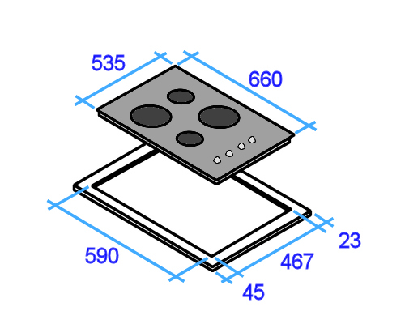

The diagram at left shows the cooktop dimensions and cut-out dimensions.

The white border around the cut-out represents the cooktop overlap where it sits on the bench top.

1. How far in from the splashback will you draw your rear cut-out line? Mark the measurement on the 3D drawing.
2. How far in from the right hand panel will you draw the right hand cut-out line? Mark the measurement on the 3D drawing.

### cooktop_4.jpg

(a) mm

(b) mm

|  |
| --- |
| Assignment 4 |

|  |  |  |  |
| --- | --- | --- | --- |
| Name |  | Date |  |

Your task is to develop a final inspection checklist for a kitchen or bathroom installation project.

You should choose a particular design of kitchen or bathroom installation that you’re familiar with, so you can include the specific features that need to be checked. It may be a standard design your company has on display in its showroom, or it may be an on-site installation you are doing at the moment. Alternatively, it could be any other kitchen or bathroom project that has recently been installed.

Write up the inspection checklist showing all the details you believe are important. Then carry out the inspection, ticking off each item and making notes as required.

You may use the template layout provided below or design you own layout. You may also use the design your company has developed for its final inspections.

|  |  |  |
| --- | --- | --- |
| Item | Checked | Comments / fixes |
|  |  |  |
|  |  |  |
|  |  |  |
|  |  |  |
|  |  |  |
|  |  |  |
|  |  |  |
|  |  |  |
|  |  |  |
|  |  |  |