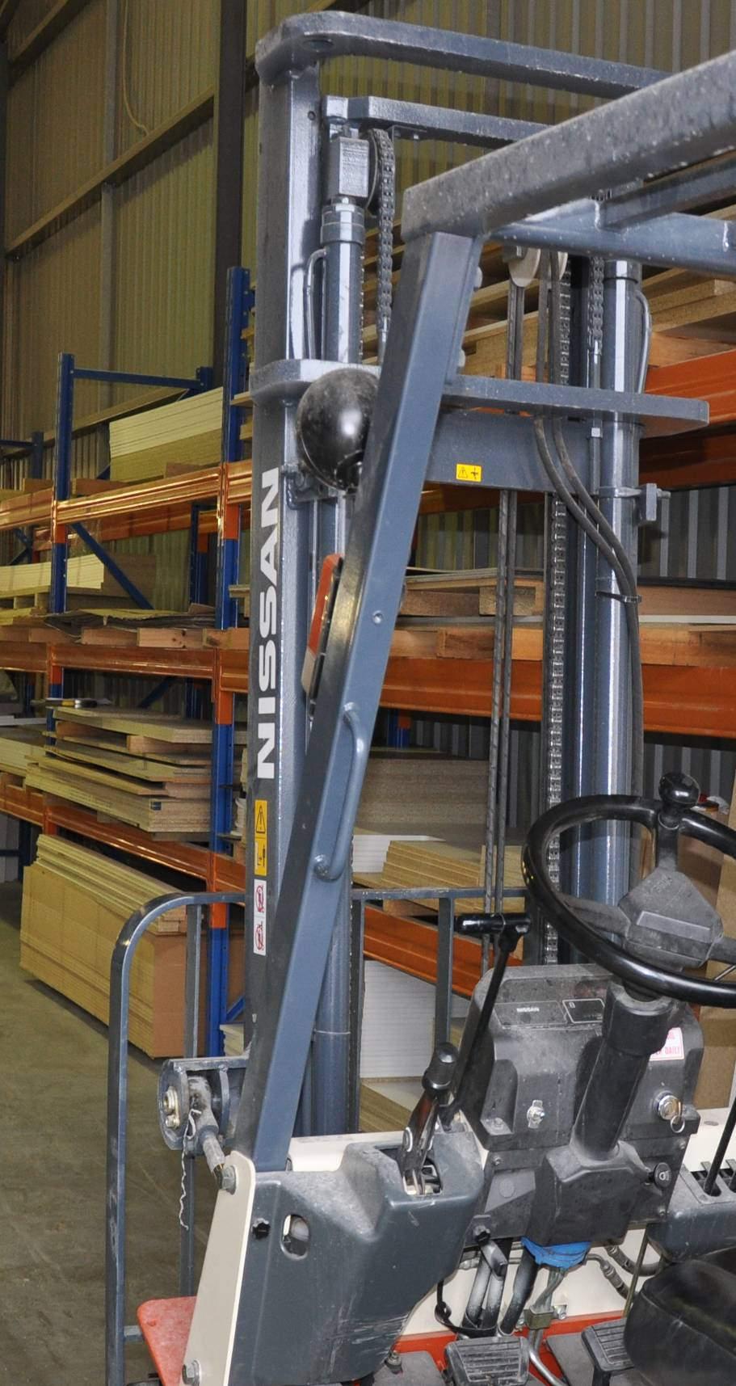

Working sustainably

**Work book**

**Developed in 2011-2012 for the WELL Program**

DRAFT VERSION

October 11



**Supporting:**

***MSAENV272B  
Participate in environmentally sustainable work practices***

Working sustainably

Workbook

Containing print-version written assignments supporting the unit of competency:

***MSAENV272B Participate in environmentally sustainable work practices***

These assignments are also available in an electronic ‘Word’ version, downloadable from the Kitchen and Bathroom Cabinetmaking website at:

[www.kbcabinetmaking.com.au](http://www.kbcabinetmaking.com.au)



Developed by Workspace Training for the 2011-2012

Workplace English Language and Literacy (WELL) Program

Kitchen and Bathroom Cabinetmaking resource development project



[www.workspacetraining.com.au](http://www.workspacetraining.com.au)

ISBN: 978-0-9873328-2-0

Funded under the Workplace English Language and Literacy Program by the Australian Government through the Department of Education, Employment and Workplace Relations.

COPYRIGHT

© Commonwealth of Australia. 2012



CC BY-NC-SA

This work is copyright. Except where otherwise indicated, and save for the Commonwealth Coat of Arms, the Department has applied the Creative Commons Attribution-Noncommercial-Share Alike 3.0 Australia Licence to this work.

The Department of Education, Employment and Workplace Relations must be attributed as the author of the Department’s copyright material.

As far as practicable, material for which the copyright is owned by a third party has been clearly labelled. The Department has made all reasonable efforts to ensure that this material has been reproduced in this print-based resource and the accompanying website with the full consent of the copyright owners.

Requests and enquiries concerning the Department’s copyright material should be addressed to:

The Copyright Officer   
Department of Education, Employment and Workplace Relations   
Location code C148CW2   
GPO Box 9880 Canberra ACT 2601   
Email: [copyright@deewr.gov.au](mailto:copyright@deewr.gov.au)

Questions about the design and content of the resource itself should be addressed to the project manager:

David McElvenny  
Workspace Training  
PO Box 1954 Strawberry Hills, NSW, 2012   
Email: [david@workspacetraining.com.au](mailto:david@workspacetraining.com.au)

# Table of contents

The assessment process 1

Completing the assignments 3

Assignment 1 4

Assignment 2 7

Assignment 3 10

# The assessment process

Kitchen and bathroom cabinetmaking is a practical trade that requires good hands-on skills and a sound knowledge of construction methods. Your assessor will use a range of methods to assess your ‘competence’ in the units that make up this qualification.

These may include:

* on-the-job discussions about how you go about particular workplace activities
* learning activities undertaken while you’re progressing through the unit
* practical demonstrations of your ability to use certain pieces of equipment competently and safely
* examples of products you have made and documents you have completed
* written assignments contained in the Workbooks.

The assignments contained in this Workbook are only a part of the overall assessment process for the unit. However, they are an essential part, because they allow you to demonstrate your understanding of the concepts and principles behind the skills involved.

Your assessor will talk to you about the other activities and practical demonstrations you’ll need to carry out and the timetable for completion.

### Literacy and numeracy skills

Literacy is the ability to read and write. To complete this trade qualification, you will need sufficient literacy skills to fill in forms and other types of workplace documents correctly. You will also need the skills to be able to read and understand workplace documents such as order sheets, project briefs and safe operating procedures.

Numeracy is the ability to work with numbers. Cabinetmakers need to do lots of calculations with measurements and quantities, so there will be many opportunities for you to learn and practice your numeracy skills.

When it comes to completing the written assignments for this qualification, a certain level of literacy ability is required to read the questions and write down your answers. Obviously, it’s important that you clearly understand what the assignment is asking you to do, and that your answers are a good reflection of what you really know. So if you’re having trouble reading the questions or writing down your answers, make sure you speak to your trainer before you hand the assignment in.

There are various ways your trainer can help you. For example, they may be able to ask the assignment questions verbally and help you to write down your answers. They may also be able to show you sample answers to similar questions, which will let you look at the way they’re written and give you hints on how to write your own. You may also be allowed to do the assignment with the assistance of another person.

### Applying for RPL

RPL stands for **Recognition of Prior Learning. It is a** form of assessment that acknowledges the skills and knowledge you have gained through:

* on-the-job experience
* formal training in other courses
* life experience, through your hobbies or other outside activities.

If you believe that you are already competent in some or all of the skills covered in this unit, ask your assessor about how to apply for RPL.

You’ll find an RPL checklist for this unit on the Kitchen and Bathroom Cabinetmaking website.

# Completing the assignments

There are three assignments for the unit *Working sustainably*

These are shown on the following pages, in a layout suitable for hand-written answers. You should detach each assignment from the workbook when you have finished it and hand it to your trainer for marking.

Some of the assignments may be completed electronically on your computer. If you prefer to do this you should go to the website version of this unit and look for the *Assignment* link in each of the three sections. This will allow you to save your answers in an electronic file, which can either be printed out as a hard copy or emailed direct to your trainer as an attachment.

Before you begin each assignment, make sure you read the information in the Learner Guide or on the website for this unit. You’ll find a page relating to the assignment that summarises the questions and provides extra material and pointers to help you complete them.

|  |
| --- |
| Assignment 1 |

|  |  |  |  |
| --- | --- | --- | --- |
| **Name** |  | **Date** |  |

### Task 1. Identifying resources used

Choose a product that you manufacture at work. Think about the types of resources that go into its construction and then fill in the table below.

|  |  |
| --- | --- |
| Product description |  |

|  |  |
| --- | --- |
| Items or materials in the product | Natural resources that the items come from |
|  |  |
|  |  |
|  |  |
|  |  |
|  |  |
|  |  |
|  |  |

|  |  |
| --- | --- |
| Other consumable items used | Natural resources that the consumables come from |
|  |  |
|  |  |
|  |  |
|  |  |
|  |  |
|  |  |

|  |  |
| --- | --- |
| ‘Process’ energy | Natural resources used |
|  |  |
|  |  |
|  |  |

|  |  |
| --- | --- |
| ‘Non-process’ energy | Natural resources used |
|  |  |
|  |  |
|  |  |

### Task 2. Measuring resource usage

Write down the quantities of the materials, items and other consumables that go directly into the finished product. Also specify the unit of measurement you have used to quantify the amounts.

|  |  |  |
| --- | --- | --- |
| Item or material | Unit of measure | Quantity used |
|  |  |  |
|  |  |  |
|  |  |  |
|  |  |  |
|  |  |  |
|  |  |  |
|  |  |  |
|  |  |  |
|  |  |  |
|  |  |  |

|  |  |  |
| --- | --- | --- |
| Other consumables | Unit of measure | Quantity used |
|  |  |  |
|  |  |  |
|  |  |  |
|  |  |  |
|  |  |  |
|  |  |  |

|  |  |  |  |
| --- | --- | --- | --- |
| Process energy | Unit of measure | Duration of use (or other quantity) | |
|  |  |  | |
|  |  |  | |
|  |  |  | |
| Assignment 2 | | |

|  |  |  |  |
| --- | --- | --- | --- |
| Name |  | Date |  |

### Task 1. Controlling air quality

Name a substance or emission produced at your workplace that would reduce the air quality if it was not properly controlled.

|  |
| --- |
|  |

Describe the control measures your company takes to manage the problem.

|  |
| --- |
|  |

### Task 2. Protecting stormwater

1. Name a substance or material at your workplace that could end up polluting the stormwater system if there weren’t measures in place to stop it from happening.

|  |
| --- |
|  |

1. Describe the control measures your company takes.

|  |
| --- |
|  |

### Task 3. Reading an MSDS

Choose a Material Safety Data Sheet (MSDS) that relates to a product you use at work. Answer the following questions by filling in the appropriate boxes in the table below.

1. What is the trade name or technical name of the product?

|  |
| --- |
|  |

1. What is the product used for? Provide a brief description of the product.

|  |
| --- |
|  |

1. Where is the MSDS kept that relates to this product?

|  |
| --- |
|  |

1. Is there a fire risk with the product? If so, what equipment is required to put out a fire?

|  |
| --- |
|  |

1. What should you do in the event of a spill? Describe the clean-up process.

|  |
| --- |
|  |

1. How should you dispose of the product?

|  |
| --- |
|  |

### Task 4. Following procedures

1. Give one example of an environmental policy or procedure at your workplace that directly affects the work you do.

|  |
| --- |
|  |

1. If there was an environmental incident or problem at your workplace, who would you report it to on-site?

|  |
| --- |
|  |

1. When does an incident need to be reported to the Environment Protection Authority?

|  |
| --- |
|  |

|  |
| --- |
| Assignment 3 |

|  |  |  |  |
| --- | --- | --- | --- |
| Name |  | Date |  |

### Task 1. Using less water

Take a walk around your worksite and look for any areas where water is leaking or being used unnecessarily.

The issues you find could include dripping taps, leaking connections, inefficient sprinkler systems, or even work practices that use excessive water.

1. Describe the problem and the best way to fix it.

|  |
| --- |
|  |

1. Who would you report this problem to?

|  |
| --- |
|  |

### Task 2. Using less power

Think about the ‘non-process’ power usage in your workplace – that is, the electricity used in activities not directly related to production. Areas could include amenities buildings, lunchrooms, kitchens, store rooms, etc.

Are there any actions that could be taken to conserve power usage? Describe what they are and who would be involved.

|  |
| --- |
|  |

### Task 3. Managing waste

1. What are the ‘3 Rs’ of waste management?

|  |
| --- |
|  |

1. Name an item or material that you apply this principle to at work, and describe what you do with it. If you don’t already apply this practice, describe what you could do in the future.

|  |
| --- |
|  |

### Task 4. Suggesting improvements

1. Who is responsible for environmental care in your workplace?

|  |
| --- |
|  |

1. If you came up with a new idea that made a work activity more environmentally friendly, how would you go about putting it to the company?

|  |
| --- |
|  |