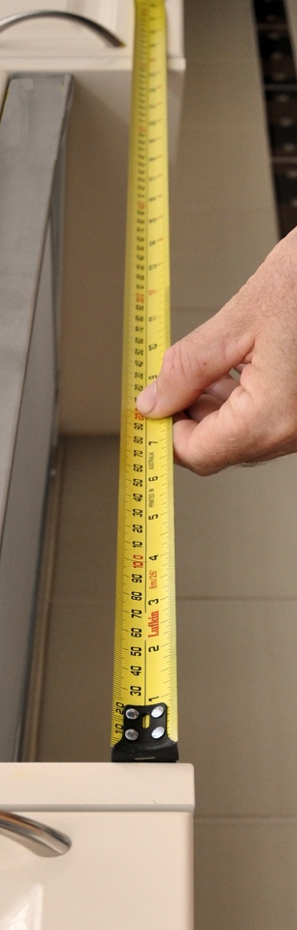

**Supporting:**

*MSAPMOPS101A  
Make measurements*

Making measurements

**Learner guide**

**Developed in 2011-2012 for the WELL Program**

DRAFT VERSION

October 11

Making measurements

Learner Guide

This unit is also available in an e-learning format, which contains additional photos, interactive exercises and a voice-over narration of the text. It can be viewed on CD-ROM, or live on the web at:

<http://www.kbcabinetmaking.com.au/>



Developed by Workspace Training for the 2011-2012

Workplace English Language and Literacy (WELL) Program

Kitchen and Bathroom Cabinetmaking resource development project



[www.workspacetraining.com.au](http://www.workspacetraining.com.au)

ISBN: 978-0-9873328-1-3

Funded under the Workplace English Language and Literacy Program by the Australian Government through the Department of Education, Employment and Workplace Relations.

COPYRIGHT

© Commonwealth of Australia. 2012



***CC BY-NC-SA***

This work is copyright. Except where otherwise indicated, and save for the Commonwealth Coat of Arms, the Department has applied the Creative Commons Attribution-Noncommercial-Share Alike 3.0 Australia Licence to this work.

The Department of Education, Employment and Workplace Relations must be attributed as the author of the Department’s copyright material.

As far as practicable, material for which the copyright is owned by a third party has been clearly labelled. The Department has made all reasonable efforts to ensure that this material has been reproduced in this print-based resource and the accompanying website with the full consent of the copyright owners.

Requests and enquiries concerning the Department’s copyright material should be addressed to:

The Copyright Officer

Department of Education, Employment and Workplace Relations

Location code C148CW2

GPO Box 9880 Canberra ACT 2601

Email: [copyright@deewr.gov.au](mailto:copyright@deewr.gov.au)

Questions about the design and content of the resource itself should be addressed to the project manager:

David McElvenny

Workspace Training

PO Box 1954 Strawberry Hills, NSW, 2012

Email: [david@workspacetraining.com.au](mailto:david@workspacetraining.com.au)

## About this resource

This learner guide is one of 11 learner guides developed for the *Kitchen and Bathroom Cabinetmaking* project, funded by the WELL Program in 2011-2012. The guides are aligned to the following core and elective competencies from the *Certificate III in Cabinetmaking (Kitchens and Bathrooms) LMF32109*:

*LMFKB2001A Prepare for cabinet installation*

*LMFKB3001A Identify processes in kitchen and bathroom*

*LMFKB3002A Determine requirements for installation*

*LMFKB3003A Check and measure fit of cabinets*

*LMFKB3004A Conduct on-site adjustments to cabinets*

*LMFKB3005A Fabricate cabinets for the built-in environment*

*LMFKB3006A Install fitted cabinets and components*

*LMFFM3006B Install furnishing products*

*MSAENV272B Participate in environmentally sustainable work practices*

*MSAPMOHS200A Work safely*

*MSAPMOPS101A Make measurements*

The purpose of the guides is to help apprentice cabinetmakers acquire the background knowledge needed to satisfy the theoretical components of these units. However, they are not designed to replace the practical training necessary to develop the hands-on skills required. Learners will still need to receive extensive on-the-job training and supervision before they will be ready to be formally assessed in these units.

### E-learning version

All of these units are also available in an e-learning format, which contains additional photos, interactive exercises and a voice-over narration of the text. The   
e-learning version can be viewed live on the web at:

<http://www.kbcabinetmaking.com.au/>

The web version can also be purchased on a CD at a cost-recovery price from the project developer:

David McElvenny (project manager)

Workspace Training

PO Box 1954 Strawberry Hills, NSW, 2012

Email: [david@workspacetraining.com.au](mailto:david@workspacetraining.com.au)

## Acknowledgements and disclaimer

### Project team

Project manager: David McElvenny

Instructional design: Kath Ware

Technical developer (website): Jim Vaughan

Assistant technical developer (and voice-over artist): Alex Vaughan

Quality assurance consultant: Giselle Mawer

Industry coordinator: Gary Dunshea (MSA Industry Skills Council)

Lead advisor: Rob Cole (Furnishing Industry Association of Australia)

### Technical Advisory Group

**New South Wales**

Brad Holmes – Hunter TAFE

Grant Cohen – Hunter TAFE

Dean Brakell – Furnishing Industry Association of Australia

Warren Peters – South West Sydney Institute of TAFE

Sean Greening – South West Sydney Institute of TAFE

**ACT**

Martin Jud – Canberra Institute of Technology

**Victoria**

Bryon Stanley – Furnishing Teacher's Advisory Group (VIC, SA, TAS)

Richard Brooks – Cabinet Makers Association

Simon Hampton – Wodonga TAFE

John Simpson – Holmesglen TAFE

**Tasmania**

Stephen Kirkman – Skills Institute Tasmania

**Queensland**

Rob McAdam – Skills TECH Australia

Brad Buhse – Skills TECH Australia

Roberto Viola – Gold Coast Institute of TAFE

**South Australia**

John Holst – Marleston TAFE

Dean Hart – Mt Gambier TAFE

Martin Videon – Furnishing Industry Association of Australia

**Northern Territory**

Hermann Oltrop – Charles Darwin University

**Western Australia**

Garry Michels – Polytechnic West

Keith Campbell – Polytechnic West

Adrian Boyling – Polytechnic West

David Boaden – Polytechnic West

Lorenzo Procopio – South West Institute of Technology

**National**

Laurie Kruize – Housing Industry Association

### Photographs and graphics

All photos were taken by David McElvenny. All graphics were drawn by Kath Ware. We would like to thank the following companies for allowing us to take photos of their installers and workshop employees and generously providing technical advice:

Canobolas Kitchen Designs Flair Kitchens

Danson’s Kitchens and Joinery Lamtex Innovative Furniture

Fewings Joinery Stateline Cabinets

B&B Joinery Ian McConnell Constructions

Krauss Kitchens

### Financial contributions

This resource was largely funded by the Workplace English Language and Literacy Program, through the Department of Education, Employment and Workplace Relations. However, due to the scale of the project and the provision of print-based and website resources, additional financial assistance was provided by the following organisations:

Manufacturing Skills Australia (Industry Skills Council)

Furnishing Industry Association of Australia

### Disclaimer

The content of this learner guide is provided for educational purposes only. No claim is made as to the accuracy or authenticity of the content. The views expressed in this publication do not necessarily represent the view of the Minister for Education or the Australian Government. The Australian Government does not give any warranty nor accept any liability in relation to the contents of this work.

**Table of contents**

[Introduction 1](#_Toc315352834)

[Section 1](#_Toc315352835) [Calculating 3](#_Toc315352836)

[Overview 5](#_Toc315352837)

[Using a calculator 6](#_Toc315352838)

[Working with fractions 8](#_Toc315352839)

[Decimals and percentages 11](#_Toc315352840)

[The metric system 14](#_Toc315352841)

[Using tallies 17](#_Toc315352842)

[Section 2](#_Toc315352843) [Measuring 21](#_Toc315352844)

[Overview 23](#_Toc315352845)

[Length 24](#_Toc315352846)

[Area 27](#_Toc315352847)

[Angles 32](#_Toc315352848)

[Volume 36](#_Toc315352849)

[Avoiding errors 39](#_Toc315352850)

[Assignment 42](#_Toc315352851)

[Practical demonstration 44](#_Toc315352852)

[Answers to Learning activities 45](#_Toc315352853)

|  |
| --- |
| Introduction |

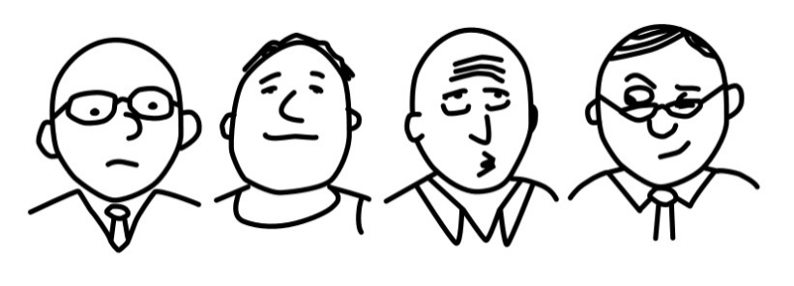Ask a mathematician what 2 + 2 equals, and he’ll tell you it’s 4.

Ask a metal worker, and he’ll probably say 4.00.

Ask an engineer, and he’s likely to say 4 to 5, but best to build in a safety margin and call it 8.

Ask an economist, and he’ll look at you sideways and whisper: What do you want it to equal?

Numbers go hand in hand with measurements. They help to express size and quantity, and to make comparisons between things. But they can be used with different levels of precision, depending on your needs and the type of measurements you’re carrying out.

This unit supports the competency standard ‘*Make measurements’,* which is used in a wide range of qualifications in the manufacturing industry.

Because of this, we’ll look at the way numbers are used by manufacturing workers in general for taking measurements and doing basic calculations. So the focus of the unit will be on broad principles and mathematical rules, which will allow you to apply these concepts to your own situation back on the job.

### Working through this unit

There are two sections in this unit:

1. Calculating
2. Measuring.

Each section contains an *Overview* and several *Lessons* which cover the content material.

At the end of Section 2 is the *Assignment* for the unit. This is designed to test your ability to use a variety of measurements in typical calculations. Your trainer may ask you to submit the assignments as part of your assessment evidence for the unit. You will find a template version with spaces for your answers in the separate Workbook.

An electronic ‘Word’ template of the assignment is available on the website for this resource, at: <http://www.kbcabinetmaking.com.au/>

The electronic version can be completed on-screen and sent to the trainer either as:

* a printed hard copy, mailed through the post
* an electronic file, emailed as an attachment.

### Practical demonstration

Because the process of measuring is very much a practical activity, your final assessment of competency will include several hands-on demonstrations. To help you get ready for these activities, there is a *Practical demonstration* checklist at the at the end of Section 2, after the Assignment, listing the sorts of things your trainer will be looking for.

Make sure you talk to your trainer or supervisor about any of the details that you don’t understand, or aren’t ready to demonstrate, before the assessment event is organised. This will give you time to get the hang of the tasks you will need to perform, so that you’ll feel more confident when the time comes to be assessed.



# Section 1

# Calculating

|  |
| --- |
| Overview |

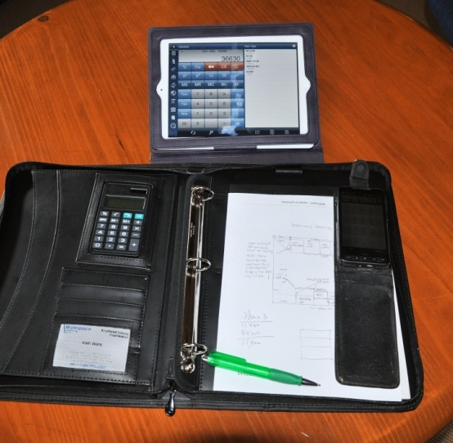There are some calculations you can do in your head. Counting items and working out simple quantities are calculations that people do all the time, almost without thinking about it. But as the numbers get bigger or more complex, most people need to use a calculator to be sure that they’ve got the right result.

Fortunately, calculators are everywhere these days. You’ll find them in mobile phones, on rulers, in large diaries, and of course as self-contained pocket-sized devices.

If you need to do specialised calculations as part of your work, it’s easy to carry a scientific calculator, laptop computer or tablet with you so that it’s on hand when required.

In this section, we’ll cover some basic calculations and mathematical procedures that you need to know in order to work with numbers. We’ll also look at the metric system and discuss the terms that apply to various units of measure.

### Completing this section

There are five lessons in this section:

* *Using a calculator*
* *Working with fractions*
* *Decimals and percentages*
* *The metric system*
* *Using tallies.*

These lessons will provide you with background information to help you with the calculations that we’ll be doing in Section 2.

|  |
| --- |
| Using a calculator |

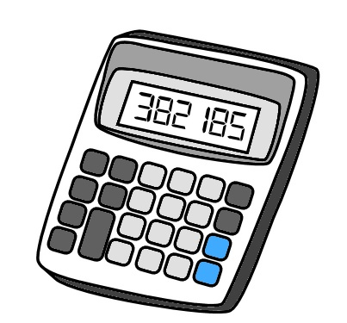If you’re having trouble using a calculator, the best advice is to read the manufacturer’s instructions. Different calculators operate in different ways, and they don’t always follow the same order for entering numbers and functions.

Here’s a few general hints on how to use a calculator effectively.

**1. Clear the calculator** before you start any new calculation.

This will ensure that nothing you did before gets mixed up with the calculation you are about to begin.

**C**

**2. Write down the numbers first** if they are complicated.

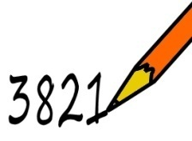You should also write them down if someone is calling them out to you, such as while taking a series of measurements. Then you can be sure that you’re entering the right numbers, especially if they have decimal points or several zeros.

**3. Estimate the answer** in your head if the numbers are long or complicated.

This will help you to pick up mistakes, because it will give you an idea of the size of the answer you’re looking for.

**4000**

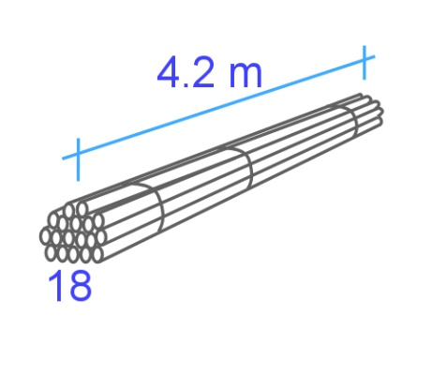For example, if you had 18 rods that were each 4.2 metres long, and you wanted to know what the total metreage was, you could do the following calculation in your head:

**20** (rounding up 18) **x** **4** (rounding down 4.2) **=** **80**

So when you do the actual calculation and find that the answer is 75.6 metres, you’ll know that it sounds about right.

The rule of thumb for rounding off numbers is:

Ending in a **5 or more** **– round up**

Ending in a **4 or less** **– round down**

##### Learning activity 1

Below are some rounding exercises. Write down your answer in the box beside each calculation. When you’ve finished, check your answers in the Answers section at the back.

1. Round off these numbers to the nearest whole number.

6.3

5.2

2. Round off these numbers to the nearest ten.

78

14

3. Round off these numbers to the nearest hundred.

85

530

4. Estimate the answers to these calculations. (You may either do these sums in your head, or use a calculator. But remember to write down your *estimated* answer, not the actual answer.)

42 x 68

56 x 93

28 x 3.9

7.2 x 2.1

|  |
| --- |
| Working with fractions |

Fractions are made up of two parts. The top part is called the **numerator** and tells you how many pieces you’ve got. The bottom part is called the **denominator** and tells you how many pieces make up the whole.

**3**

**4**

numerator

denominator

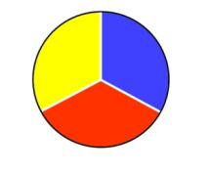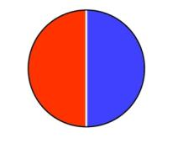For example, if there are two pieces in the whole, each piece is one half. That is, each piece represents 1 out of 2, or 1/2.

If there are 3 pieces, each one will be a third, or 1/3.

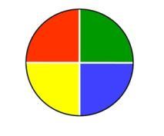

If there are 4 pieces, each will be one quarter, or 1/4.

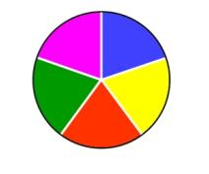

If there are 5 pieces, each will be a fifth, or 1/5.

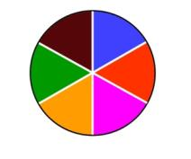

If there are 6 pieces, each will be a sixth, or 1/6.

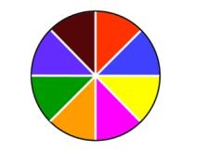

If there are 8 pieces, each will be an eighth, or 1/8.

### Equivalent fractions

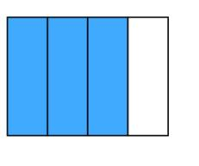When you divide the same whole into different numbers of pieces, you can write the same proportion in different ways.

**3**

**4**

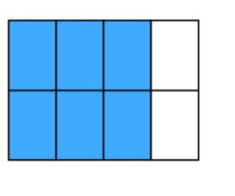For example, this whole is divided into 4 pieces, and 3 of them are shaded blue. In other words, we’ve shaded 3 quarters of the whole, or 3/4.

But if we divide the same whole into 8 pieces but still shade the same amount, we’ve now shaded 6 eighths of the whole, or 6/8.

**6**

**8**

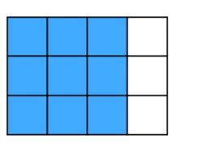This means that 3/4 is equivalent to 6/8.

If we divide the original whole into 12 pieces, we’ll have shaded 9 pieces. Therefore:

**9**

**12**

3/4 = 6/8 = 9/12

So if you were presented with the fraction 9/12, how would you know it was really the same proportion as 3/4?

All you need to do is divide the top and bottom of the fraction by the same number. In this case, we know that 3 will divide evenly into both 9 and 12. That is:

9 ÷ 3 = 3

12 ÷ 3 = 4

Another way of writing this is:

9 ÷ 3 3

=

12 ÷ 3 4

We can also run the calculation in reverse by multiplying both halves of the fraction by the same number. That is:

3/4 = 9/12, because:

3 x 3 9

=

4 x 3 12

Note that with some of the fractions shown above, the numerator is on top and the denominator is on the bottom. But the other fractions are written with the numerator and denominator beside each other, separated by the fraction bar. Both of these layouts are common, and it is acceptable to use either. In practice, you’ll probably find that hand-written fractions are easier to write with the numerator above the denominator.

##### Learning activity 2

Here are some fraction exercises. Write your answers in the boxes provided, and then check them in the Answers section at the back.

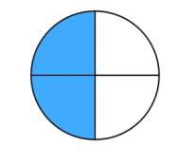

=

1. Write down the divisions and shaded portions  
in this circle as two equivalent fractions.

2. Rewrite this fraction as a proportion of 100.

3/10 = /100

3. Rewrite this fraction in its simplest form.

20/50 = /

4. You have two drill bits. The diameter of one is 3/8 inch, and

/ inch

the other is 1/4 inch. Which one will drill the bigger hole?

|  |
| --- |
| Decimals and percentages |

Now that we’ve looked at how fractions work, let’s see how they relate to decimals and percentages.

### From fractions to decimals

fraction bar

**1**

**2**

The fraction bar is like a division sign. For example, 1/2 is another way of saying: 1÷ 2.

If you do this calculation on your calculator, you will find that it equals 0.5. That is:

1÷ 2 = 0.5

To put it another way, 0.5 is the **decimal equivalent** of 1/2.

It’s easy to confirm this answer by doing the calculation in reverse. That is, if 1/2 equals 0.5, then 0.5 times 2 should equal 1. You can check this on your calculator:

0.5 x 2 = 1

In the same way, the fraction 1/4 is equivalent to the decimal 0.25. To check whether this is correct, the calculation would be:

1÷ 4 = 0.25

And to double-check it in reverse:

0.25 x 4 = 1

### From fractions to percentages

A percentage is simply another way of writing a fraction which has a denominator of 100. **Per cent** means ‘per 100’, or ‘for every 100’.

For example: 50% = 50/100

We also know that 50/100 = 5/10 = 1/2.

Therefore: 50% = 1/2.

To test it:

50% x 2 = 100%

Here’s another example: 10% = 10/100 = 1/10

To test it:

10% x 10 = 100%

### Decimals and percentages

Notice that percentages and decimals are basically the same thing. The only difference is:

* a percentage is a proportion of 100
* a decimal is a proportion of 1.

Therefore:

* to change a decimal to a percentage, **multiply** by 100
* to change a percentage to a decimal, **divide** by 100.

##### Learning activity 3

1. Complete the table below. Then check your answers in the Answers section at the back.

|  |  |  |
| --- | --- | --- |
| **Fraction** | **Decimal** | **Percentage** |
| 1/100 |  |  |
| 1/20 |  |  |
| 1/10 |  |  |
| 1/8 |  |  |
| 1/5 |  |  |
| 1/4 |  |  |
| 1/2 |  |  |
| 1 |  |  |

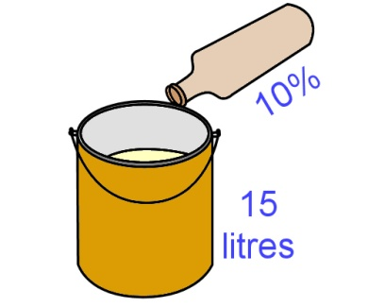2. Let’s say you have 15 litres of paint, and you’re going to apply it with a spray gun. The manufacturer’s advice is to add 10% thinners to the paint to improve the flow. How many litres of thinners should you add?

litres



3. If you earned $800 per week and paid 30% in tax, how much tax would you pay each week?

$

|  |
| --- |
| The metric system |

Before the 1970s, the units of measure used in Australia generally came from the **imperial system**. This was a reference to ‘imperial’ Britain, because that’s where the system was first developed. Length, for example, was measured in inches, feet, yards and miles. Weight was measured in ounces, pounds, stone and tons.

However, between the 1970s and 1980s Australia progressively converted its measurement units across to the International System of Units – called the ‘SI’ (an abbreviation of the French ‘Système International’). This is commonly referred to as the **metric system**.

The metric system is based on the **decimal system** of numbers. This means that all measurement units are based on multiples of 10.

For example, the standard unit of length is the **metre**. So the other units used to denote longer and shorter lengths are in multiples of 10 from the ‘one metre’ standard. Set out below is the table of metric length units ranging from the millimetre (mm) to the kilometre (km).

|  |  |  |  |
| --- | --- | --- | --- |
| **Length** | **Abbreviation** | **Proportion  of 1 metre** | **Some typical uses** |
| 1 millimetre | mm | 1/000 or 0.001 | Building and manufacturing |
| 1 centimetre | cm | 1/100 or 0.01 | Dressmaking |
| 1 decimetre | dm | 1/10 or 0.1 | Log diameters |
| 1 metre | m | 1 | Standard unit of length |
| 1 decametre | dam | 10 | Meteorology |
| 1 hectometre | hm | 100 | Surveying |
| 1 kilometre | km | 1000 | Distance measurement |

As you look down this list of terms, you’ll probably notice that not all of these units are commonly used.

Metres and kilometres are terms used by just about everyone, including in ordinary day-to-day conversations. Millimetres are widely used in building, construction and manufacturing. Centimetres are also common in particular fields. But decimetres, decametres and hectometres have only limited usage in specialist areas.

Nonetheless, the **prefix** (first half of the term) of each of these units is very handy to know, because it tells you what the quantity is in relation to the standard unit of measure, whatever it is that you’re measuring. For example:

**Milli** always means 1/1000, so:

* 1 millimetre (mm) is 1/1000 of 1 metre (m)
* 1 millilitre (mL) is 1/000 of 1 litre (L)
* 1 milligram (mg) is 1/1000 of 1 gram (g)

**Kilo** always means 1000, so:

* 1 kilometre (km) is 1000 metres
* 1 kilolitre (kL) is 1000 litres
* 1 kilogram (kg) is 1000 grams.

##### Learning activity 4

On the following page is a table showing various lengths in kilometres (km) centimetres (cm) and millimetres (mm). Rewrite each of these measurements in metres, or proportions of a metre.

Remember that the decimal point is critical in metric measurements. If you’re not sure where the point should go, refer back to the table of metric measurements above.

It’s also good practice to put a zero in front of the decimal point if the number is less than 1. That is, it’s better to write ‘0.5’ than ‘.5’, because there is less chance of misreading the measurement when you come back to it later.

Check your answers in the Answers section at the back.

|  |  |
| --- | --- |
| **Length** | **Length in metres** |
| 1.5 km | m |
| 1 km | m |
| 1/2 km | m |
| 1/4 km | m |
| 350 cm | m |
| 185 cm | m |
| 4800 mm | m |
| 3660 mm | m |
| 900 mm | m |
| 255 mm | m |
| 75 mm | m |
| 25 mm | m |
| 9 mm | m |
| 3 mm | m |

|  |
| --- |
| Using tallies |

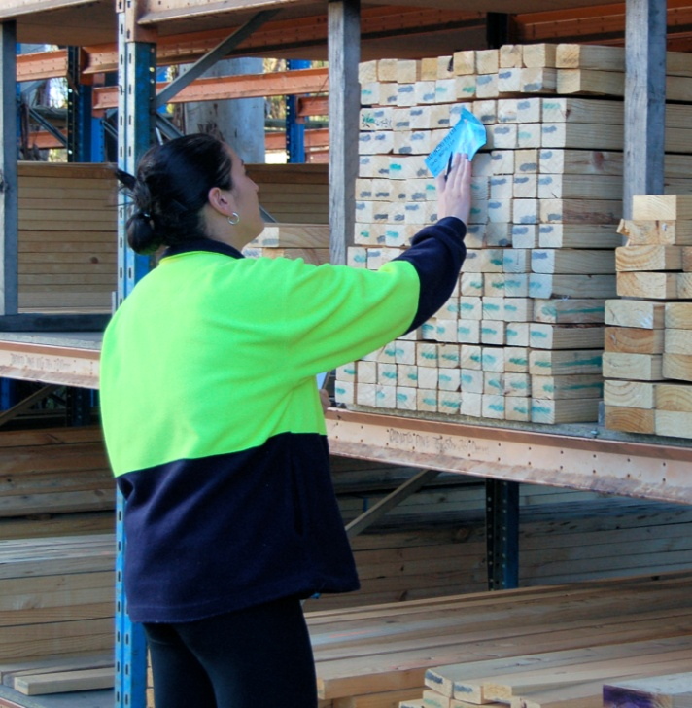Tallies are used to record quantities of particular items or products. For instance, if you wanted to write down how many power tools you had taken onto a jobsite, your tally might read:

1 x jigsaw; 1 x circular saw; 3 x cordless drills; 2 x claw hammers ... and so on.

But if you had a product that was already expressed in terms of its cross-section size, such as 70 x 45 timber, it would get very confusing if you started to use the ‘x’ (‘times’) sign to also indicate the number and length of the pieces.

Set out below are some examples of how to record tallies when you’re working with items that are referred to by their cross sectional dimensions. Note that in most instances, the **size** of a piece generally refers to its cross section, and the **length** refers to its lengthwise run. It’s also common practice to express **size in millimetres** and **length in metres**.

### 140_19.jpgExample 1: timber boards

Let’s say you have 15 pieces of radiata pine, all 140 mm x 19 mm in size. We’ll say that 5 pieces are   
2.4 metres in length, 7 pieces are 2.7 metres and   
3 pieces are 3.6 metres.

To show this as a tally, you would write:

140 x 19 radiata: 5/2.4, 7/2.7, 3/3.6

Now let’s say we wanted to know how many **lineal metres** this tally represents. Note that ‘lineal’ means ‘in a line’ – so to put the question another way: What is the **total metreage** of this timber stock if the boards were all laid out in a line?

The easiest way to find the answer is to use a calculator with a memory button. Remember that not all calculators work in exactly the same way, but the sequence of numbers and function buttons you’d press would be something like this:

*Clear memory* – make sure the memory is clear before you start.

**CM**

*Clear all* – make sure the input is also clear

**C**

**5 x 2.4** 5 pieces times 2.4 metres in length, add to *Memory plus* subtotal

**M+**

**7 x 2.7** 7 pieces times 2.7 metres in length, add to *Memory plus* subtotal

**M+**

**3 x 3.6** 3 pieces times 3.6 metres in length, add to *Memory plus* subtotal.

**M+**

*Read memory* – read the total in the memory.

**RM**

If you don’t have a calculator with a memory button, you can simply multiply each line separately and then add the subtotals together. The mathematical way of writing up this calculation is:

(5 x 2.4) + (7 x 2.7) + (3 x 3.6) = 41.7

### steel_angle.jpgExample 2: steel angle

Now we’ll say that there are two different sizes in galvanised steel angle. One has a cross section of 25 mm x 25 mm, 3 mm thick. The other is 50 mm x 50 mm, 6 mm thick.

Let’s say that there are 2 pieces of 25 x 25, with 1 at 6.0 metres and 1 at 7.2 metres; and 4 pieces of 50 x 50, with 2 at 3.0 and 2 at 4.2.

Because there are two different sizes, we’ll need two separate tallies. They will read:

25 x 25 x 3 gal angle: 1/6.0, 1/7.2

50 x 50 x 6 gal angle: 2/3.0, 2/4.2

Notice that the 6 metre and 3 metre lengths are shown as 6.0 and 3.0. This is good practice when you’re writing up a tally, especially when there are other pieces with lengths that involve a decimal place, because it shows that you haven’t made a mistake or rounded up the length to the nearest metre.

### ply_wood.jpgExample 3: plywood sheets

Sheet materials sometimes have their dimensions shown in metres and sometimes in millimetres.   
For example, if you had two sheets of ply that were   
18 mm thick, 2.4 metres long and 1.2 metres wide,   
it could be written up as:

18 mm ply: 2 / 2.4 x 1.2

or alternatively

18 mm ply: 2 / 2400 x 1200

##### rods_4.jpgLearning activity 5

How many lineal metres (l/m) are in this bundle of steel rods?

l/m

13 mm dia. steel rod: 5/4.2, 3/4.8, 2/6.0

Check your answers in the Answers section at the back.



# Section 2

# Measuring

|  |
| --- |
| Overview |

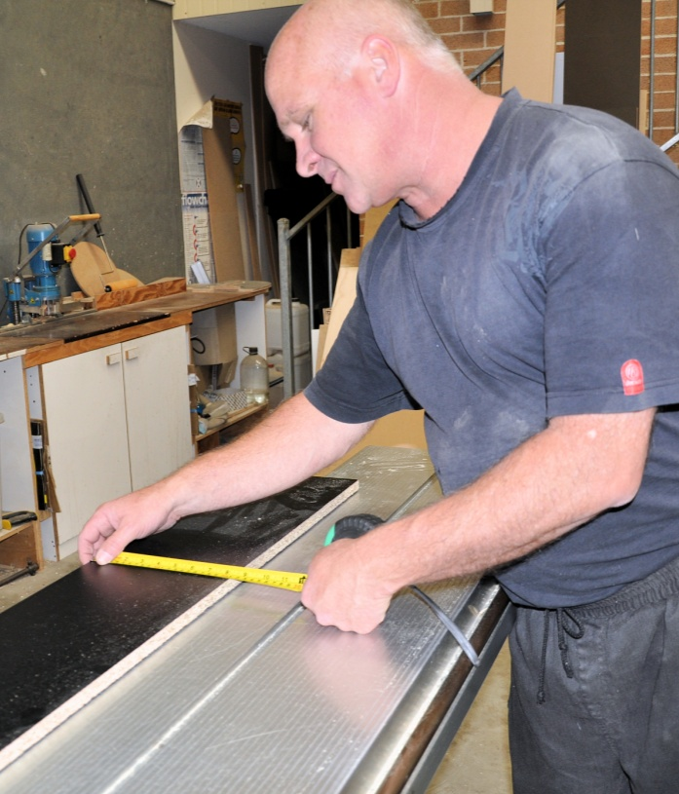Now that we’ve covered the main terms used in the metric system and looked at the relationship between fractions, decimals and percentages, it’s time to apply these principles to some workplace calculations.

In this section, we’ll start with measurements of length, and work up to volume calculations for three dimensional shapes. We’ll also talk about methods of checking the angles and squareness of manufactured items. And we’ll introduce some of the measuring instruments used in the manufacturing industry and discuss ways of making sure that the measurements you take with them are reliable and accurate.

### Completing this section

There are five lessons in this section:

* *Length*
* *Area*
* *Angles*
* *Volume*
* *Avoiding errors.*

These lessons will provide you with background information that will help you with the Assignment for the unit. You’ll find the Assignment at the end of this section, together with the Practical Demonstration checklist. For more details on these assessment activities, go back to the Introduction page.

|  |
| --- |
| Length |

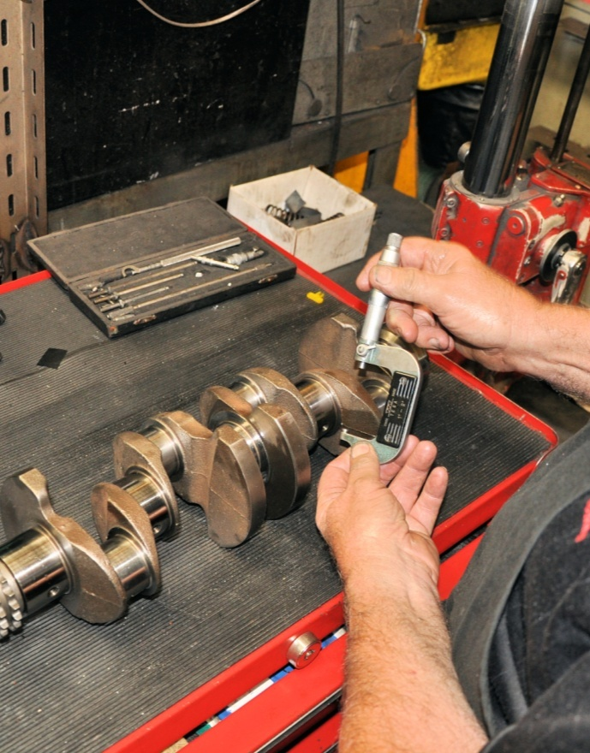In Section 1 we talked about the metric system, and used the units of **length** to show how the different **prefixes** relate to each other – such as kilo-, deci-, centi- and milli-.

In the building, furnishing and manufacturing industries, measurements are generally recorded in **millimetres**.

In cases where thicknesses or tolerances of less than a millimetre need to be measured, such as in metalwork and machining, the unit of measure often used is the micrometre.

One **micrometre** is 1/1,000,000 (one millionth) of a metre, or 1/1,000 (one thousandth) of a millimetre. Its symbol is ‘µm’, which is sometimes written as ‘um’.

Many people prefer to use the old fashioned term **micron** instead of micrometre. This is designed to avoid confusion with the measuring device called the **micrometer**, although strictly speaking 'micron' is no longer officially recognised as a term under the SI system.

In practice, micrometres are often expressed as millimetres to several decimal places. For example, 500 µm might simply be referred to as 0.5 mm, and 50 µm would be 0.05 mm

### Measuring devices

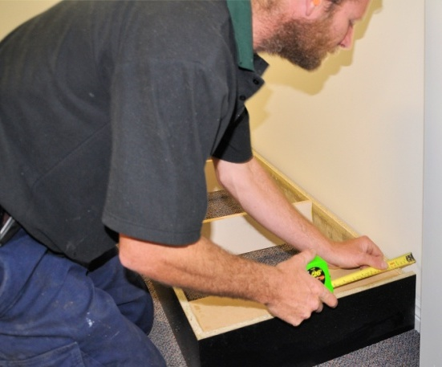The most common general-purpose measuring device is the **tape measure**. Its main advantage is that the long tape can wind up into a pocket-sized unit.

Spring loaded retractable tape measures range in length from tiny 1 metre tapes to the standard 7 to 8 metre tradesperson’s tape. Open reel and closed reel tapes, used by surveyors and builders, typically range from 30 metres to 100 metres.

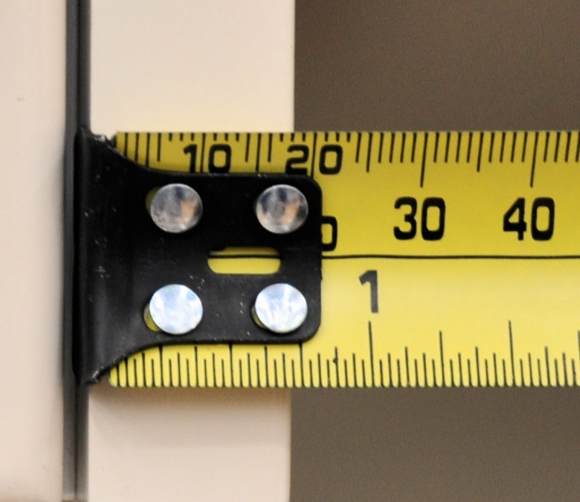When you look closely at the end of a normal retractable tape, you’ll notice that the steel hook is secured with rivets, with a bit of play in the holes allowing it to move back and forth. The amount of movement allowed is the same as the thickness of the hook.

Its purpose is to compensate for the hook thickness when you either push the tape up against an object for an inside measurement or hook it over the object for an outside measurement.

Other common measuring devices are as follows:

|  |  |
| --- | --- |
| steel_rule.jpg | **Steel rule** – very rugged, good for fine measurements, able to be used as a straight edge. |
| folding_rule.jpg | **Folding rule** – not so popular these days, but still sometimes used by carpenters. |
| vernier_caliper.jpg | **Vernier caliper** – used for measuring thicknesses and diameters very precisely, in some cases to an accuracy of 10 micrometres, or 0.01 mm. |
| laser_distance_meter.jpg | **Laser distance meter** – measures digitally with a laser beam; can be either hand held or combined with a laser level. |

##### Learning activity 6

Below are four segments of a tape measure, together with an arrow pointing to a particular length. See if you can write down the correct length in millimetres for each one.

Don’t be fooled – some of these are harder than they look! Remember, you’ll need to take into account the units of measure, and on two of the segments, the previous markings on the left hand side that aren’t visible.

This is good practice for the times when you’re actually using a tape measure on the job, especially when you’re measuring long lengths. It takes concentration to read off the correct measurement without misreading the position of the graduations on the tape.

Write your answers in the boxes provided. When you’ve finished, check your answers in the Answers section at the back.

|  |  |
| --- | --- |
| tape_2.jpg1. | mm |
| tape_3.jpg2. | mm |
| tape_7.jpg3. | mm |
| tape_4.jpg4. | mm |
| tape_5.jpg5. | mm |

|  |
| --- |
| Area |

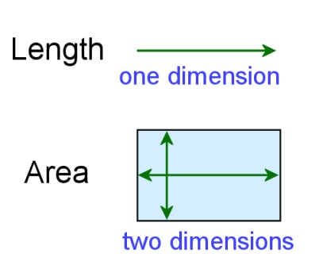If you think of length as being one dimensional, that is, going in one direction only, then **area is two dimensional**, because it has length and width.

Let’s have a look at the area of some common shapes.

### area_2a.jpgSquares and rectangles

The area of any square or rectangle is simply its length times its width. For example, if a rectangle is 3 metres long and 2 metres wide, its area is:

Length x width = 3 m x 2 m = 6 square metres (m2)

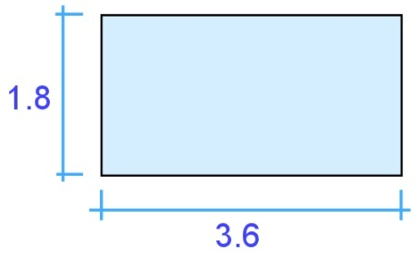What if you had a sheet of particle board measuring 3.6 m x 1.8 m? Its area is simply:

Length x width = 3.6 m x 1.8 m = 6.48 m2

### Triangles

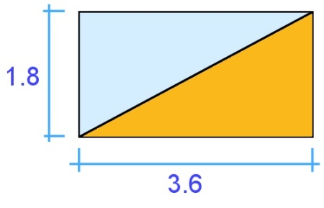Let’s say you cut the sheet of particle board in half diagonally, forming two equal triangles. The area of each triangle is exactly half of the original rectangle. That is:

Length x height ÷ 2 = 3.6 x 1.8 ÷ 2 = 3.24 m2

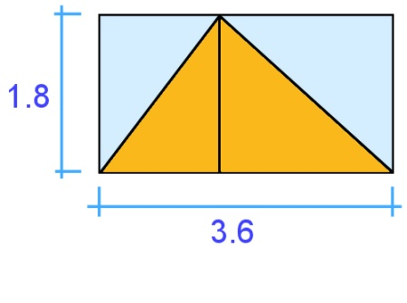This proves that a triangle is half the area of the rectangle or square that it came from. So even if you had a triangle that didn’t have a right angle in it, the calculation is still the same, because you could simply divide the triangle into 2 triangles, and the rectangle around it into 2 rectangles.

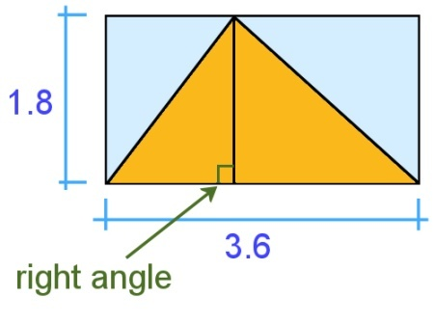But note that you must always measure the height of the triangle at right angles (90 degrees) to the base.

You can’t measure the diagonal line in the triangle, because that’s not the true height of the rectangle that goes around it.

### Circles

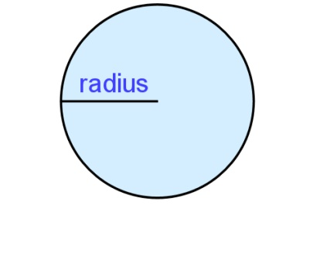You may remember from your school days that the formula for the area of a circle is: **π r 2**, where π (called ‘pi’) is 3.14, and ‘r’ is the radius of the circle.

If you’re happy using that formula you can stay with it, but you might prefer this simplified version – which is actually the same, but just put in different terms:

Area of a circle = diameter x diameter x 3.14   
2 2

Another way of writing this is:

Area = (diameter ÷ 2) x (diameter ÷ 2) x 3.14

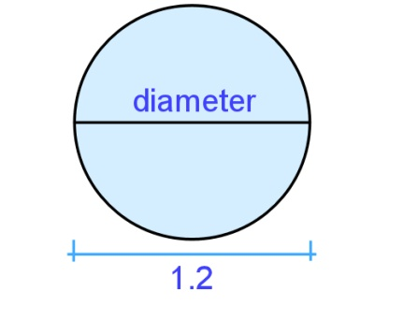Here’s an example. If a circle is 1.2 m in diameter, what’s its area? The answer is:

Area = (diameter ÷ 2) x (diameter ÷ 2) x 3.14

= (1.2 ÷ 2) x (1.2 ÷ 2) x 3.14

= 0.6 x 0.6 x 3.14

= 1.13 m2

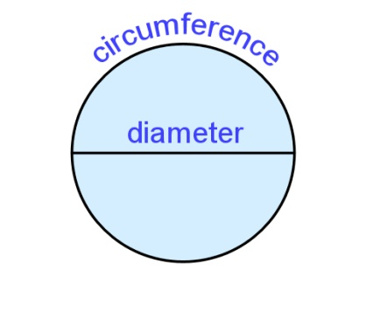So where does 3.14 come from? This is actually the approximate ratio between the **circumference**, or outside measurement, of the circle and its diameter. In other words, the circumference of a circle is about 3.14 times longer than its diameter.

When ‘pi’ is used in this formula it has the effect of helping to shrink the area of the square that goes around the circle down to the area of the circle itself.

### Compound shapes

If you can break a shape up into its basic parts, you can calculate its area by adding the separate areas together. Here’s three examples.

#### Example 1: L shape

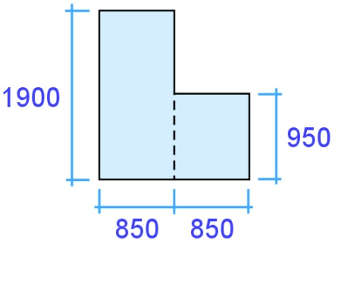This L shape is basically two rectangles. What is its area? Note that the measurements in the diagram are shown in millimetres, so you’ll need to convert them into metres for the calculation.

Rectangle 1: 1.9 x 0.85 = 1.615 m2

Rectangle 2: 0.95 x 0.85 = 0.808 m2

Total area: 1.615 + 0.808 = 2.423 m2

Written mathematically, this would be: (1.9 x 0.85) + (0.95 x 0.85) = 2.423 m2

#### area_10a.jpgExample 2: Gable end of a house

This shape is a triangle plus a rectangle

Triangle: 1.59 x 4.125 ÷ 2 = 3.279 m2

Rectangle: 2.75 x 4.125 = 17.05 m2

Total area: 5.58 + 17.05 = 22.63 m2

Written mathematically: (1.8 x 6.2 ÷ 2) + (6.2 x 2.75) = 22.63 m2

#### Example 3: Kitchen bench top

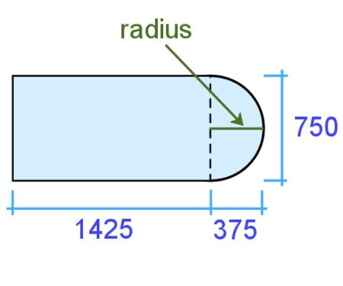This shape is half a circle plus a rectangle. We know that the diameter of the circle is 750 mm, because that’s the width of the bench.

Therefore we know that the curve begins at 1425 mm along the bench, because the radius of the circle is half of the diameter. That is:

Radius = 750 ÷ 2 = 375 mm.

The formula for finding the area of a semicircle is simply:

Semicircle area = area of circle ÷ 2.

In other words:

Semicircle area = (diameter ÷ 2) x (diameter ÷ 2) x 3.14 ÷ 2

= (0.75 ÷ 2) x (0.75 ÷ 2) x 3.14 ÷ 2

= 0.375 x 0.375 x 3.14 ÷ 2

= 0.22 m2

Now we can do the rest of the calculation:

Rectangle: 1425 x 750 = 1.069 m2

Total area: 0.22 + 1.069 = 1.289 m2

Written mathematically: (0.75 ÷ 2 x 0.75 ÷ 2 x 3.14 ÷ 2) + (1.425 x 0.750) = 1.289 m2

##### Learning activity 7

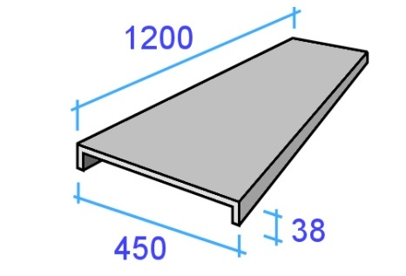You have just fabricated a set of steel shelves for a workshop, and now you need to spray paint them before they’re installed. The paint manufacturer says that the undercoat covers 12 m2 for every litre of paint.

There are 20 shelves in total, and the dimensions of each shelf are:

Length: 1.2 m

Width: 450 mm

Fold at the front and back: 38 mm

How much undercoat will you need if you’re going to spray all surfaces?

Use the format below to set out your calculations. This will help you to keep track of your answers as you work through the exercise. Once you’ve finished, check your answers in the Answers section at the back.

#### Area of top and underside:

m (length)

m2

m (width)

(no. sides)

x x =

#### Area of folds:

x x x

(no. sides)

m (length)

(no. folds)

m (width)

=

m2

**Total area of each shelf:**

m2 (area of top and underside)

m2 (folds)

m2

+ =

**Total square metreage:**

m2

(no. shelves)

m2 (for each shelf)

x =

**Amount of paint required:**

litres

m2 (coverage per litre)

m2 (total)

÷ =

|  |
| --- |
| Angles |

When two straight lines meet, they form an **angle** between them. If the lines are walls in a square room, or the sides of a square box, they will form a **right angle**.

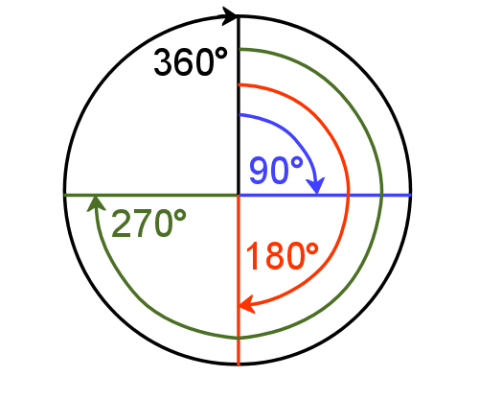Another way of referring to a right angle is to say it is 900 (degrees). This is a reference to the amount of **turn** between the 2 lines. That is, if you had a circle and drew a radius from the middle to the top, and then rotated it one quarter of a turn, you would have turned the radius through 900.

One full turn around a circle is 3600. This means that every angle formed between the two lines will be something less than that – for example, one quarter is 900, half is 1800, three quarters is 2700.

### Setting out and checking angles

The most common hand-held tools used to set out angles are:

|  |  |
| --- | --- |
| carpenter_square.jpg | **Carpenter’s square,** also called a framing square, because it is sometimes used to set out angles on roof framing timbers, such as rafters. |
| combo_square.jpg | **Combination square**, which allows you to set out 900 and 450 angles. |
| bevel_square.jpg | **Bevel**, which lets you set any angle you like. |
| protractor.jpg | **Protractor**, which is like a bevel but has the degrees marked in an arc. |
| angle_finder.jpg | **Electronic angle finder**,which provides a digital readout of the angle formed by the arms. |

### Using a level

**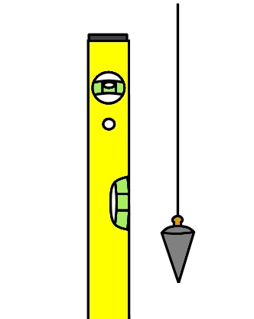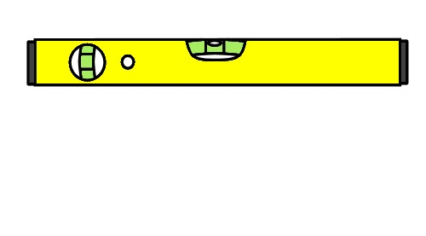Level** means perfectly horizontal. A spirit level allows you to check that a surface or line is horizontal. It works on the principle that the bubble will find the highest point in a glass tube, because it is lighter that the surrounding fluid.

Since the tube is curved slightly with the highest point in the middle, the bubble floats exactly in the middle when the level is horizontal.

You can also use a level to check whether a surface or line is **plumb**. ‘Plumb’ means perfectly vertical, and comes from a Latin word meaning ‘lead’. This is a reference to the **plumb bob**,which traditionally was always made of lead. When a plumb bob is hung from a string, gravity draws the weight downwards, and the string forms a vertical line.

The angle formed between a vertical line and a horizontal line is exactly 900. So there are many times, particularly in building projects, when you can check whether two surfaces form a right angle by simply using a level.

### angle_2.jpgMeasuring diagonals

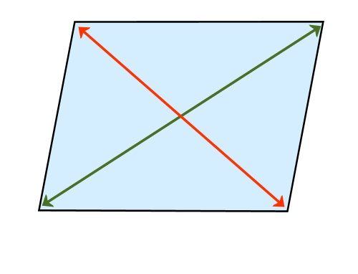If you’re manufacturing an object that’s rectangular in shape, one way of checking the sides for ‘square’ is to measure the diagonals. This principle works because the opposite sides of a square or rectangle are always **parallel** – that is, the same distance apart at both ends. Therefore, if the corners are square, the two diagonals will be the same length.

If the diagonals are not the same length, then the corners can’t be square, even if the sides are still parallel. It’s worth keeping this in mind as a reminder that you can’t simply measure the lengths of the sides to check that an item is square – this won’t tell you whether the corners are at right angles.

### Using the 3, 4, 5 rule

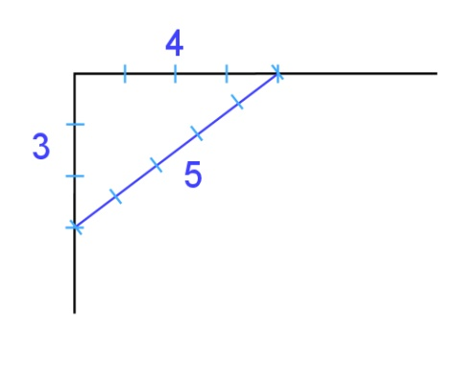Can you still check an angle for square using a tape measure if the object doesn’t have opposite corners? The answer is yes – by using the 3, 4, 5 rule. This is an application of an old formula that Pythagoras, the ancient Greek philosopher, came up with over 2,500 years ago.

Let’s say you wanted to check whether the walls in the corner of a room were square, but it was a big open-plan room that didn’t have opposite corners to measure.

The 3, 4, 5 rule states that if you measure 3 units along one wall and mark the point, and 4 units along the other wall and mark the point, the distance between the two points should be 5 units if the corner is square.

It doesn’t matter what length a ‘unit’ is, as long as the proportions are 3, 4 and 5. That is, your lengths could be 3 metres, 4 metres, 5 metres; or 3 feet, 4 feet, 5 feet; or 6, 8, 10 or any other multiple of 3, 4, 5.

##### angle_6.jpgLearning activity 8

1. Here is a cabinet under construction. The sides   
   are all cut to the correct lengths, but the diagonals aren’t equal. This means that the cabinet isn’t square.
2. Which two angles are more than 900 and which two are less than 900?

More than 900 : and

Less than 900 : and

1. Which two corners does the cabinetmaker need to push towards each other to square up the cabinet?

and

1. What length will both diagonals be when the cabinet is square?

mm

mm

1. 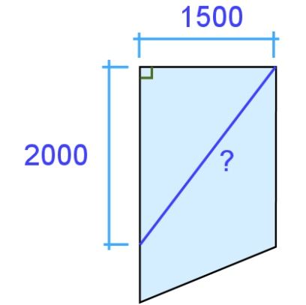A steel fabricator has a large off-cut of checker plate, and wants to know whether the top left hand corner is square. The sheet is 1500 mm wide, but its lengthwise dimensions vary because it has been cut on an angle.

The fabricator measures 2000 mm down on the left hand side and marks the point. He then measures between that mark and the top right hand point.

What length will this diagonal line be if the top left corner is square?

Check your answers in the Answers section at the back.

|  |
| --- |
| Volume |

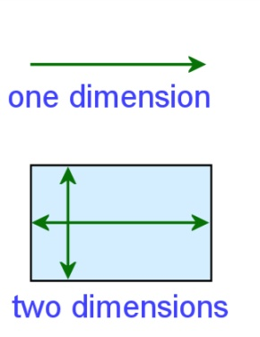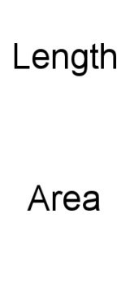So far we’ve described **length** as being one dimensional and **area** as two dimensional. But for an object to take up space in the real world it needs a third dimension. **Volume** is a way of measuring three dimensional space.

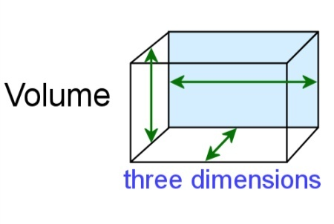We know that if a square measures one metre by one metre, it will have an area of one square metre (m2).   
If we now give it a depth of one metre, it will have a volume of one cubic metre (m3). This is the standard unit of volume in the SI metric system.

Large objects, building materials and spaces are often measured in cubic metres. But a more common measure for fluids and the capacity of containers is litres (L).

Here are some metric volume measurements:

1 cubic metre (m3) = 1,000 litres (L) = 1,000,000 cubic centimetres (cm3)

1 L = 1,000 millilitres (mL) = 1,000 cm3

1 mL = 1 cm3

Let’s apply these units of volume to some typical examples.

#### Example 1: Concrete driveway

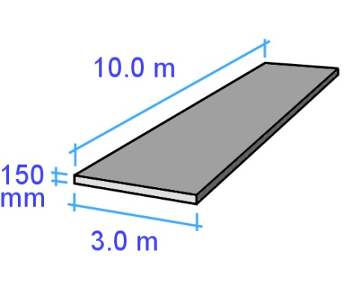How much concrete do you need to order for a driveway that measures 10 m in length, 3 m in width and 150 mm in thickness?

Notice that there is a combination of units here – the length and width are in metres and the thickness is in millimetres. So the first thing we need to do is convert the thickness to metres: 150 mm = 0.150 cm3

Now we can do the calculation.

Volume of a rectangular prism = length x width x thickness

= 10 m x 3 m x 0.15 m

= 4.5 m3

In practice, you might add 10% to cover variations in the ground level which will affect the thickness of the slab. This means you would add 0.45 m3 to the total.

#### fuel_tin.jpgExample 2: 2-stroke fuel

A common petrol:oil ratio for 2-stroke engines is 25:1. This means that for every 25 parts of petrol you need to mix in 1 part of 2-stroke oil.

If you had a 4 litre container of petrol, how much oil do you need to add?

We know that:

1 L = 1000 mL, so

4 L = 4,000 mL.

Therefore:

4,000 mL (petrol) ÷ 25 = 160 mL (2-stroke oil).

#### water_tank.jpgExample 3: Water tank

How much water can a tank hold with a diameter of   
1800 mm and a height of 1500 mm?

Cylinder volume = area of circle (cross section) x height

= diameter x diameter x 3.14 x height  
 2 2

= 1.8 ÷ 2 x 1.8 ÷ 2 x 3.14 x 1.5

= 0.9 x 0.9 x 3.14 x 1.5

= 3.815 m3

Since there are 1000 litres in 1 m3, the volume in litres is:

3.815 m3 x 1000 = 3815 L

##### volume_3.jpgLearning activity 9

1. You are landscaping your front yard and have decided to spread topsoil over the lawn area. The topsoil will be an average of 50 mm thick, and needs to cover an area of 7 metres by 8.5 metres.

How much topsoil will you need?

m (thickness)

m (width)

m (length)

Volume of topsoil: = x x

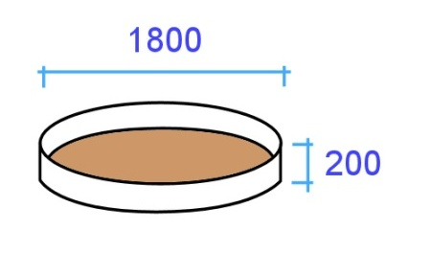  
 =

m3

2. You also want to put a water feature pond at one end of the yard. The pond will be round, with a diameter of 1.8 metres. The depth will be 200 mm. How much water will the pond hold when it is full?

m (diameter)

m (diameter)

Surface area of pond = ÷ 2 x ÷ 2 x 3.14

=

m2

m (depth)

m2 (surface area)

Volume of pond in m3 = x

=

m3

Volume of pond in litres = x 1000 =

L

m3

Check your answers in the Answers section at the back.

|  |
| --- |
| Avoiding errors |



|  |
| --- |
|  |

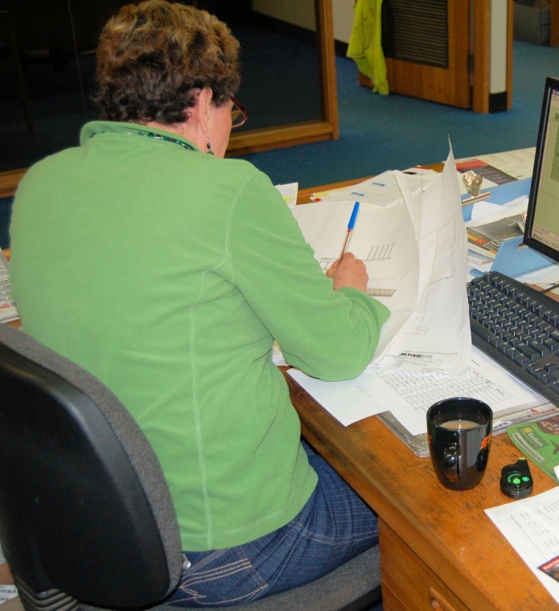Throughout this unit we’ve touched on a few issues that can cause errors in measurements and calculations. The suggestions we’ve provided so far for avoiding errors include:

* **estimating** **the answers** you would expect to see in a calculation, so that if there is a glaring error you can pick it up more easily
* **writing down the numbers first**, especially if someone else is calling them out to you, so that you have a written record of the measurements or quantities
* **reading the numbers and graduations** **carefully** on a tape measure, to make sure that you are taking off the correct measurement from the correct section of the tape.

Below are some more suggestions for making sure that the measurements you take are accurate and correct.

### Reading dials and gauges

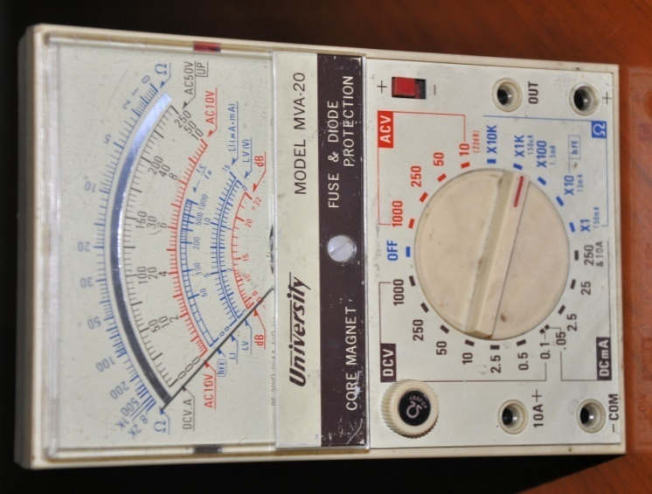A common error when reading dials or gauges is to look at the pointer from an angle to the scale. This means that instead of reading off the mark immediately behind the pointer, you read a mark that is either on the left or right hand side of the pointer.

The problem is called **parallax error**, because ‘parallax’ refers to the way an object seems to change its position when your own point of observation changes.

Some instruments have a mirror on the dial so that you can line up the pointer with its own reflection, to make sure that your reading is exactly at right angles to the scale. Even if there isn’t a mirror, the simple solution to the problem is to use one eye only and make sure you’re looking at the scale at exactly 90 degrees.

It is even possible to get a parallax error with a ruler or tape measure if the graduations are not hard against the mark or edge that you want to measure. Again, always make sure that your eye is at 90 degrees to the scale when you take the measurement. In the case of the tape measure, you should also push down the steel blade so that the top edge is flat against the object you’re measuring.

### Calibrating instruments

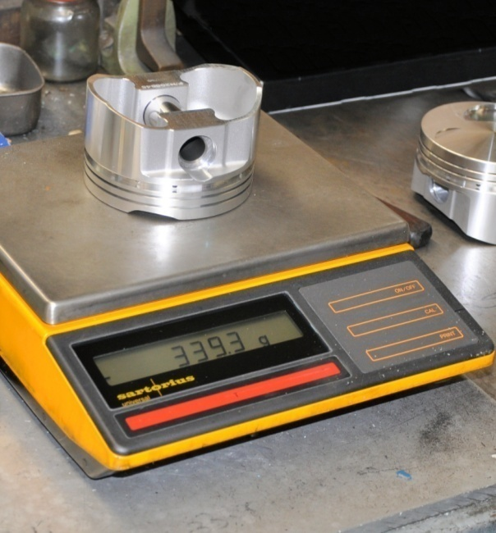Some measuring instruments need to be calibrated before they are used. This often means adjusting the zero mark on the gauge to correspond with a true zero reading.

Weighing scales are an example of an instrument that must be set to zero before you start taking measurements.

Some instruments also need to be adjusted differently for particular types of materials. For example, moisture meters for timber use different scales depending on the species of hardwood or softwood being measured.

The simplest way of making these sorts of allowances is to have a conversion chart that enables the user to add or subtract amounts to give a ‘corrected’ reading.

### ‘Measure twice, cut once’

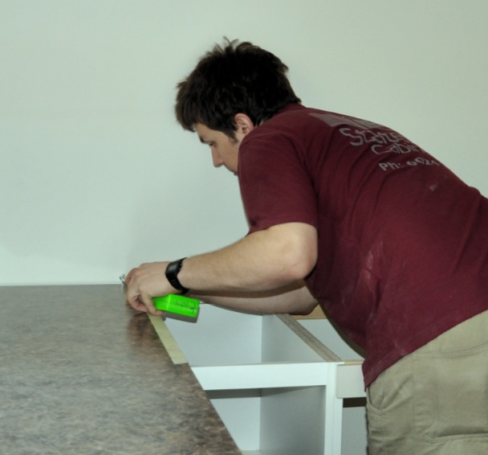This is an old saying that just about every apprentice or worker has heard from their boss. It’s a good saying, because it’s a little reminder that simple mistakes can happen any time, and they’re easy to fix if all that’s needed is another quick check.

But once you’ve cut the piece or committed yourself in some other way to the measurement you’ve just taken, it may end up being a very big mistake if your measurement turned out to be wrong.

In that sense, the extra time taken to double-check a measurement or calculation is time very well spent, because at the very least it will give you the confidence that you were right the first time. And if it does happen that your second reading is different from the first one, you’ll have given yourself a get-out-of-jail-free card, because you can immediately correct the error before it causes you any grief or expense.

##### Learning activity

What types of measuring devices do you use that require calibration? Who does the calibration? What is the calibration process?

Have a think about these points, because you will need to choose a measuring instrument and describe the calibration process in your final assignment. If you don’t know enough about a particular instrument to answer these questions, ask your supervisor or trainer for help. See if you can get the instruction booklet for the device you have chosen and do some research. Best of all, ask someone to carry out the calibration process with you and explain the finer details.

# Assignment

1. 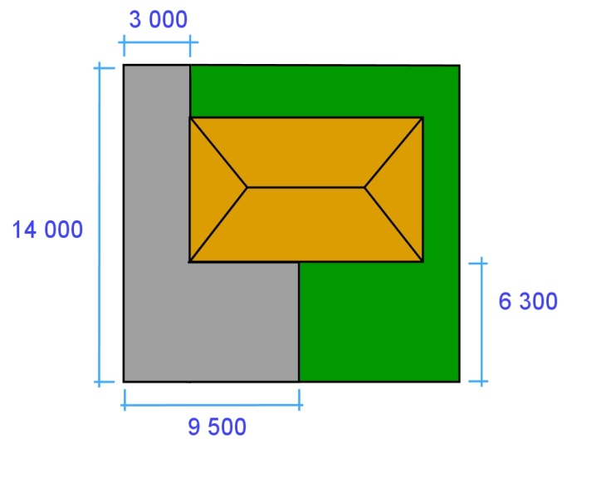You have decided to put in a concrete driveway and rear carport at your house. You have submitted the plan at right to the local council.
2. What is the surface area of concrete in square metres?
3. If the slab is 100 mm thick, how many cubic metres of concrete will there be?
4. If you allow an extra 10% for minor variations in thickness, how much concrete will you order from the supplier?

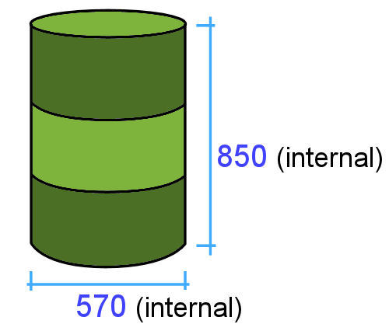2. A 44 gallon drum has an internal diameter of 570 mm and height of 850 mm.

1. What is the drum’s capacity in litres? (Use the measurements above to calculate the volume.)
2. 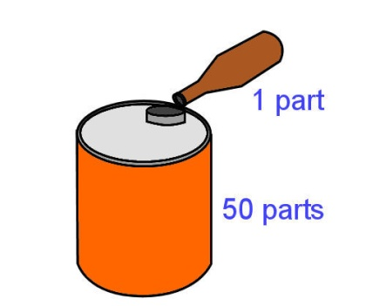If you filled the drum with water, what would the total weight be? (Water weighs 1 tonne per m3, and the drum itself weighs 10 kg.)
3. Your chainsaw uses high grade two-stroke oil in a 50:1 ratio with petrol. If the fuel container holds 5 litres of petrol, how much oil will you need to add?

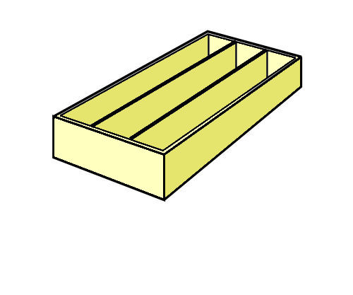

1. You are about to put a plywood back on a set of bookshelves. How will you check with a tape measure whether all four corners of the bookshelf are square?
2. Choose one measuring instrument that requires calibration, or setting to zero, before it is used.
   1. What is the instrument called?
   2. What does it measure?
   3. What is the process of calibrating the instrument?
   4. What would happen if you took a measurement when the instrument was not calibrated correctly?

# Practical demonstration

The checklist sets out the sorts of things your trainer will be looking for when you undertake the practical demonstrations for this unit. Make sure you talk to your trainer or supervisor about any of the details that you don’t understand, or aren’t ready to demonstrate, before the assessment event is organised. This will give you time to get the hang of the tasks you will need to perform, so that you’ll feel more confident when the time comes to be assessed.

When you are able to tick all of the YES boxes below you will be ready to carry out the practical demonstration component of this unit.

### Practical demonstration checklist

You will be asked to select a range of measuring devices or instruments that you use at work and demonstrate your ability to use each one competently. Your trainer will need to see you carry out these activities over a period of time, to make sure that you are satisfying these ‘demonstration criteria’ consistently under different conditions.

|  |  |
| --- | --- |
| Demonstration criteria | YES |
| 1. Describes the purpose of the measuring device and the units of measure it uses. | ❑ |
| 1. Checks the device for faults and identifies the parts that are most prone to malfunction. | ❑ |
| 1. Where required, checks that the device is correctly calibrated. | ❑ |
| 1. Uses the device to measure a range of items and demonstrates the process of checking that the measurements are reliable and accurate. | ❑ |
| 1. Explains any external factors that need to be taken into account, such as temperature, humidity, or changing conditions in the item being measured. | ❑ |
| 1. Carries out any necessary calculations relating to the measurements taken. | ❑ |
| 1. Records the results correctly, using the appropriate symbols and abbreviations. | ❑ |
| 1. Describes the process of reporting faults and dealing with malfunctions. | ❑ |

# Answers to Learning activities

##### Learning activity 1

1. 6.3 **6**

5.2 **5**

2. 78 **80**

14 **10**

3. 85 **100**

530 **500**

4. 42 x 68 40 x 70 = **2800**

56 x 93 60 x 90 = **5400**

28 x 3.9 30 x 4 = **120**

7.2 x 2.1 7 x 2 = **14**

##### Learning activity 2

1. **1/2 = 2/4**

Proof: 1 x 2 = 2

2 x 2 4

2. **30/100**

Proof: 3 x 10 = 30

10 x 10 100

3. 20/50 = **2/5**

Proof: 20 ÷ 10 = 2

50 ÷ 10 5

4. **3/8 inch** will be bigger, because the other drill bit is 1 x 2 = 2

4 x 2 8

##### Learning activity 3

1.

|  |  |  |
| --- | --- | --- |
| Fraction | Decimal | Percentage |
| 1/100 | **0.01** | **1%** |
| 1/20 | **0.05** | **5%** |
| 1/10 | **0.1** | **10%** |
| 1/8 | **0.125** | **12.5%** |
| 1/5 | **0.2** | **20%** |
| 1/4 | **0.25** | **25%** |
| 1/2 | **0.5** | **50%** |
| 1 | **1.0** | **100%** |

2. 10% = 1/10 = 0.1

Therefore:

15 (litres) x 0.1 (thinners) = **1.5 litres**

3. 30% = 30/100 = 0.3

Therefore:

$800 (wage) x 0.3 (tax) = **$240**

##### Learning activity 4

|  |  |
| --- | --- |
| Length | Length in metres |
| 1.5 km | **1500 m** |
| 1 km | **1000 m** |
| 1/2 km | **500 m** |
| 1/4 km | **250 m** |
| 350 cm | **3.5 m** |
| 185 cm | **1.85 m** |
| 4800 mm | **4.8 m** |
| 3660 mm | **3.66 m** |
| 900 mm | **0.9 m** |
| 255 mm | **0.255 m** |
| 75 mm | **0.075 m** |
| 25 mm | **0.025 m** |
| 9 mm | **0.009 m** |
| 3 mm | **0.003 m** |

##### Learning activity 5

5/4.2, 3/4.8, 2/6.0 = **47.4 l/m**

##### Learning activity 6

|  |  |
| --- | --- |
| tape_2.jpg1. | **2200 mm** |
| tape_3.jpg2. | **3110 mm** |
| tape_7.jpg3. | **7328 mm** |
| tape_4.jpg4. | **1780 mm** |
| tape_5.jpg5. | **4585 mm** |

##### Learning activity 7

Area of top and underside:1.2 (length) x 0.45 (width) x 2 (no. of sides) = **1.08 m2**

Area of folds:1.2 (length) x 0.038 (width) x 2 (no. of sides) x 2 (no. of folds) = **0.1824 m2**

Total area of each shelf: 1.08 (area of top/underside) + 0.1824 (area of folds) = **1.2624 m2**

Total square metreage: 1.2624 (m2 for each shelf) x 20 (no. of shelves) = **25.248 m2**

Amount of paint required: 25.248 (total m2) ÷ 12 (m2coverage per litre) = **2.104 litres**

##### Learning activity 8

1. (a) Which two angles are more than 900 and which two are less than 900?

More than 900 : **A and B**

Less than 900 : **C and D**

1. **C and D** need to be pushed towards each other
2. Both diagonals will be **1570 mm** long when the cabinet is square. This is halfway between 1580 and 1560.

2. The diagonal length will be **2500 mm**. This is because the ratio of 1500 : 2000 : 2500 is the same as 3 : 4 : 5.

You can do this in your head by multiplying 3, 4 and 5 by 1000 (3000, 4000, 5000) and then halving each number

##### Learning activity 9

1. Volume of topsoil: 7 (length) x 8.5 (width) x 0.05 (thickness) = **2.975 m3**

You could round this up to 3 m3

2. Surface area of pond = 1.8 (dia.) ÷ 2 x 1.8 (dia.) ÷ 2 x 3.14 = **2.543 m2**

Volume of pond in m3 = 2.543 (m2 surface area) x 0.2 depth = **0.509 m3**

Volume of pond in litres = 0.509 m3 x 1000 = **509 L**