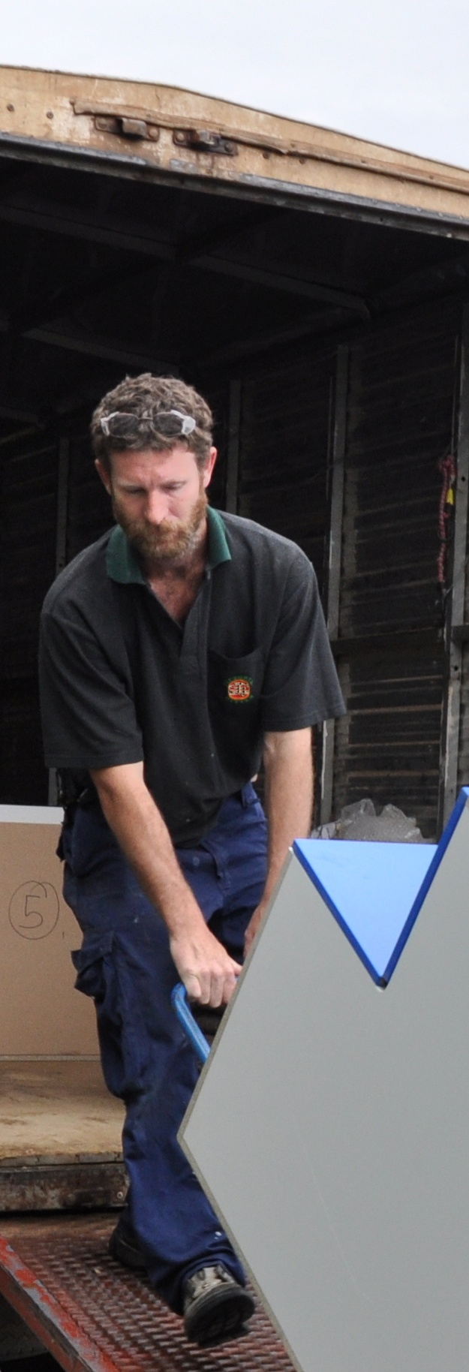

**Supporting:**

***LMFKB2001A  
Prepare for cabinet installation***

Preparing for installation

**Learner guide**

**Developed in 2011-2012 for the WELL Program**

DRAFT VERSION

October 11

Preparing for installation

Learner Guide

This unit is also available in an e-learning format, which contains additional photos, interactive exercises and a voice-over narration of the text. It can be viewed on CD-ROM, or live on the web at:

<http://www.kbcabinetmaking.com.au/>



Developed by Workspace Training for the 2011-2012

Workplace English Language and Literacy (WELL) Program

Kitchen and Bathroom Cabinetmaking resource development project



[www.workspacetraining.com.au](http://www.workspacetraining.com.au)

ISBN: 978-0-9873328-4-4

Funded under the Workplace English Language and Literacy Program by the Australian Government through the Department of Education, Employment and Workplace Relations.

COPYRIGHT

© Commonwealth of Australia. 2012



***CC BY-NC-SA***

This work is copyright. Except where otherwise indicated, and save for the Commonwealth Coat of Arms, the Department has applied the Creative Commons Attribution-Noncommercial-Share Alike 3.0 Australia Licence to this work.

The Department of Education, Employment and Workplace Relations must be attributed as the author of the Department’s copyright material.

As far as practicable, material for which the copyright is owned by a third party has been clearly labelled. The Department has made all reasonable efforts to ensure that this material has been reproduced in this print-based resource and the accompanying website with the full consent of the copyright owners.

Requests and enquiries concerning the Department’s copyright material should be addressed to:

The Copyright Officer

Department of Education, Employment and Workplace Relations

Location code C148CW2

GPO Box 9880 Canberra ACT 2601

Email: [copyright@deewr.gov.au](mailto:copyright@deewr.gov.au)

Questions about the design and content of the resource itself should be addressed to the project manager:

David McElvenny

Workspace Training

PO Box 1954 Strawberry Hills, NSW, 2012

Email: [david@workspacetraining.com.au](mailto:david@workspacetraining.com.au)

## About this resource

This learner guide is one of 11 learner guides developed for the *Kitchen and Bathroom Cabinetmaking* project, funded by the WELL Program in 2011-2012. The guides are aligned to the following core and elective competencies from the *Certificate III in Cabinetmaking (Kitchens and Bathrooms) LMF32109*:

*LMFKB2001A Prepare for cabinet installation*

*LMFKB3001A Identify processes in kitchen and bathroom*

*LMFKB3002A Determine requirements for installation*

*LMFKB3003A Check and measure fit of cabinets*

*LMFKB3004A Conduct on-site adjustments to cabinets*

*LMFKB3005A Fabricate cabinets for the built-in environment*

*LMFKB3006A Install fitted cabinets and components*

*LMFFM3006B Install furnishing products*

*MSAENV272B Participate in environmentally sustainable work practices*

*MSAPMOHS200A Work safely*

*MSAPMOPS101A Make measurements*

The purpose of the guides is to help apprentice cabinetmakers acquire the background knowledge needed to satisfy the theoretical components of these units. However, they are not designed to replace the practical training necessary to develop the hands-on skills required. Learners will still need to receive extensive on-the-job training and supervision before they will be ready to be formally assessed in these units.

### E-learning version

All of these units are also available in an e-learning format, which contains additional photos, interactive exercises and a voice-over narration of the text. The   
e-learning version can be viewed live on the web at:

<http://www.kbcabinetmaking.com.au/>

The web version can also be purchased on a CD at a cost-recovery price from the project developer:

David McElvenny (project manager)

Workspace Training

PO Box 1954 Strawberry Hills, NSW, 2012

Email: [david@workspacetraining.com.au](mailto:david@workspacetraining.com.au)

## Acknowledgements and disclaimer

### Project team

Project manager: David McElvenny

Instructional design: Kath Ware

Technical developer (website): Jim Vaughan

Assistant technical developer (and voice-over artist): Alex Vaughan

Quality assurance consultant: Giselle Mawer

Industry coordinator: Gary Dunshea (MSA Industry Skills Council)

Lead advisor: Rob Cole (Furnishing Industry Association of Australia)

### Technical Advisory Group

**New South Wales**

Brad Holmes – Hunter TAFE

Grant Cohen – Hunter TAFE

Dean Brakell – Furnishing Industry Association of Australia

Warren Peters – South West Sydney Institute of TAFE

Sean Greening – South West Sydney Institute of TAFE

**ACT**

Martin Jud – Canberra Institute of Technology

**Victoria**

Bryon Stanley – Furnishing Teacher's Advisory Group (VIC, SA, TAS)

Richard Brooks – Cabinet Makers Association

Simon Hampton – Wodonga TAFE

John Simpson – Holmesglen TAFE

**Tasmania**

Stephen Kirkman – Skills Institute Tasmania

**Queensland**

Rob McAdam – Skills TECH Australia

Brad Buhse – Skills TECH Australia

Roberto Viola – Gold Coast Institute of TAFE

**South Australia**

John Holst – Marleston TAFE

Dean Hart – Mt Gambier TAFE

Martin Videon – Furnishing Industry Association of Australia

**Northern Territory**

Hermann Oltrop – Charles Darwin University

**Western Australia**

Garry Michels – Polytechnic West

Keith Campbell – Polytechnic West

Adrian Boyling – Polytechnic West

David Boaden – Polytechnic West

Lorenzo Procopio – South West Institute of Technology

**National**

Laurie Kruize – Housing Industry Association

### Photographs and graphics

All photos were taken by David McElvenny. All graphics were drawn by Kath Ware. We would like to thank the following companies for allowing us to take photos of their installers and workshop employees and generously providing technical advice:

Canobolas Kitchen Designs Flair Kitchens

Danson’s Kitchens and Joinery Lamtex Innovative Furniture

Fewings Joinery Stateline Cabinets

B&B Joinery Ian McConnell Constructions

Krauss Kitchens

### Financial contributions

This resource was largely funded by the Workplace English Language and Literacy Program, through the Department of Education, Employment and Workplace Relations. However, due to the scale of the project and the provision of print-based and website resources, additional financial assistance was provided by the following organisations:

Manufacturing Skills Australia (Industry Skills Council)

Furnishing Industry Association of Australia

### Disclaimer

The content of this learner guide is provided for educational purposes only. No claim is made as to the accuracy or authenticity of the content. The views expressed in this publication do not necessarily represent the view of the Minister for Education or the Australian Government. The Australian Government does not give any warranty nor accept any liability in relation to the contents of this work.

**Table of contents**

[**Introduction 1**](#_Toc329178506)

[Section 1](#_Toc329178507) [Organising items 3](#_Toc329178508)

[Overview 5](#_Toc329178509)

[Tools and equipment 6](#_Toc329178510)

[Components and hardware 10](#_Toc329178511)

[Safety requirements 12](#_Toc329178512)

[Assignment 1 14](#_Toc329178513)

[Section 2](#_Toc329178514) [Going to the site 15](#_Toc329178515)

[Overview 17](#_Toc329178516)

[Before you leave 18](#_Toc329178517)

[Transporting cabinets 20](#_Toc329178518)

[Arriving at the site 23](#_Toc329178519)

[Assignment 2 26](#_Toc329178520)

[Practical demonstration 27](#_Toc329178521)

|  |
| --- |
| Introduction |

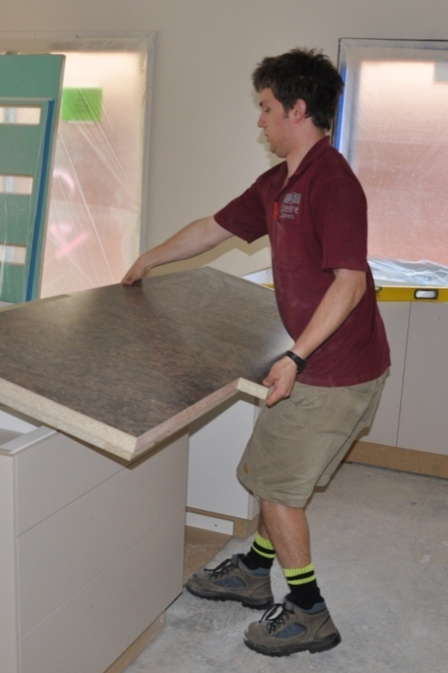Have you ever heard of the **5 P’s**?

**P**roper   
**P**reparation   
**P**revents   
**P**oor   
**P**erformance.

For the kitchen and bathroom installer, this little saying is a reminder that a smooth and efficient installation job doesn’t just happen by accident. It is the product of careful planning, and the ability to take note of all of the issues that are likely to have an impact on the work to be done.

This unit is all about how to properly prepare for an on-site installation. It will cover the processes of getting everything organised to go out to the jobsite, and what to do once you get there.

### Working through this unit

There are two sections in this unit:

* Organising items
* Services and design.

Each section contains an *Overview*, an *Assignment*, and several *Lessons* which cover the content material. Your trainer may ask you to submit the assignments as part of your assessment evidence for the unit. You will find hard-copy answer sheets for these assignments in the separate Workbook.

Electronic ‘Word’ templates of the assignments are available on the website for this resource, at: <http://www.kbcabinetmaking.com.au/>

The electronic versions can be completed on-screen and sent to the trainer either as:

* a printed hard copy, mailed through the post
* an electronic file, emailed as an attachment.

### Practical demonstration

Your final assessment of competency in this unit will include one or more practical demonstrations. Their purpose is to assess your ability to put your knowledge into practice and physically carry out the process of preparing for cabinet installations. To help you get ready for these hands-on assessment activities, there is a *Practical demonstration* checklist at the back of this Learner guide.

The checklist sets out the sorts of things your trainer will be looking for when you undertake the practical demonstrations. Make sure you talk to your trainer or supervisor about any of the details that you don’t understand, or aren’t ready to demonstrate, before the assessment event is organised. This will give you time to get the hang of the tasks you will need to perform, so that you’ll feel more confident when the time comes to be assessed.

# DSC_0075 (2).jpg

# Section 1

# Organising items

|  |
| --- |
| Overview |

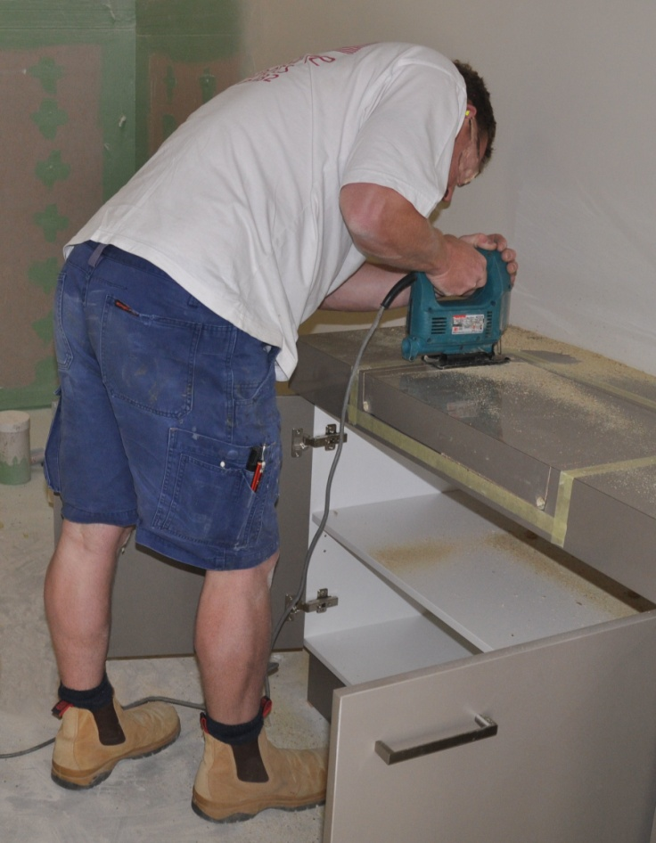Working at the client’s jobsite isn’t like being in your own workshop. When you arrive on-site to do an installation, you’re no longer in your own environment where everything you want is on hand and the work area is set out the way you like it.

In this section, we’ll cover the process of organising the tools and equipment you’ll need for a particular job, and making sure that you’ve packed the right components and hardware items.

We’ll also look at the sorts of safety requirements you might encounter on a jobsite, including the PPE (personal protective equipment) and documentation you should carry with you.

### thinking manCompleting this section

The assignment for this section is designed to check your understanding of the main preparations you need to make at the workshop when you're getting ready to go out on-site. Have a look at Assignment 1 on page 14 to see what you’ll need to do to complete it.

There are also three lessons for this section:

* Tools and equipment
* Components and hardware
* Safety requirements.

These lessons will provide you with background information that will help you with the assignment.

|  |
| --- |
| Tools and equipment |

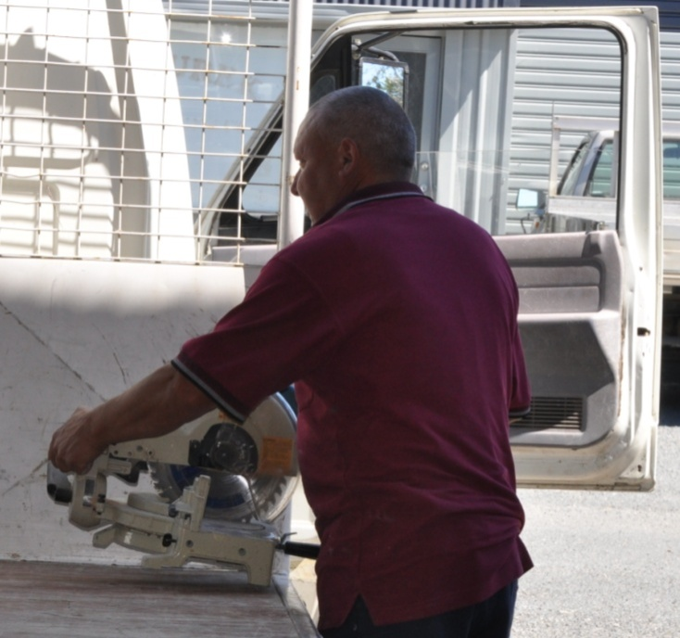Selecting the right tools and equipment for an on-site installation takes some thinking ahead. On the one hand you don’t want to leave anything behind that might suddenly be needed when you’re in the middle of the job. On the other hand you can’t take everything with you from the workshop.

So you have to mentally go through the job while you’re getting the gear ready, to make sure that everything you're likely to encounter has been catered for.

You also need to think about the site conditions and the services that are   
available. For example, if you know that you’ll need to use power tools and the mains power isn’t yet connected, your only choices will be to either take a generator with you or use battery operated tools.

The site assessment checklist is an important reminder of the various issues you’ll need to deal with on-site. This document will help you to think through the different elements of the job while you’re assembling the tools and equipment required.

### Tagged power tools

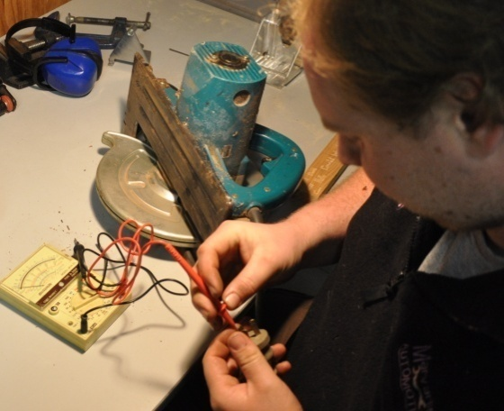All power tools used at work need to be tested and tagged every three months by an authorised person. The test is designed to ensure that the tools are safe and not likely to cause a fire or electric shock.

Once a piece of equipment has been tested and passed, the authorised person attaches a tag to it, stating their name or company they work for and the test date.

If a power tool is faulty, or the tag is out of date, make sure you take it straight to the person responsible for getting it fixed. Don’t pack a faulty tool up with the rest of the gear going out on-site. And don’t put it back on the shelf in the workshop for someone else to pick up later.

### Tools, equipment and PPE

Below are the sorts of tools and other items typically taken on-site by kitchen and bathroom installers.

#### DSC_0195 (2).jpgPower operated tools and equipment

* Jig saw (and spare blades)
* Circular saw
* Generator (and fuel)
* Dust extractor
* Drop saw
* Power box
* Nail gun
* Electric planer
* Electric drill (plus drill bits)
* Cordless drill (plus battery charger and fully charged batteries).

#### DSC_0141 (2).jpgHand tools

* Clamps
* Tenon Saw
* Hacksaw
* Spanners
* Pliers
* Corking gun
* Combination square
* Spirit level
* Hammer
* Hand saw
* Files
* Stanley knife (with spare blades)
* Screw drivers
* Chalk line
* Hole saws
* Scraper.

#### Personal protective equipment (PPE)

* Safety glasses
* Dust mask
* High visibility vest or clothing
* Ear muffs or ear plugs
* Hard hat
* Safety boots
* Gloves.

#### Other items

* 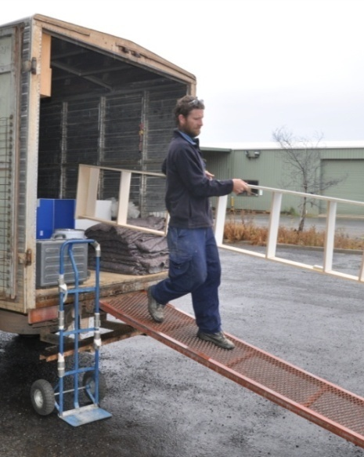Tape measure
* Hand brush
* Saw stools (at least two)
* Portable lighting
* Pencils
* Packers and wedges
* Extension cords
* Step ladder
* Broom
* Cleaning products.

##### Learning activity

The best way to ensure that you don’t forget to pack any of the tools and equipment needed for a job is to use a checklist.

You can make up a permanent checklist on a piece of plywood so it can be used each time you pack up the gear in the workshop, and when you re-pack it on-site to bring it all back.

Write the name and number of tools on the left hand side of the ply. Run a strip of masking tape down the right hand side.

Put a half cross against each item that you take when you leave the workshop. Complete the cross when you put the item back in your vehicle to leave the site.

Once you return, you can tear off the masking tape and replace it with a new piece, ready for the next job.

In between installations, hang the plywood checklist up near the area where you keep the tools and equipment.

|  |
| --- |
| Components and hardware |

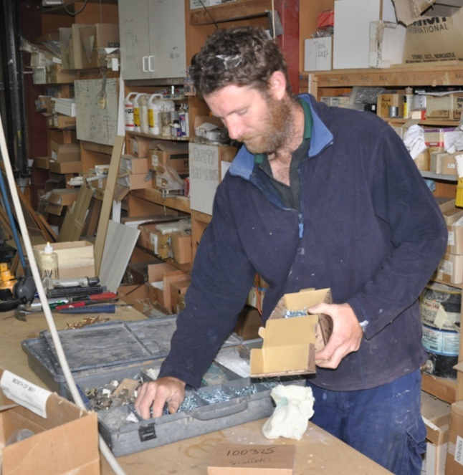Your company will use some form of checklist or job sheet to identify all of the cabinets and other fixtures to be installed. Anything that’s on the list can simply be ticked off as you load it onto the truck.

But components, general hardware and disposable items will need to be carefully considered as you work your way through the checklist, because these are the sorts of items that can easily get left behind.

Set out below are examples of the components and other items you’re likely to need.

### Cabinet components

The cabinet components you take will depend on the specifications of the job. They may include:

* 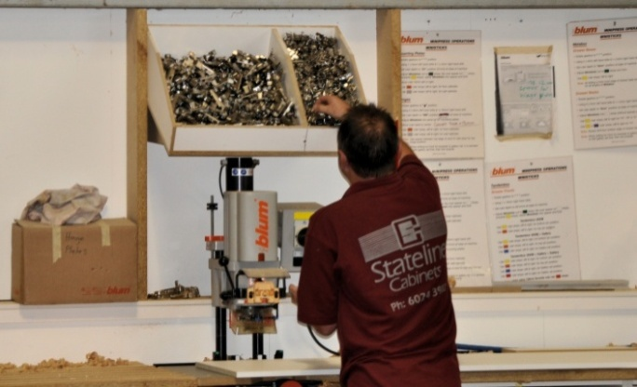handles
* hinges
* touch catches
* drawer runners / slides
* baskets
* legs / plinths
* locks / latches.

Make sure that hinges, draw runners and other components with left and right hand variations are the correct ones for the job. Check that the colour and texture are right, and that all sets are matched correctly. Also check that there are no scratches or blemishes on items that will be visible in the finished project.

Some items have a tendency to lose grub screws or attachments, or develop a malfunction that takes time to fix. In these cases you should check that moving parts are operating properly and that everything is in place as you pack each item. It might take an extra couple of minutes in the workshop, but it can save a lot of time at the jobsite when you want to avoid hold-ups wherever you can.

### Hardware and disposables

Most of the items listed below could be taken to all installation jobs as a matter of course, so that they’re always on hand when they’re needed. They include:

* 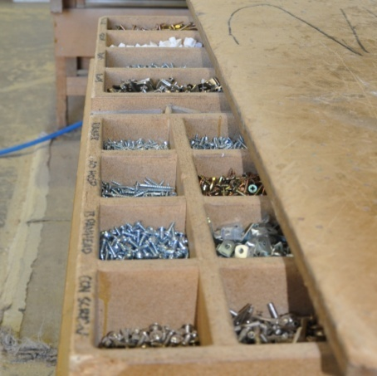door bumpers
* right angle brackets
* adjustable shelf brackets
* screws
* screw caps (in required colours)
* plasterboard anchors (such as Wall Mates)
* biscuits (for joining panels)
* toggle bolts
* cartridge gap filler (such as No More Gaps) and spare nozzles.

##### Learning activity

The lists of components and hardware items shown above are only examples of what you might need on the job.

What other items would you include for the types of installations that you’re involved in? If you’re not doing any on-site installations yet, ask your supervisor or one of the installers what other items they tend to take with them.

Share your answers with your trainer and other learners in your group.

|  |
| --- |
| Safety requirements |

Safety is strict on building sites these days. It needs to be – lots of tradespeople, delivery drivers and visitors come and go during the day, and everyone depends on each other to keep the site safe.

Large sites are likely to have more safety requirements than small domestic projects, particularly if they involve multi-storey construction. For example, you may be required to sign in and out each day at the site office, and wear prescribed PPE such as a hard hat and high visibility vest while you’re in work areas.

Below are the sorts of questions you need to ask yourself when you’re getting ready to go out to the site.

* Will I need to take any signage to indicate where the team is while we’re working?
* Have all team members been inducted and received authorisation to come on-site?
* Do all team members have a White Card?
* Have the necessary documents been completed and signed off, such as the Safe Work Method Statement (SWMS) and any relevant Safe Operating Procedures (SOPs)?
* Are there Material Safety Data Sheets (MSDSs) on hand for all chemicals and hazardous substances being taken to the site?
* Have all electrical tools been tested and tagged?
* Will there be a first aid kit on-site, or am I responsible for taking one myself?
* Will there be a fire extinguisher on-site, or should I take one myself?
* Does there need to be a qualified first-aider on-site at all times?
* Will there be adequate lighting for the whole time my team is on-site?

##### Learning activity

Some of the safety requirements listed above might be new to you. For instance, you may not have come across a White Card before, or you may not be familiar with MSDSs or SWMSs.

These aspects of ‘work health and safety’ (WHS) are covered in more detail in the unit *Working safely.* Make sure you look up anything you’re not sure about, or ask your trainer or supervisor for more information.

|  |
| --- |
| Assignment 1 |

Provide short answers to the following questions:

1. How would you decide which tools to take with you to the jobsite for a kitchen or bathroom installation?
2. What sorts of checks should you carry out on the tools as you pack them up ready to go?
3. How would you know what components and hardware items to take?
4. What sorts of checks should you carry out on the components and hardware to make sure that they’re right for the job and in proper working order?
5. What is a White Card, and when do you need to have one?

### Completing this assignment

You will find a hard-copy template for this assignment in your Workbook. There is also an electronic version of the template on the website. See the *Introduction* (page 1) for more details on how to access this file.



# Section 2

# Going to the site

|  |
| --- |
| Overview |

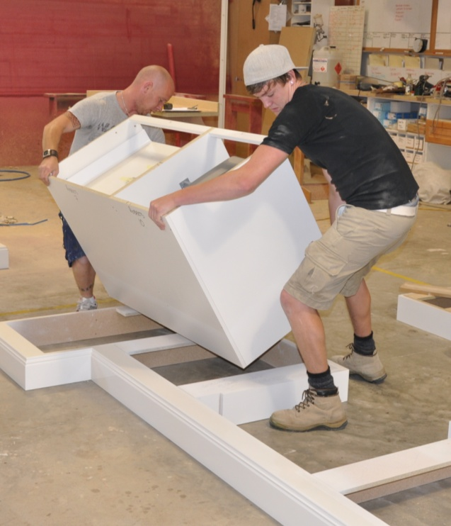Once you’ve got all the gear organised and you’re happy that everything is in order, it’s time to load up and drive out to the jobsite. In this section we’ll go through some of the final checks you should make to ensure that you can get your vehicle into the unloading area on-site without any problems.

We’ll also talk about methods of loading, unloading and transporting cabinets that will help to protect the items you’re carrying as well as the health of your back. And we’ll discuss the preparations you should make once you arrive on-site and get organised for the installation itself.

### thinking manCompleting this section

The assignment for this section is designed to give you practice in sketching a simple on-site plan, showing the layout and positioning of cabinets and other features. Have a look at Assignment 2 on page 26 to see what you’ll need to do to complete it.

There are three lessons for this section:

* Before you leave
* Transporting cabinets
* Arriving at the site.

These lessons will provide you with background information that will help you with the assignment.

|  |
| --- |
| Before you leave |

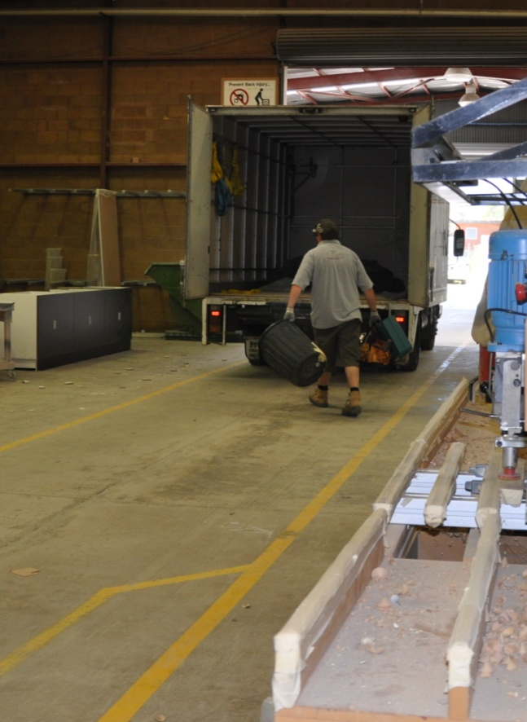There are various things you should double-check before you load up your vehicle and get ready to leave for the jobsite.

Some of these issues may have already been highlighted when the site assessment was carried out. They would include checking on site access and making sure that large components like plinth bases and pantry units are able to be carried up stairways or through doorways.

But other issues will be at the mercy of unpredictable changes in circumstances, such as weather conditions on the day, other workers on-site, and unexpected hold-ups or problems.

(For more information on the sorts of things you should look for during the initial site assessment, go to the ‘Site assessment’ section of the unit: *Installation requirements*.)

Below are some typical questions you should ask before you load the truck, just to be sure that everything is in order and there won’t be any unhappy surprises when you arrive at the site.

* Can the delivery truck gain close access to the actual work area, or should the cabinets be sent on smaller vehicles, such as utilities?
* Is power available on-site, or do alternative arrangements need to be made – such as taking a generator, or using power from the next door neighbour?
* Is there a general store nearby, or does everyone need to take their own food and drink with them?
* If it’s been raining, will the wet conditions affect site access – such as requiring everyone to bring a second pair of boots to wear after they’ve walked through the mud?
* Is parking available outside, or do special arrangements need to be made for vehicles – such as parking exemption permits from the local council?

##### Learning activity

What issues have you come across that caused unexpected problems when the truck arrived on-site? Maybe the issue was serious enough to stop any work being carried out until it was solved. Or maybe it just caused unnecessary inconvenience to the installers.

Was there any way you could have avoided the problem, or been advised in advance so you could deal with it before you arrived at the site?

Share your answers with your trainer and other learners in your group.

|  |
| --- |
| Transporting cabinets |

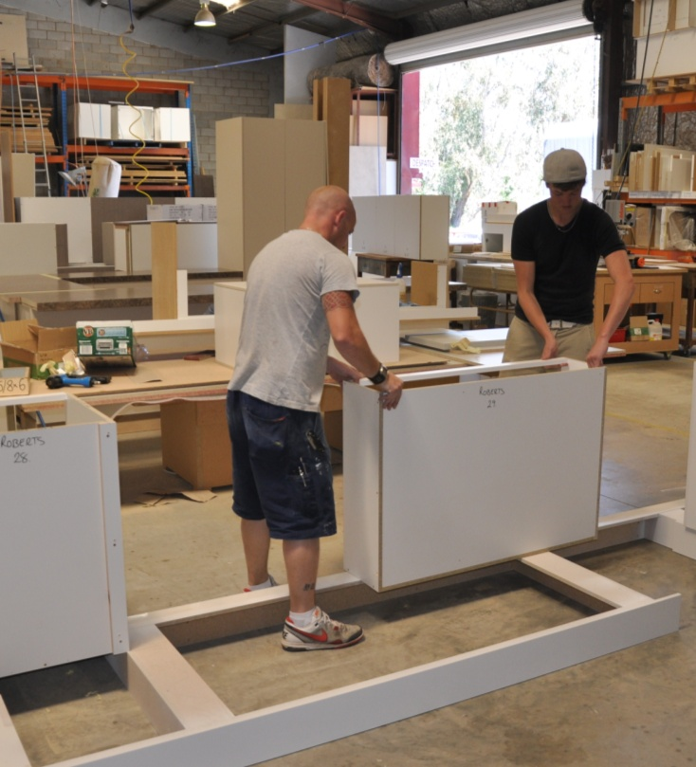In the workshop, everyone will have taken a lot of care to protect the cabinets, doors, bench tops and other fixtures while they were being made. So the last thing you want to do is damage any of the items while they’re being taken to the site.

Some materials are more fragile than others, and so need to be treated with more care when they’re being transported in the truck. But whatever the products are, the client will expect everything in the finished project to look brand new and spotless, regardless of any issues you might have had to deal with along the way.

Here’s some hints on avoiding bumps and scuffs to the units while they are being moved from the workshop to the site:

* **Don’t drag or push large units** – get help if you can’t lift an item on your own, or if you have trouble holding it steady on a trolley.
* **Remove adjustable shelves** and wrap them up in a protective covering, such as a blanket, cardboard or bubble wrap. Do the same with kickboards.
* **Put cushioning between items** that might rub against each other or against the side of the truck.
* **Keep protective coverings clean** and free from dirt or grit, to avoid the problem of embedded particles scratching the finished surfaces of units.
* **Try to fill up empty spaces** in the truck when you’re packing items in place.
* **Secure all cabinets** in the truck with straps so they can’t move around while in transit. If you use ropes, be sure to protect the corners of cabinets with cardboard, wood or metal corners to stop the ropes from ‘biting’ into the edges.
* **Check the straps** during the trip to make sure they haven’t loosened up.

### Good manual handling practices

‘Manual handling’ means physically moving things around by hand. There’s lots of manual handling involved in taking cabinets to the jobsite and putting them into position, ready for fixing.

One of the most vulnerable parts of your body to a manual handling injury is your back. Fortunately, these injuries can easily be avoided simply by using good practices.

Here are the main steps you should follow when you need to lift and carry a large, heavy or awkward object.

1. **Size up the load** and decide whether you’ll need help to lift or move it.
2. **Check the path** you will be taking to make sure there are no obstacles in the way.
3. **Place your feet firmly on the ground** and put your body in a balanced position.
4. **Bend your knees** to get down to the load,and keep your back as straight as possible.
5. **Use your legs** to do the lifting as you stand up straight.
6. **Keep the load close** to your body while you’re carrying it.

To put the object down again, use the same procedure as for picking it up – keep your body well balanced and use your legs, not your back.

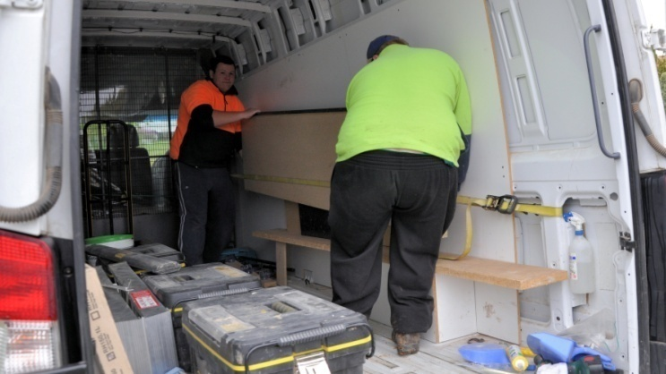Also remember that while your joints and muscles are under strain, you should **avoid twisting your back**.

If you need to change direction while you’re picking up, carrying or putting down a load, swivel on your feet so that your whole body moves in the same direction.

For more details on good manual handling practices and ways to avoid back strain, refer to the unit *Working safely*.

##### Learning activity

Think about the manufactured items or products that are most prone to damage when they’re being moved from the workshop to the jobsite. What are they? How do you look after them to make sure they don’t suffer any damage?

Share your answers with your trainer and other learners in your group.

|  |
| --- |
| Arriving at the site |

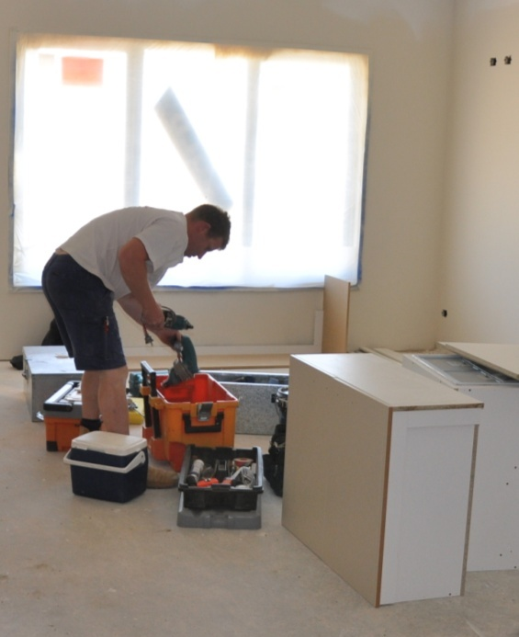Once you arrive on-site, the first thing you should do is introduce yourself to the person in charge. If your contact person is the homeowner, let them know what you plan to do and how long you’re likely to be there. If the installation job is on a large building site, you’ll need to see the supervisor or site manager before you start.

By this stage you should have already checked that any required preliminary work has been completed. But you’ll still need to make sure everything is in the correct position – such as plumbing outlets and electrical wires. If something’s not right it may affect your installation, or even hold you up completely until the problem is fixed.

Once you’ve established that you’re ready to proceed, have a good look around the area and decide where the best place will be to carry out dusty jobs, and where you should put the cabinets, tools and other items. You may need to clean up the work area and put drop sheets down on the floor to protect it.

### Coping with weather extremes

Very hot or rainy conditions can cause extra headaches when you’re unloading and storing items. Laminated bench tops, in particular, should never be left out in the direct sun on a hot day because the laminate may start to lift or the top could develop a bow. All veneered products should be kept out of the rain.

If you’re unable to unload and carry the items straight into the room they need to go in, try to find a sheltered area such as a carport or verandah. Also cover the units with a tarp or some other protective material, such as cardboard or plywood, to keep dust and other particles off the surfaces. Make sure the area you’ve chosen isn’t going to become a passageway for other tradespeople or workers.

### Room access

On some jobsites you might find that getting the cabinets and bench tops into the kitchen proves to be difficult. This might be because the room is up a flight of stairs, or the doorway is around the corner from the hallway.

Ideally, this sort of problem would already have been identified when the site assessment was carried out, so you would have worked out a solution in advance. But it could mean that you need to pass the bench tops in through an open window, or remove a glass sliding door to get access.

### Room layout

If you’re installing cabinets in more than one room, you’ll have to be careful that the right items go into the right place. This is especially the case in new apartments or villas, where all the kitchens and bathrooms in the block can look much the same. Sometimes there are minor variations in colour schemes or options between the different apartments, so you need to know exactly which set of cabinets go where. The layout plan for each room should have these details marked.

### Setting up extension leads

If the power source is not close to the area you’re working in, you may need to run an extension lead some distance. Always make the effort to keep extension leads safe, because they can be a serious hazard to your own team as well as other workers on-site if you don’t.

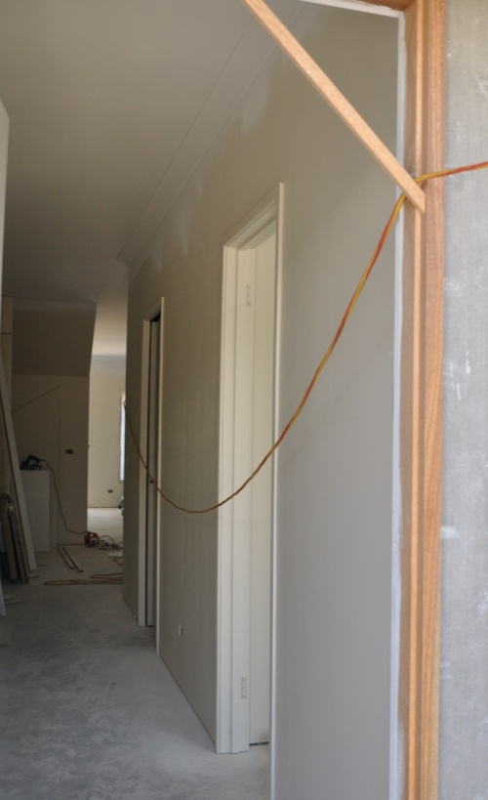Here’s some tips on using extensions leads safely:

* Make sure you unwind a long lead fully before you use it. Leads that are left coiled up can generate a lot of heat when there's a current passing through them.
* Check the plugs at each end to make sure that the wires aren't starting to pull out. If the plugs or lead are not in good condition, tag it and take it straight back to your supervisor for repairs.
* Never pull a plug out of a socket by tugging on the lead. Always hold the body of the plug when you remove it.
* Keep leads clear of wet patches on the ground or floor. This especially applies to any joins in leads.
* As a rule of thumb, use leads rated at a minimum of 10 amps for power tools, and 15 amps or more for large machines.
* Try to keep the lead as short as possible for the job you're going. The longer a lead is, the higher the voltage drop will be from one end to the other, so the higher its amp rating will need to be.
* Don’t drape leads across walkways, access-ways or vehicle paths. If there is no alternative to running a lead across a thoroughfare, make sure the lead is very obvious, and either protect it from vehicle and pedestrian traffic or put it overhead.

##### Learning activity

One alternative to using 240 volt power equipment is to get an equivalent tool that’s battery operated. The problem is that they’re often not as powerful, and of course they need to be recharged regularly. Nonetheless, as batteries continue to improve in performance and power output, an increasing variety of cordless tools is coming onto the market, including circular saws, planers, and even chainsaws.

What cordless tools do you use on-site? List the brand names and sizes or models.

Share your answers with your trainer and other learners in your group.

|  |
| --- |
| Assignment 2 |

Provide short answers to the following questions:

1. If it was raining on the day that you were delivering the cabinets to the site, what sorts of problems might occur, and how would you address them?
2. Name five good practices relating to using extension leads on-the-job.
3. What steps should you follow when lifting and carrying large or awkward objects to avoid a back injury?

### Completing this assignment

You will find a hard-copy answer sheet for this assignment in your Workbook. There is also an electronic version of the answer sheet on the website. See the *Introduction* for more details on how to access this ‘Word’ file (page 1).

# Practical demonstration

The checklist sets out the sorts of things your trainer will be looking for when you undertake the practical demonstrations. Make sure you talk to your trainer or supervisor about any of the details that you don’t understand, or aren’t ready to demonstrate, before the assessment event is organised. This will give you time to get the hang of the tasks you will need to perform, so that you’ll feel more confident when the time comes to be assessed.

When you are able to tick all of the YES boxes below you will be ready to carry out the practical demonstration component of this unit.

### Practical demonstration checklist

You will be asked to prepare for installations in a range of situations. Your trainer will need to see you carry out these activities over a period of time, to make sure that you are satisfying these ‘demonstration criteria’ consistently under different conditions.

|  |  |
| --- | --- |
| Demonstration criteria | YES |
| 1. Carries all necessary OHS authorisations, such as White Card, safe work method statement (or equivalent) and site induction sign-off. | ❑ |
| 1. Packs all required Material Safety Data Sheets (MSDSs) for any hazardous substances taken to the site. | ❑ |
| 1. Follows all company safety policies and procedures while at work and any additional site-specific policies while at the jobsite. | ❑ |
| 1. Packs the appropriate personal protective equipment (PPE) for the work to be undertaken on-site. | ❑ |
| 1. Selects the correct tools and equipment for the work to be undertaken and checks that they are in good working order and properly tagged. | ❑ |
| 1. Checks that batteries for cordless tools are properly charged, and packs spare batteries and/or battery charger. | ❑ |
| 1. Checks on the availability of on-site mains power, and selects the right equipment to cater for the power requirements. | ❑ |
| 1. Identifies correct cabinets, components and other items from the installation plan and checks their quality as each item is selected. | ❑ |
| 1. Loads items onto the vehicle safely and securely, using good manual handling practices and avoiding damage to the goods. | ❑ |
| 1. Unloads goods at the site carefully and safely, and places them in appropriate locations for the work to be carried out. | ❑ |
| 1. Prepares the work area for the installation. | ❑ |
| 1. Accurately completes all required documentation. | ❑ |