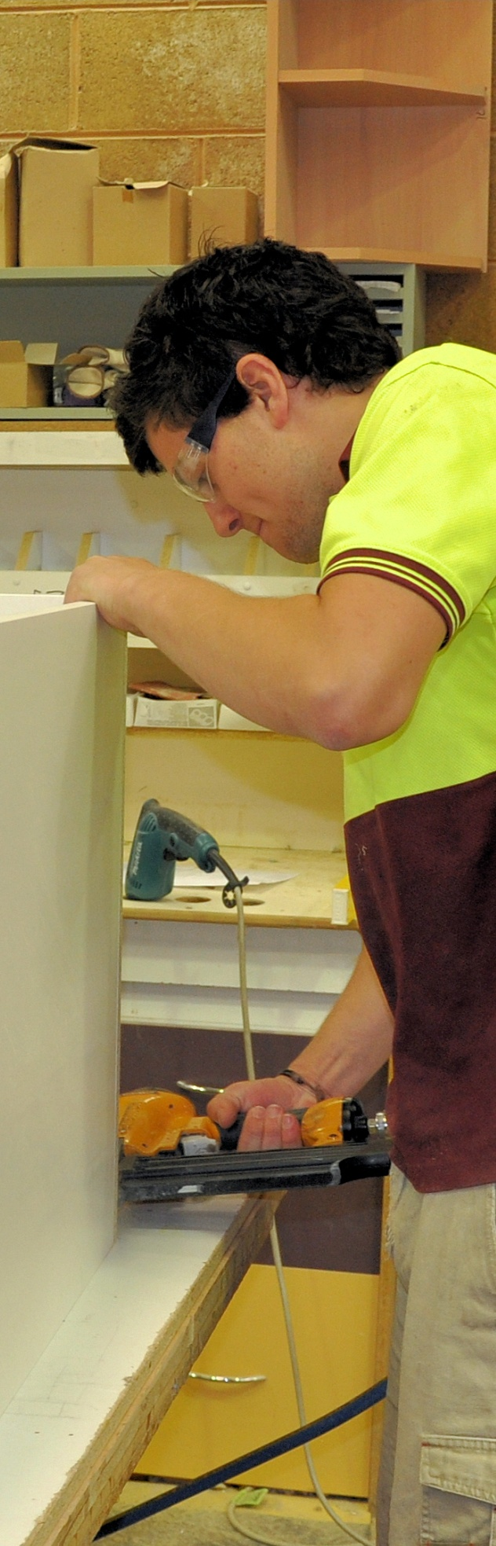

**Supporting:**

***LMFKB3005A  
Fabricate cabinets for   
the built-in environment***

Fabricating cabinets

**Work book**

**Developed in 2011-2012 for the WELL Program**

Fabricating cabinets

Workbook

Containing print-version written assignments supporting the unit of competency:

***LMFKB3005A Fabricate cabinets for the built-in environment***

These assignments are also available in an electronic ‘Word’ version, downloadable from the Kitchen and Bathroom Cabinetmaking website at:

[www.kbcabinetmaking.com.au](http://www.kbcabinetmaking.com.au)



Developed by Workspace Training for the 2011-2012

Workplace English Language and Literacy (WELL) Program

Kitchen and Bathroom Cabinetmaking resource development project



[www.workspacetraining.com.au](http://www.workspacetraining.com.au)

ISBN: 978-0-9873328-9-9

Funded under the Workplace English Language and Literacy Program by the Australian Government through the Department of Education, Employment and Workplace Relations.

COPYRIGHT

© Commonwealth of Australia. 2012



CC BY-NC-SA

This work is copyright. Except where otherwise indicated, and save for the Commonwealth Coat of Arms, the Department has applied the Creative Commons Attribution-Noncommercial-Share Alike 3.0 Australia Licence to this work.

The Department of Education, Employment and Workplace Relations must be attributed as the author of the Department’s copyright material.

As far as practicable, material for which the copyright is owned by a third party has been clearly labelled. The Department has made all reasonable efforts to ensure that this material has been reproduced in this print-based resource and the accompanying website with the full consent of the copyright owners.

Requests and enquiries concerning the Department’s copyright material should be addressed to:

The Copyright Officer   
Department of Education, Employment and Workplace Relations   
Location code C148CW2   
GPO Box 9880 Canberra ACT 2601   
Email: [copyright@deewr.gov.au](mailto:copyright@deewr.gov.au)

Questions about the design and content of the resource itself should be addressed to the project manager:

David McElvenny  
Workspace Training  
PO Box 1954 Strawberry Hills, NSW, 2012   
Email: [david@workspacetraining.com.au](mailto:david@workspacetraining.com.au)

# Table of contents

The assessment process 1

Completing the assignments 3

Assignment 1 4

Assignment 2 8

Assignment 3 12

# The assessment process

Kitchen and bathroom cabinetmaking is a practical trade that requires good hands-on skills and a sound knowledge of construction methods. Your assessor will use a range of methods to assess your ‘competence’ in the units that make up this qualification.

These may include:

* on-the-job discussions about how you go about particular workplace activities
* learning activities undertaken while you’re progressing through the unit
* practical demonstrations of your ability to use certain pieces of equipment competently and safely
* examples of products you have made and documents you have completed
* written assignments contained in the Workbooks.

The assignments contained in this Workbook are only a part of the overall assessment process for the unit. However, they are an essential part, because they allow you to demonstrate your understanding of the concepts and principles behind the skills involved.

Your assessor will talk to you about the other activities and practical demonstrations you’ll need to carry out and the timetable for completion.

### Literacy and numeracy skills

Literacy is the ability to read and write. To complete this trade qualification, you will need sufficient literacy skills to fill in forms and other types of workplace documents correctly. You will also need the skills to be able to read and understand workplace documents such as order sheets, project briefs and safe operating procedures.

Numeracy is the ability to work with numbers. Cabinetmakers need to do lots of calculations with measurements and quantities, so there will be many opportunities for you to learn and practice your numeracy skills.

When it comes to completing the written assignments for this qualification, a certain level of literacy ability is required to read the questions and write down your answers. Obviously, it’s important that you clearly understand what the assignment is asking you to do, and that your answers are a good reflection of what you really know. So if you’re having trouble reading the questions or writing down your answers, make sure you speak to your trainer before you hand the assignment in.

There are various ways your trainer can help you. For example, they may be able to ask the assignment questions verbally and help you to write down your answers. They may also be able to show you sample answers to similar questions, which will let you look at the way they’re written and give you hints on how to write your own. You may also be allowed to do the assignment with the assistance of another person.

### Applying for RPL

RPL stands for **Recognition of Prior Learning. It is a** form of assessment that acknowledges the skills and knowledge you have gained through:

* on-the-job experience
* formal training in other courses
* life experience, through your hobbies or other outside activities.

If you believe that you are already competent in some or all of the skills covered in this unit, ask your assessor about how to apply for RPL.

You’ll find an RPL checklist for this unit on the Kitchen and Bathroom Cabinetmaking website.

# Completing the assignments

There are three assignments for the unit *Fabricating cabinets*.

These are shown on the following pages, in a layout suitable for hand-written answers. You should detach each assignment from the workbook when you have finished it and hand it to your trainer for marking.

Some of the assignments may be completed electronically on your computer. If you prefer to do this you should go to the website version of this unit and look for the *Assignment* link in each of the three sections. This will allow you to save your answers in an electronic file, which can either be printed out as a hard copy or emailed direct to your trainer as an attachment.

Before you begin each assignment, make sure you read the information in the Learner Guide or on the website for this unit. You’ll find a page relating to the assignment that summarises the questions and provides extra material and pointers to help you complete them.

|  |
| --- |
| Assignment 1 |

|  |  |  |  |
| --- | --- | --- | --- |
| Name |  | Date |  |

### Question 1

There are two main methods used to produce timber veneers. Name each one and briefly describe the process.

|  |
| --- |
| Method 1: |

|  |
| --- |
| Method 2: |

### Question 2

(a) What is MDF?

|  |
| --- |
|  |

(b) How is the structure of MDF different from particleboard?

|  |
| --- |
|  |

(c) What does MDF's structure allow you to do with the board that you couldn’t do with particleboard?

|  |
| --- |
|  |

### Question 3

1. What is a ‘substrate’?

|  |
| --- |
|  |

1. Name the two most common substrate board products in kitchen and bathroom cabinets?

|  |
| --- |
| Substrate 1: |

|  |
| --- |
| Substrate 2: |

### Question 4

1. What is the difference between a high pressure and low pressure laminate? Include an example (such as a name brand) for each one.

|  |
| --- |
|  |

### Question 5

Name four types of surface finishes commonly used on cabinet doors. For each one, state how the surface finish is applied, and briefly describe its main advantages and disadvantages.

1. Example 1

|  |
| --- |
| Surface finish: |
| Method of application: |
| Advantages: |
| Disadvantages: |

1. Example 2

|  |
| --- |
| Surface finish: |
| Method of application: |
| Advantages: |
| Disadvantages: |

1. Example 3

|  |
| --- |
| Surface finish: |
| Method of application: |
| Advantages: |
| Disadvantages: |

1. Example 4

|  |
| --- |
| Surface finish: |
| Method of application: |
| Advantages: |
| Disadvantages: |

### Question 6

Describe two methods you use in your own workplace to reduce the strain on your body when moving large sheets of material around.

|  |
| --- |
| Method 1: |

|  |
| --- |
| Method 2: |

|  |
| --- |
| Assignment 2 |

|  |  |  |  |
| --- | --- | --- | --- |
| Name |  | Date |  |

### Question 1

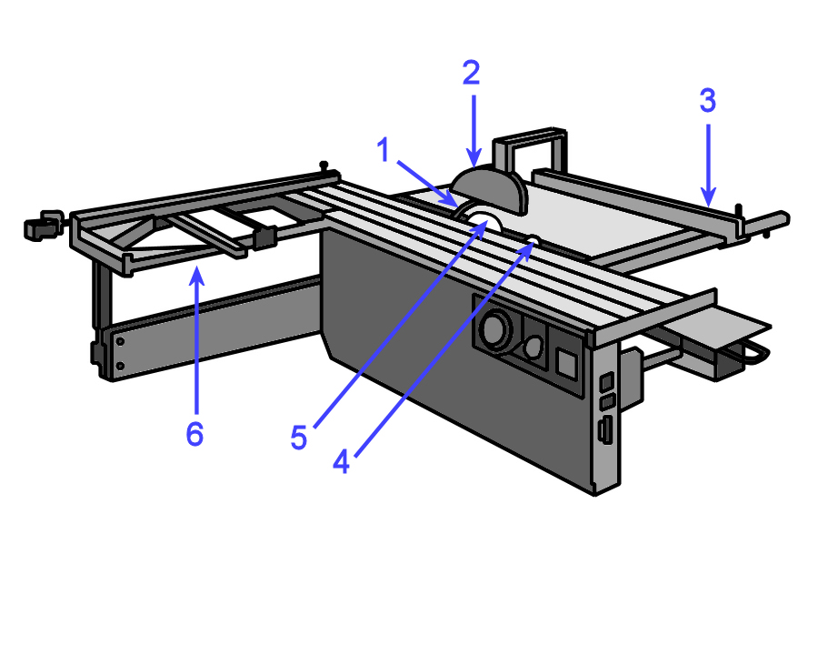Name the parts labelled on the saw diagram below, and provide a brief explanation of their purpose.

|  |  |  |
| --- | --- | --- |
| **No** | **Part name** | **Purpose** |
| **1** |  |  |
| **2** |  |  |
| **3** |  |  |
| **4** |  |  |
| **5** |  |  |
| **6** |  |  |

### Question 2

You need to cut the components shown below from a single sheet of 2400 x 1200 x 16 MDF. Once the components are cut to size they will be sprayed with a high gloss polyurethane lacquer.

|  |  |  |  |  |
| --- | --- | --- | --- | --- |
| **Item** | **Quantity** | **Height** | **Width** | **Material** |
| Doors | 6 | 745 | 450 | 16 mm MDF |
| Drawer fronts | 6 | 160 | 450 | 16 mm MDF |

1. Draw up a cutting pattern to show how you will recover these components from the sheet plan shown below.

1200

2400

1. Just say the customer decided to use a sliced-cut timber veneer finish instead of polyurethane lacquer. Could you use the same cutting pattern? Why or why not?

|  |
| --- |
|  |

### Question 3

Describe one potential quality problem that you should look out for at each of the following stages of the production process. For each problem, describe the most likely cause (or causes) and provide a possible solution.

1. When the board is picked up off a stack held in storage

|  |
| --- |
| Problem:  Cause:  Solution: |

1. When the board is cut to size on a panel saw

|  |
| --- |
| Problem:  Cause:  Solution: |

1. When the board is edged on an edge bander

|  |
| --- |
| Problem:  Cause:  Solution: |

|  |
| --- |
| Assignment 3 |

|  |  |  |  |
| --- | --- | --- | --- |
| Name |  | Date |  |

### Question 1

1. What are the main characteristics of the System 32 method of construction?

|  |
| --- |
|  |

1. Why is System 32 so efficient when you are installing hardware items?

|  |
| --- |
|  |

### Question 2

Choose one type of concealed hinge that you use at work and provide the following details:

1. State the name of the manufacturer and product name of the hinge.
2. List the items of equipment needed to install the hinge, including hand tools.
3. Briefly describe the process used to install the hinge.
4. Name one quality check you need to make to ensure that the hinge has been installed correctly and is working properly.

|  |  |
| --- | --- |
| **Type of hinge:** |  |
| **Manufacturer:** |  |
| **Product name:** |  |
| **Equipment needed:** |  |
| **Quality check:** |  |

### Question 3

Choose one style of carcase you manufacture and provide the following details:

1. Name the materials used in the carcase.
2. List all hand tools and fasteners used. If there is more than one type of fastener, name each one and state where it is used.
3. Describe how you check that the carcase is square before you fix the back panel into position.
4. Name one potential problem you need to look out for while carrying out the assembly process and describe how you would deal with it.

|  |  |
| --- | --- |
| **Type of carcase:** |  |
| **Materials used:** |  |
| **Hand tools:** |  |
| **Fasteners:** |  |
| **Checking for square:** |  |
| **Potential problem:** |  |

### Question 4

Choose one drawer design you use in your cabinets and provide the following details:

1. State the manufacturer and product name, if it is a patented drawer system. If not, state the manufacturer and product name of the drawer slides (and any other items of specialist hardware).
2. List the different materials or components used in the sides, back, front and base.
3. Briefly describe the method used to fix the base into position.
4. Briefly describe the method used to fix the drawer front into position.
5. Briefly describe the method used to install the runners into the cabinet carcase.
6. List the main quality checks you should carry out to make sure the drawer is installed correctly and running properly.

|  |  |
| --- | --- |
| **Type of drawer:** |  |
| **Manufacturer:** |  |
| **Product name:** |  |
| **Materials used:** |  |
| **Method to fix base:** |  |
| **Method to fix front:** |  |
| **Method to install runners:** |  |
| **Quality checks:** |  |